|  |
| --- |
| **18EES101J-BASIC ELECTRICAL AND ELECTRONICS ENGINEERING (LAB)** |
| **RECORD**  **SEMESTER I**    **ACADEMIC YEAR: 2020-21**  **NAME : Kunal Keshan S**  **REG. NO.: RA2011004010051**  C:\Users\System 1\Desktop\11.png  **DEPARTMENT OF ELECTRICAL & ELECTRONICS ENGINEERING**  **FACULTY OF ENGINEERING & TECHNOLOGY**  **SRM INSTITUTE OF SCIENCE AND TECHNOLOGY**  (Formerly SRM University, Under section 3 of UGC Act, 1956)  **S.R.M. NAGAR, KATTANKULATHUR – 603 203**  **KANCHEEPURAM DISTRICT** |



**SRM Institute of Science and Technology**

(Deemed to be University)

**S.R.M. NAGAR, KATTANKULATHUR -603 203**

**KANCHEEPURAM DISTRICT**

**BONAFIDE CERTIFICATE**

**Register No RA2011004010051**

Certified to be the bonafide record of work done by Kunal Keshan S of ECE – A department, B.Techdegree course in the Practical of 18EES101J Basic Electrical and Electronics Engineering in **SRM IST, Kattankulathur** during the academic year 2018-2019.

**Lab in-charge**

**Date: Year Co-ordinator**

Submitted for end semester examination held in______________________ Lab, SRMIST**,** Kattankulathur**.**

**Date: Examiner-1 Examiner-2**

**LIST OF EXPERIMENTS**

1. Verification of Kirchhoff’s laws

2. Verification of All Theorems (Thevenin’s theorem, Norton’s theorem, Maximum power transfer theorem)

3. Transient analysis of RL an RC series circuits

4. Load test on single phase transformer

5. Demo of DC/AC machines & Parts

6. Types of wiring (fluorescent lamp wiring, staircase wiring)

7. Characteristics of semiconductor devices (PN junction, Zener diode, BJT)

8. Wave shaping circuits (Half and full wave rectifier, clipper)

9. Displacement measurement using LVDT and pressure measurement using Strain gauge

10. Verification and interpretation of Logic Gates.

11. Reduction of Boolean expression using K-map

12. Study of modulation and demodulation techniques.

**INDEX**

|  |  |  |  |
| --- | --- | --- | --- |
| **Sl. No.** | **Name of the Experiment** | **Marks (50)** | **Signature**  **of the Staff** |
| 1 | Verification of Kirchhoff’s laws |  |  |
| 2 | Verification of All Theorems  (Thevenin’s theorem, Norton’s theorem, Maximum power transfer theorem) |  |  |
| 3 | Transient analysis of RL an RC series circuits |  |  |
| 4 | Load test on single phase transformer |  |  |
| 5 | Demo of DC/AC machines & Parts |  |  |
| 6 | Types of wiring ( fluorescent lamp wiring, staircase wiring) |  |  |
| 7 | Characteristics of semiconductor devices  (PN junction, Zener diode, BJT) |  |  |
| 8 | Wave shaping circuits  (Half and full wave rectifier, clipper) |  |  |
| 9 | Displacement measurement using LVDT and pressure measurement using Strain gauge |  |  |
| 10 | Verification and interpretation of Logic Gates. |  |  |
| 11 | Reduction of Boolean expression using K-map |  |  |
| 12 | Study of modulation and demodulation techniques. |  |  |

**General information**

**The Breadboard**

The breadboard consists of two terminal strips and two bus strips (often broken in the centre). Each bus strip has two rows of contacts. Each of the two rows of contacts are a node. That is, each contact along a row on a bus strip is connected together (inside the breadboard). Bus strips are used primarily for power supply connections, but are also used for any node requiring a large number of connections. Each terminal strip has 60 rows and 5 columns of contacts on each side of the centre gap. Each row of 5 contacts is a node.

You will build your circuits on the terminal strips by inserting the leads of circuit components into the contact receptacles and making connections with 22-26 gauge wire. There are wire cutter/strippers and a spool of wire in the lab. It is a good practice to wire +5V and 0V power supply connections to separate bus strips.

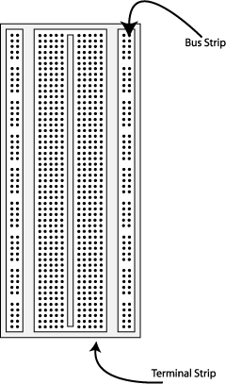    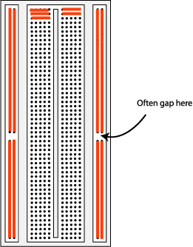

**Fig 1.** The breadboard. The lines indicate connected holes.

 The 5V supply **MUST NOT BE EXCEEDED** since this will damage the ICs (Integrated circuits) used during the experiments. Incorrect connection of power to the ICs could result in them exploding or becoming very hot - with the **possible serious injury occurring to the people working on the experiment! Ensure that the power supply polarity and all components and connections are correct before switching on power .**

**Building the Circuit**

Throughout these experiments we will use TTL chips to build circuits. The steps for wiring a circuit should be completed in the order described below:

|  |
| --- |
| 1. Turn the power (Trainer Kit) off before you build anything! |
| 1. Make sure the power is off before you build anything! |
| 1. Connect the +5V and ground (GND) leads of the power supply to the power and ground bus strips on your breadboard. |
| 1. Plug the chips you will be using into the breadboard. Point all the chips in the same direction with pin 1 at the upper-left corner. (Pin 1 is often identified by a dot or a notch next to it on the chip package) |
| 1. Connect +5V and GND pins of each chip to the power and ground bus strips on the breadboard. |
| 1. Select a connection on your schematic and place a piece of hook-up wire between corresponding pins of the chips on your breadboard. It is better to make the short connections before the longer ones. Mark each connection on your schematic as you go, so as not to try to make the same connection again at a later stage. |
| 1. Get one of your group members to check the connections, **before you turn the power on**. |
| 1. If an error is made and is not spotted before you turn the power on. Turn the power off immediately before you begin to rewire the circuit. |
| 1. At the end of the laboratory session, collect you hook-up wires, chips and all equipment and return them to the lab technician/ assisting staff. |
| 1. Tidy the area that you were working in and leave it in the same condition as it was before you started. |

**Common Causes of Problems**

|  |
| --- |
| 1. Not connecting the ground and/or power pins for all chips. |
| 1. Not turning on the power supply before checking the operation of the circuit. |
| 1. Leaving out wires. |
| 1. Plugging wires into the wrong holes. |
| 1. Driving a single gate input with the outputs of two or more gates |
| 1. Modifying the circuit with the power on. |

In all experiments, you will be expected to obtain all instruments, leads, components at the start of the experiment and return them to their proper place after you have finished the experiment. Please inform the lab technician if you locate faulty equipment. If you damage a chip, inform a lab technician/ assisting staff, don't put it back in the box of chips for somebody else to use.

DEPT. OF ELECTRICAL & ELECTRONICS ENGINEERING

SRM INSTITUTE OF SCIENCE AND TECHNOLOGY, Kattankulathur – 603 203

|  |
| --- |
| Title of Experiment : **1. Verification of Kirchhoff’s Laws** |
| Name of the candidate : Kunal Keshan S  Register Number : RA2011004010051  Date of Experiment : 16th April 2021 |

|  |  |  |  |
| --- | --- | --- | --- |
| Sl.  No. | Marks Split up | Maximum marks  (50) | Marks obtained |
| 1 | Pre Lab questions | 5 |  |
| 2 | Preparation of observation | 15 |  |
| 3 | Execution of experiment | 15 |  |
| 4 | Calculation / Evaluation of Result | 10 |  |
| 5 | Post Lab questions | 5 |  |
| **Total** | | **50** |  |

Staff Signature

**PRE LAB QUESTIONS**

**1. Define Ohm’s law.**

Ohm’s law states that the current through a conductor is directly proportional to the voltage across any two points and inversely proportional to the resistance across the conductor, given that the physical conditions and the temperature remain constant.

**2. State KCL and KVL.**

Kirchhoff’s Current Law or KCL, states that the, “total current or charge entering a junction or node is equal to the charge leaving the node.”

Kirchhoff’s Voltage Law or KVL, states that, “in any closed loop network, the total voltage around the loop is equal to the sum of all voltage drops within the same loop.”

**3. Define absolute potential and potential difference**

Absolute potential or electric potential is defined as the work that needs to be done to get an object or a particle to a point from an infinite distance.

Potential difference is the difference of the electric potential between any two points.

**4. What is the difference between mesh and loop?**

A mesh is a closed path in a circuit with no other paths inside it and a loop is any closed path through a circuit where no node more than once is encountered.

**5. What is super-node?**

A supernode is a theoretical construct that can be used to solve a circuit, it is done by viewing a voltage source on a wire as a point source voltage in a relation to other point voltages located at various nodes in the circuit, relative to a ground node assigned a zero or negative charge.

|  |  |
| --- | --- |
| **Experiment No. 1**  **Date : 16.04.2021** | **VERIFICATION OF KIRCHOFF’S LAWS** |

**Aim:**

To verify Kirchhoff’s current law and Kirchhoff’s voltage law for the given circuit.

**Apparatus Required:**

|  |  |  |  |
| --- | --- | --- | --- |
| Sl.No. | Apparatus | Range | Quantity |
| 1 | RPS (regulated power supply) | (0-30V) | 2 |
| 2 | Resistance | 330Ω, 220Ω 1kΩ | 6 |
| 3 | Ammeter | (0-30mA)MC | 3 |
| 4 | Voltmeter | (0-30V)MC | 3 |
| 5 | Bread Board & Wires | -- | Required |

**Statement:**

**KCL:** The algebraic sum of the currents meeting at a node/junction is equal to zero.

**KVL:** In any closed path / mesh, the algebraic sum of all the voltages is zero.

**Precautions:**

1. Voltage control knob should be kept at minimum position.
2. Current control knob of RPS should be kept at maximum position.

**Procedure for KCL:**

1. Give the connections as per the circuit diagram.
2. Set a particular value in RPS.
3. Note down the corresponding ammeter reading
4. Repeat the same for different voltages

**Procedure for KVL:**

1. Give the connections as per the circuit diagram.
2. Set a particular value in RPS.
3. Note all the voltage reading
4. Repeat the same for different voltages

**HARDWARE SETUP:**

**Circuit for KCL verification:**

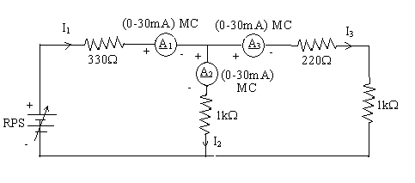

**Circuit for KVL verification:**

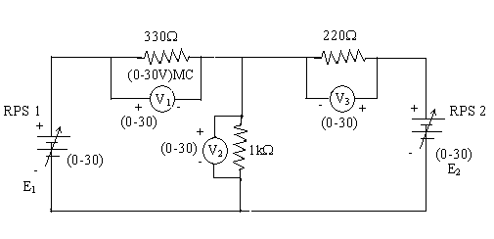

**KCL - Theoretical Values:**

|  |  |  |  |  |  |
| --- | --- | --- | --- | --- | --- |
| Sl.  No. | Voltage  E | Current | | | I1 = I2 + I3 |
| I1 | I2 | I3 |
| Volts | mA | mA | mA | mA |
| 1 | 5 | 5.68 | 3.12 | 2.56 | 5.68=3.12+2.56 |
| 2 | 10 | 11.37 | 6.25 | 5.12 | 11.37=6.25+5.12 |
| 3 | 20 | 22.74 | 12.5 | 10.24 | 22.74=12.5+10.24 |
| 4 |  |  |  |  |  |
| 5 |  |  |  |  |  |

**KCL - Practical Values:**

|  |  |  |  |  |  |
| --- | --- | --- | --- | --- | --- |
| Sl.  No. | Voltage  E | Current | | | I1 = I2 + I3 |
| I1 | I2 | I3 |
| Volts | mA | mA | mA | mA |
| 1 | 5 | 5.68 | 3.12 | 2.56 | 5.68=3.12+2.56 |
| 2 | 10 | 11.37 | 6.25 | 5.12 | 11.37=6.25+5.12 |
| 3 | 20 | 22.74 | 12.5 | 10.24 | 22.74=12.5+10.24 |

**KVL – Theoretical Values**

|  |  |  |  |  |  |  |
| --- | --- | --- | --- | --- | --- | --- |
| Sl.No. | RPS | | Voltage | | | KVL  E1 = V1 + V2 |
| E1 | E2 | V1 | V2 | V3 |
| V | V | V | V | V | V |
| 1 | 5 | 5 | 0.583 | 4.42 | 0.583 | 5=0.582+4.2 |
| 2 | 10 | 10 | 1.17 | 8.83 | 1.17 | 10=1.17+8.83 |
| 3 | 20 | 20 | 2.33 | 17.67 | 2.33 | 20=2.33+17.67 |
| 4 |  |  |  |  |  |  |
| 5 |  |  |  |  |  |  |

**KVL - Practical Values**

|  |  |  |  |  |  |  |
| --- | --- | --- | --- | --- | --- | --- |
| Sl.No. | RPS | | Voltage | | | KVL  E1 = V1 + V2 |
| E1 | E2 | V1 | V2 | V3 |
| V | V | V | V | V | V |
| 1 | 5 | 5 | 0.583 | 4.42 | 0.583 | 5=0.582+4.2 |
| 2 | 10 | 10 | 1.17 | 8.83 | 1.17 | 10=1.17+8.83 |
| 3 | 20 | 20 | 2.33 | 17.67 | 2.33 | 20=2.33+17.67 |

**Model Calculations:**

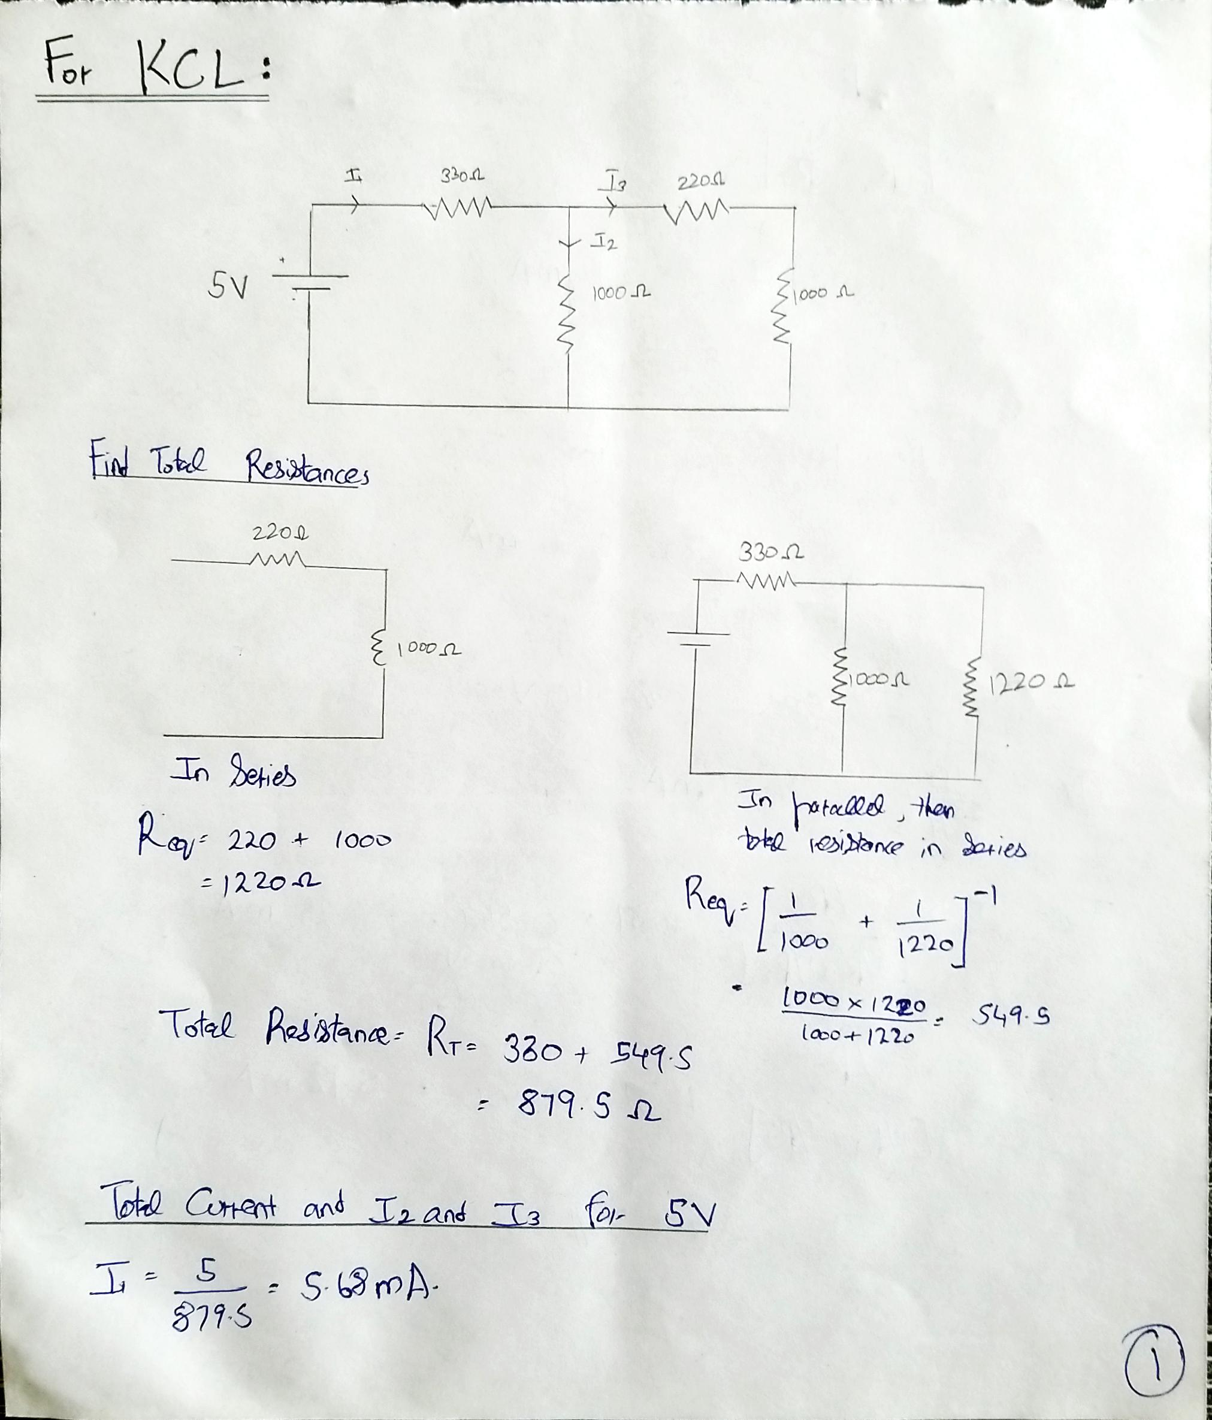

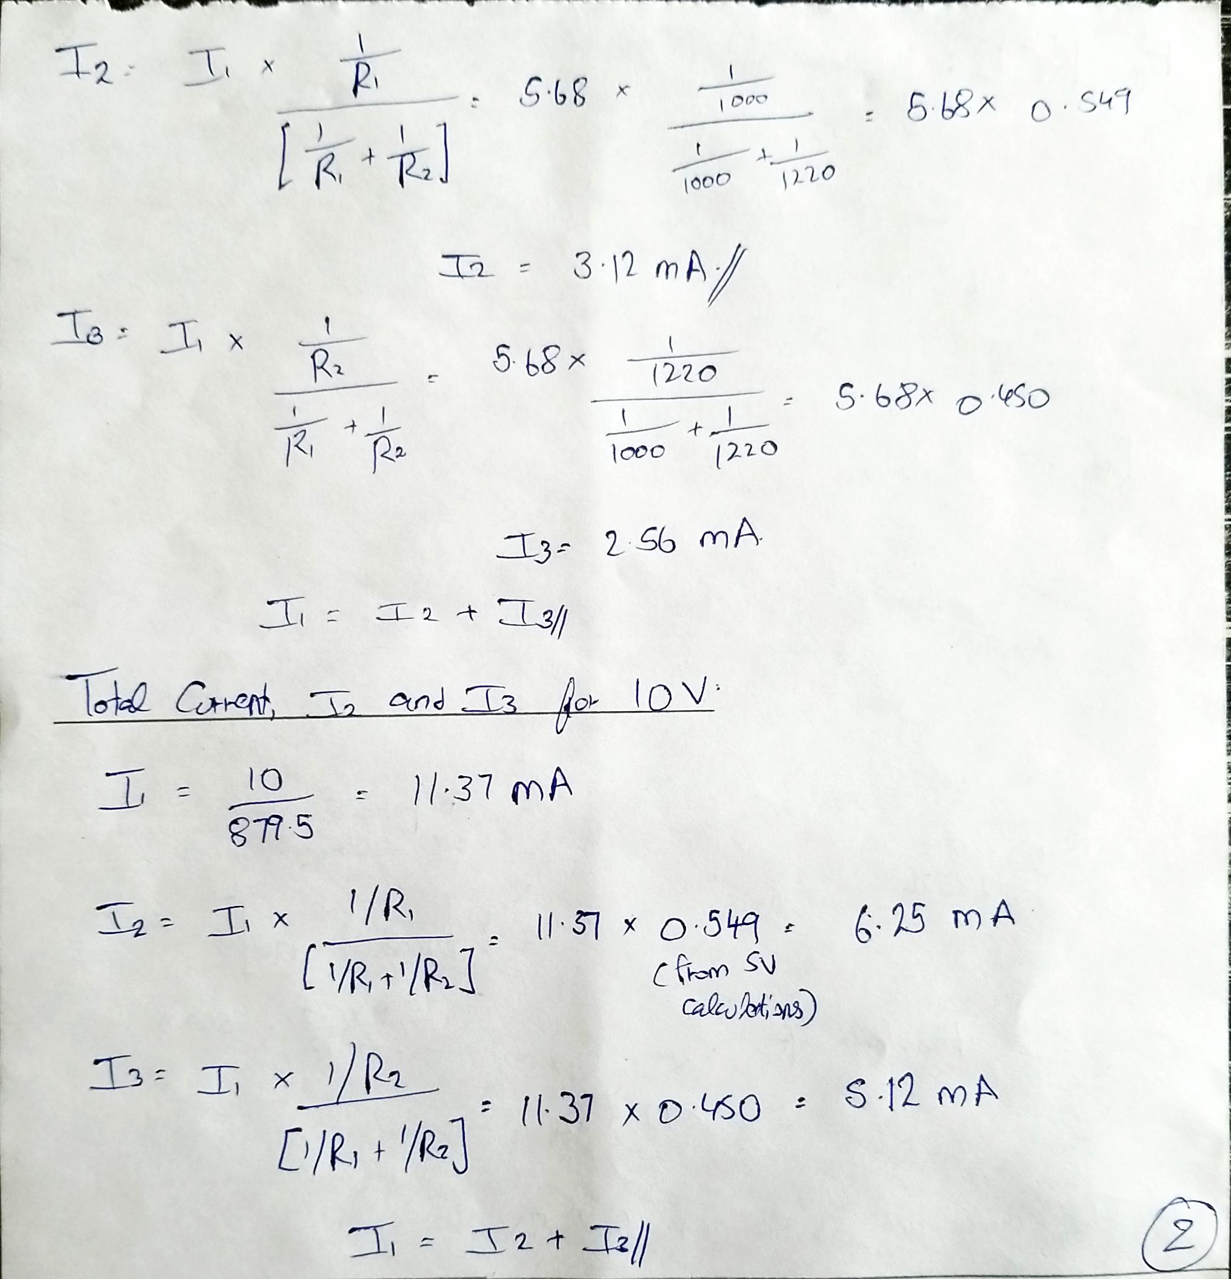

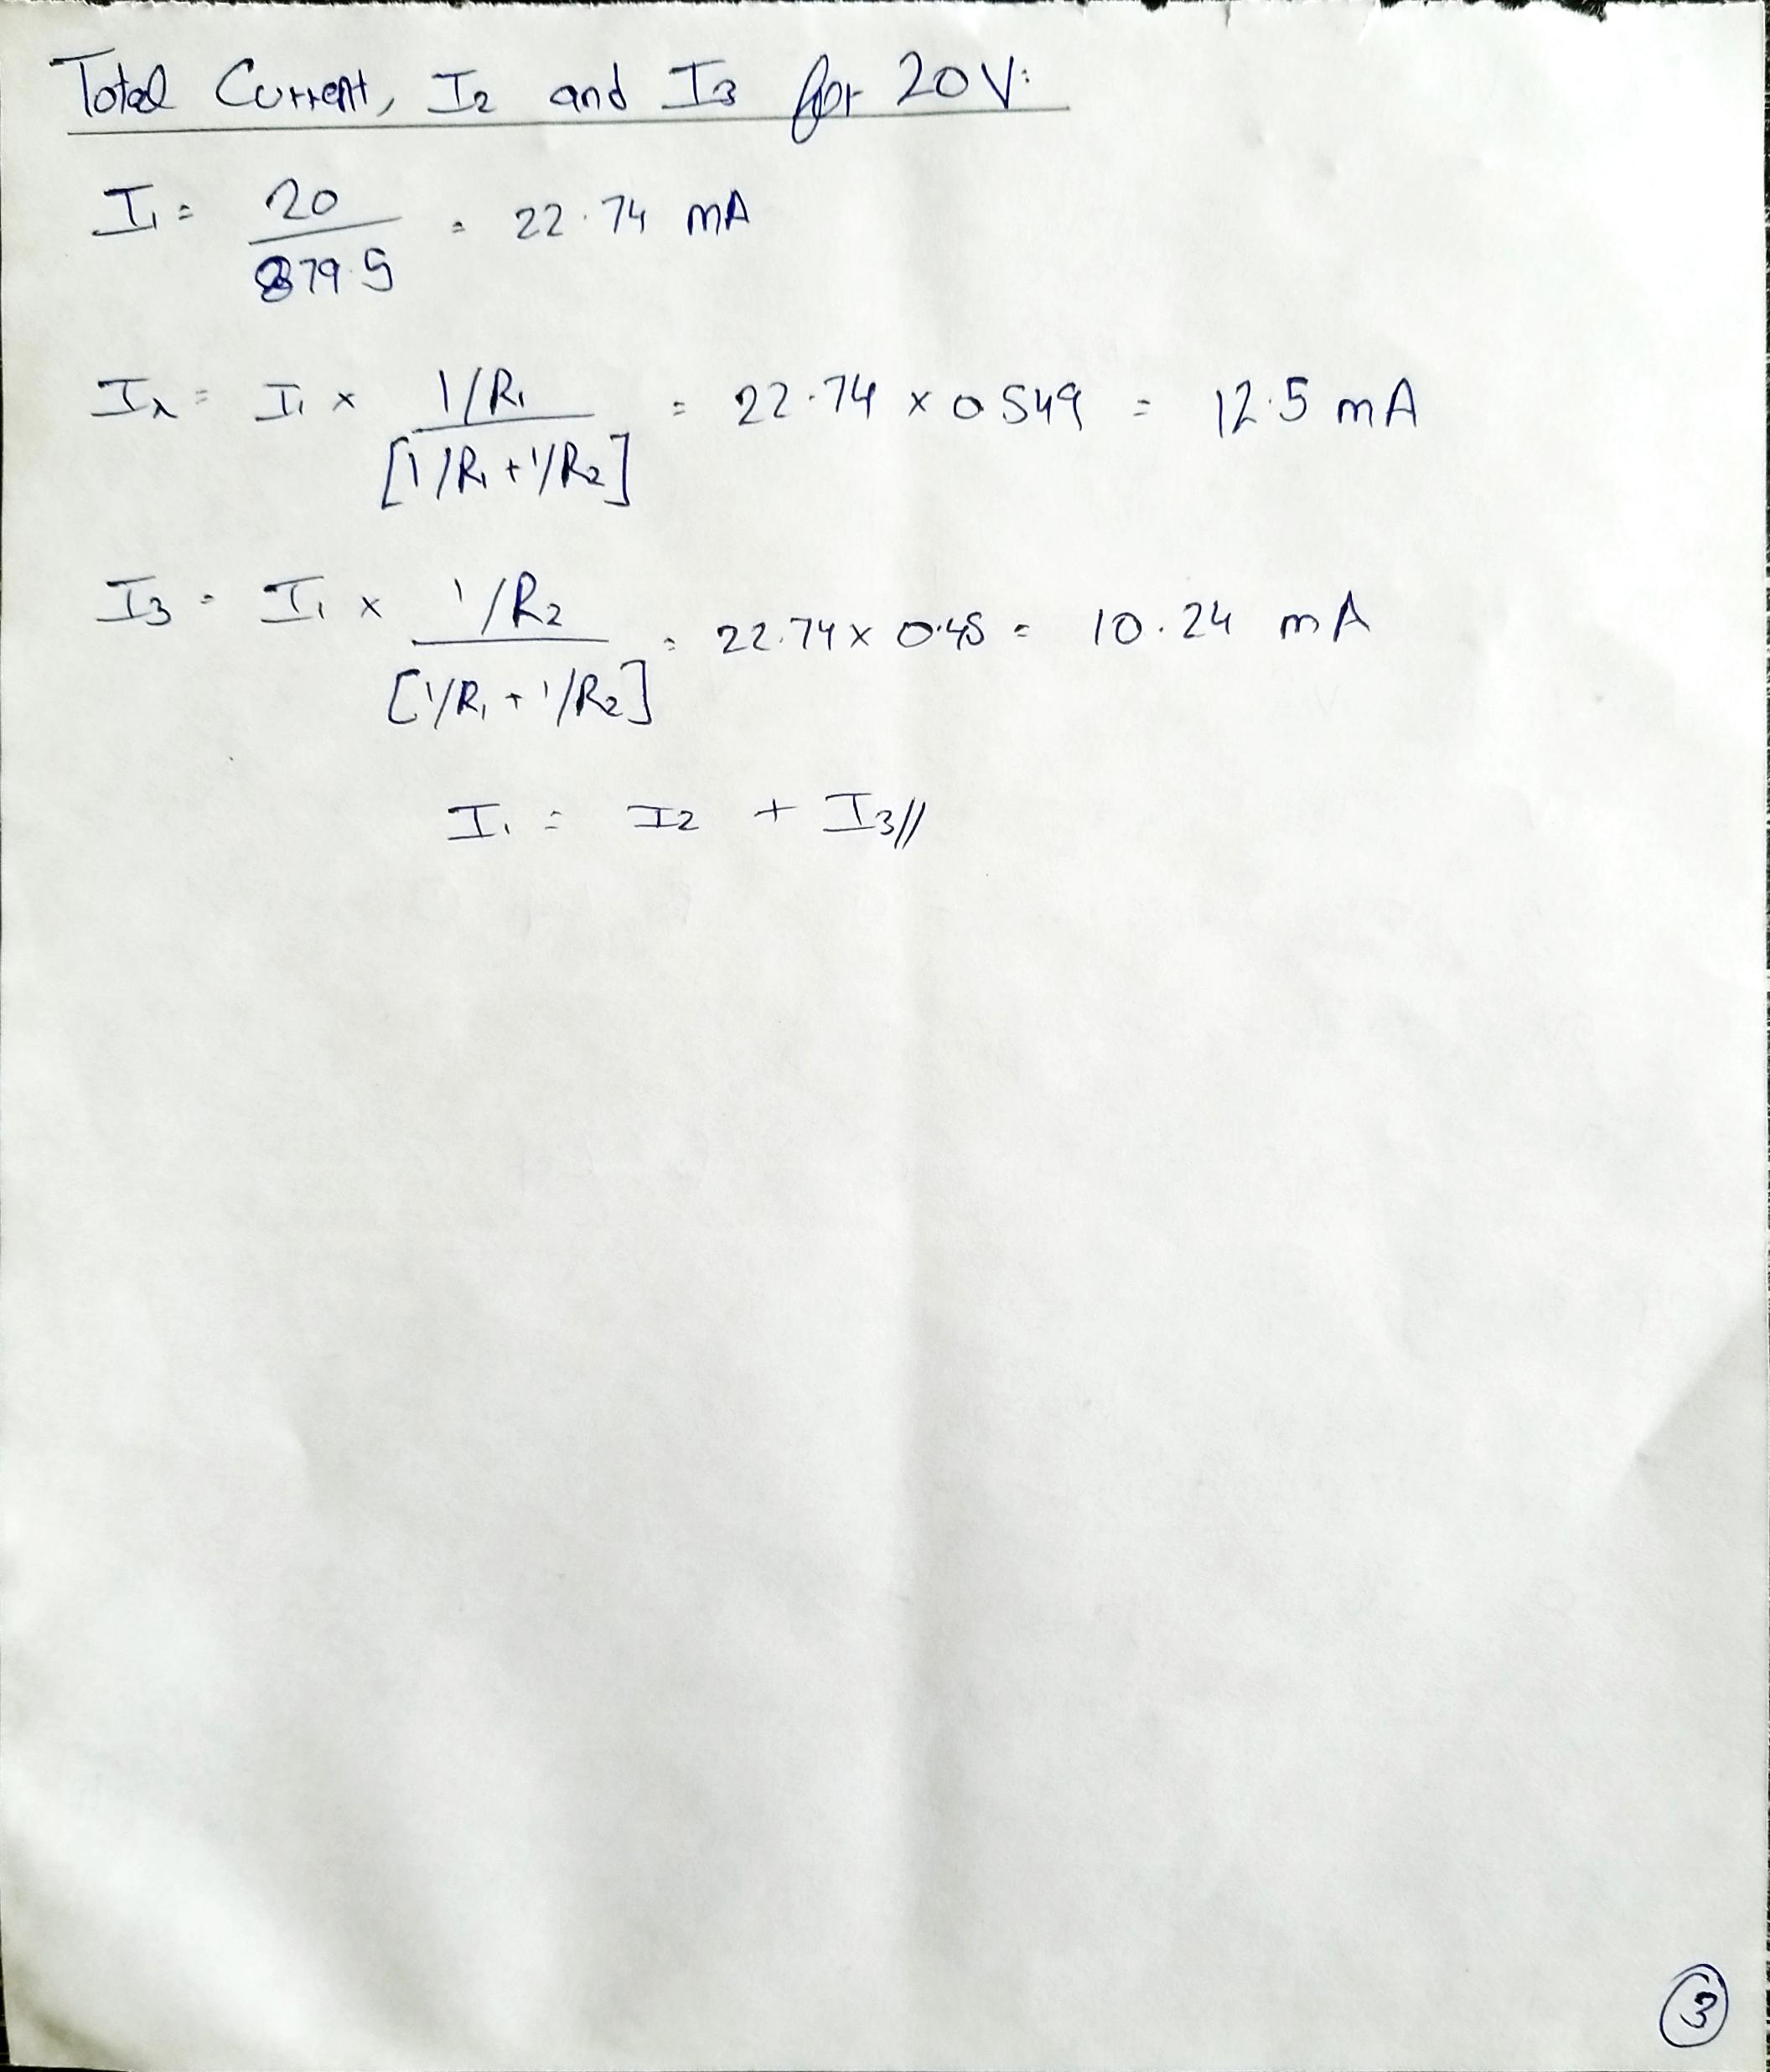

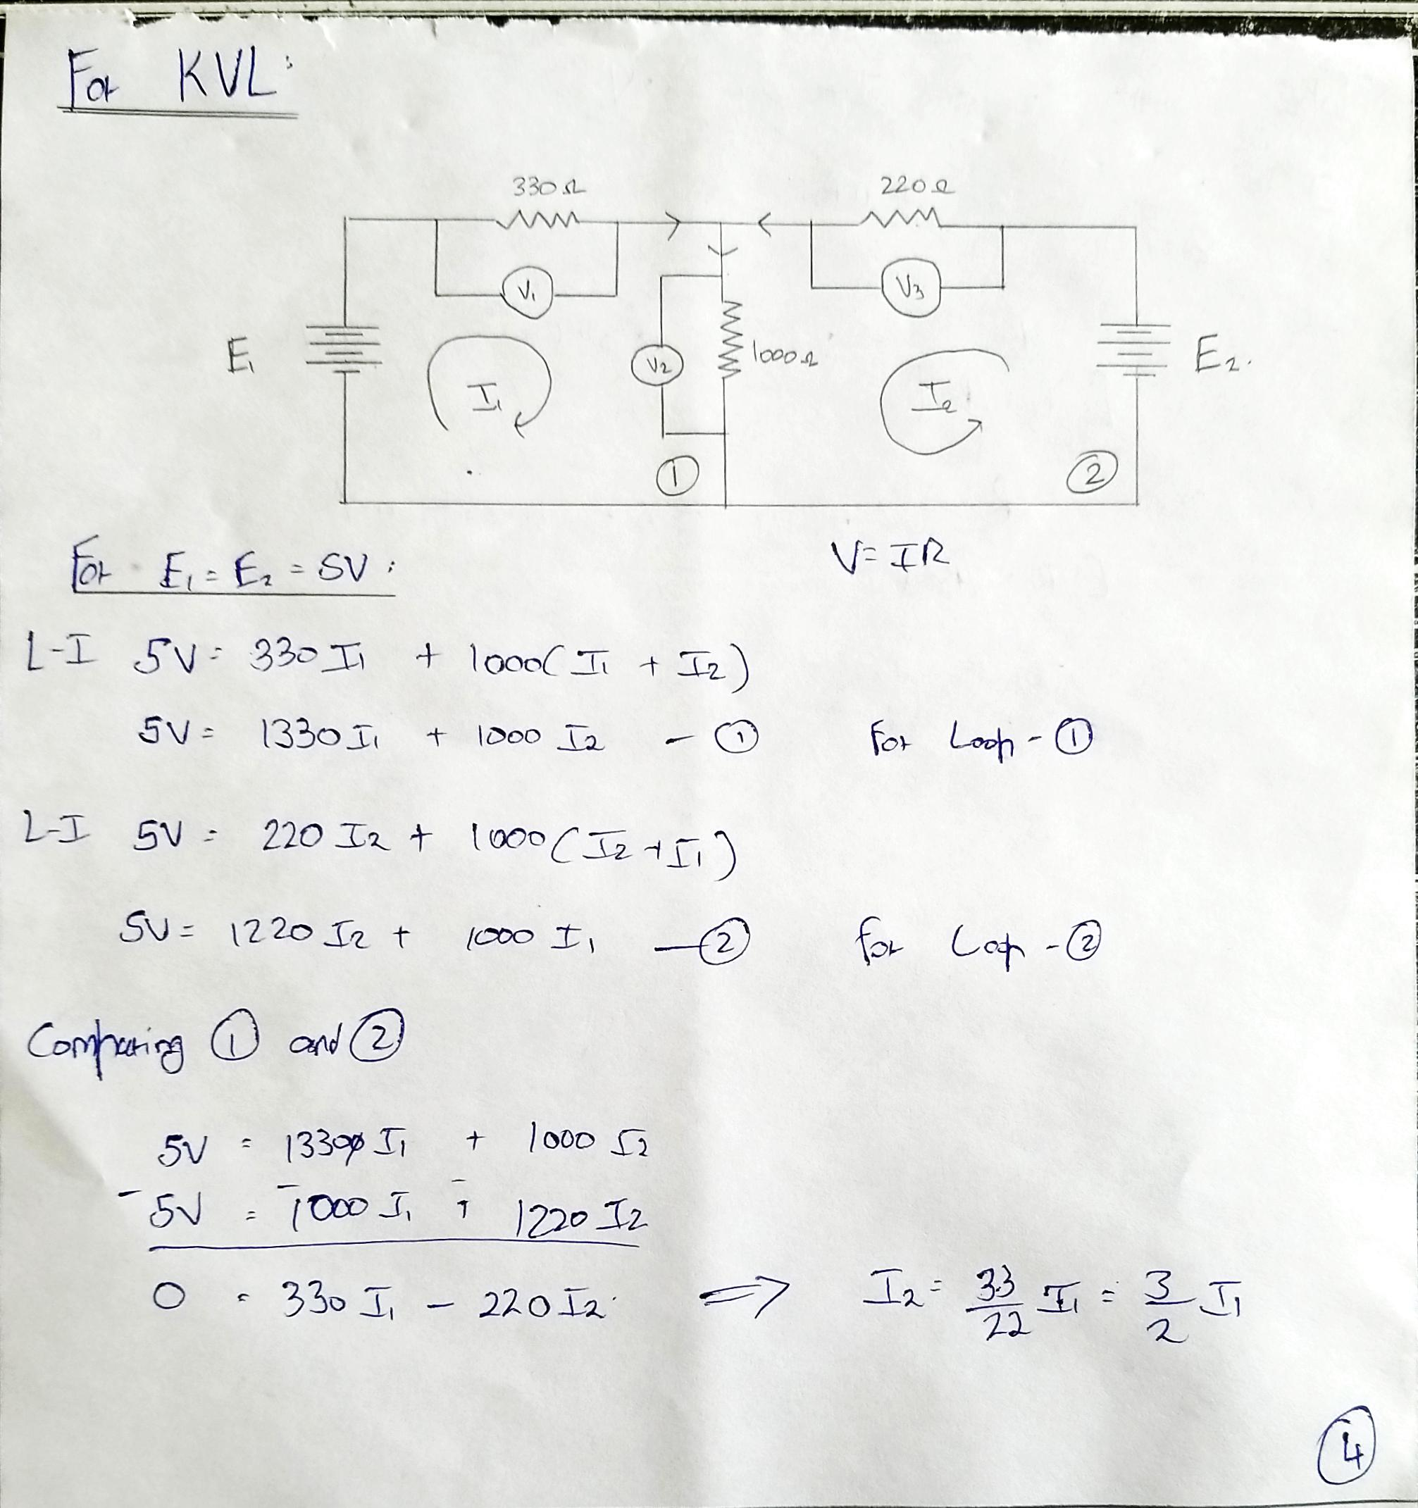

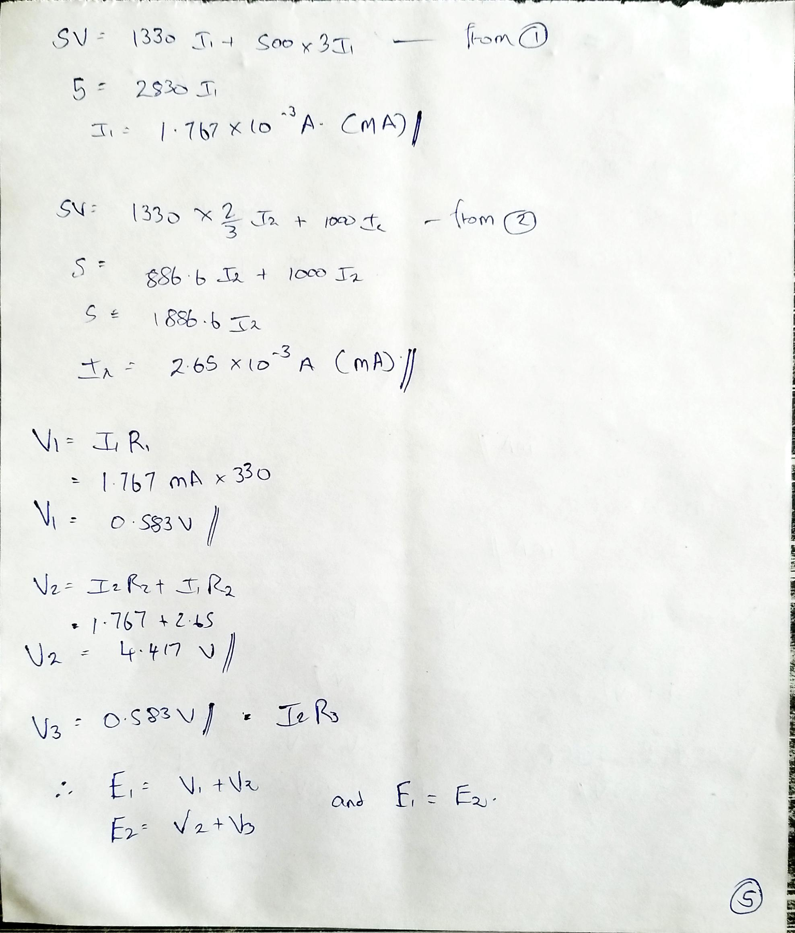



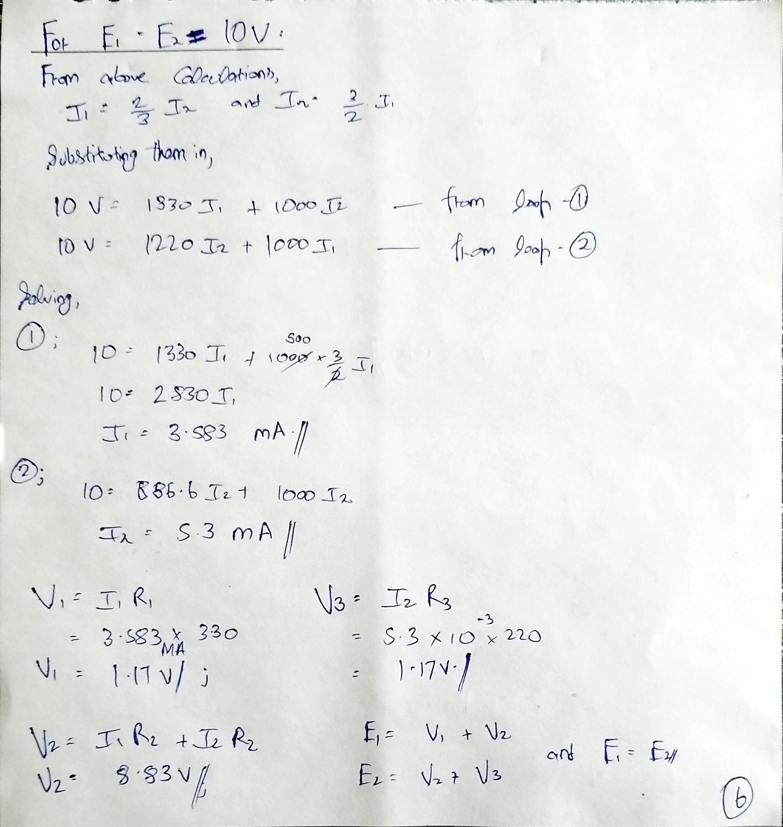

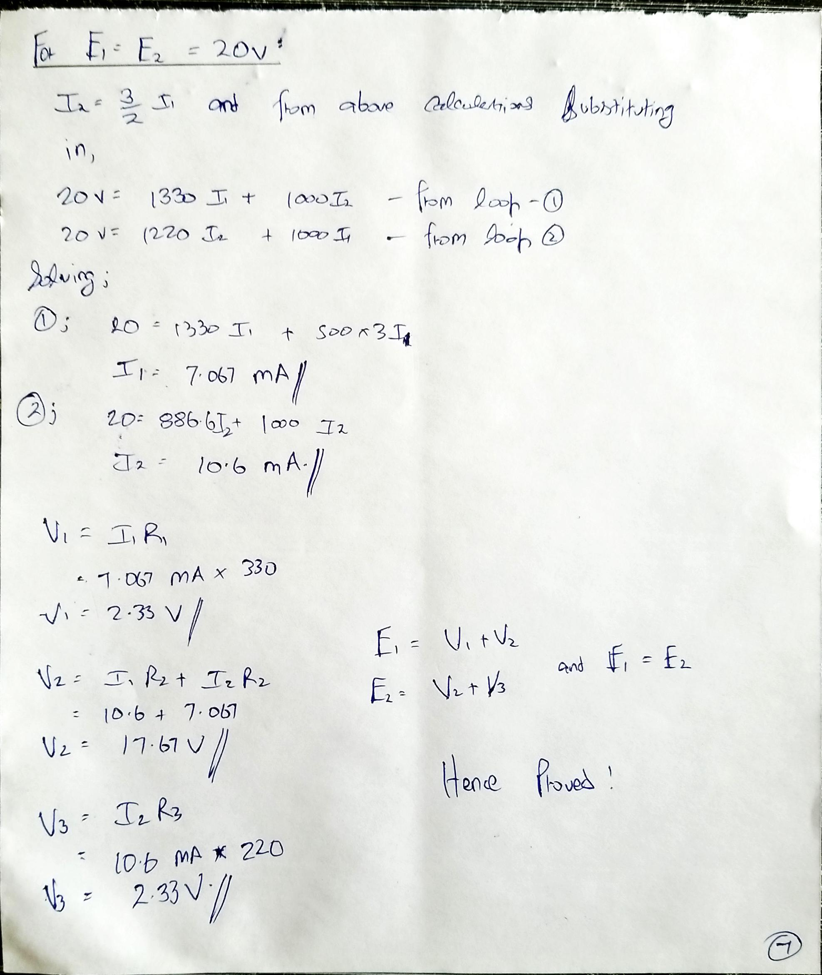

**Result:**

From the theoretical and practical values, Kirchhoff’s Current law and Kirchhoff’s Voltage Law is verified in the above circuits.

**POST LAB QUESTIONS**

1. **Illustrate KCL and KVL.**

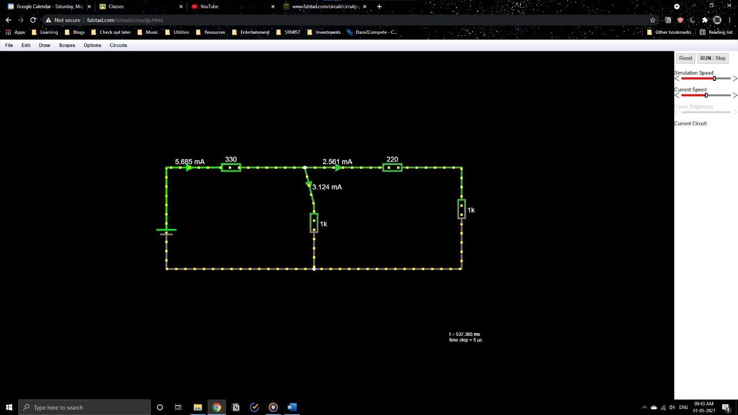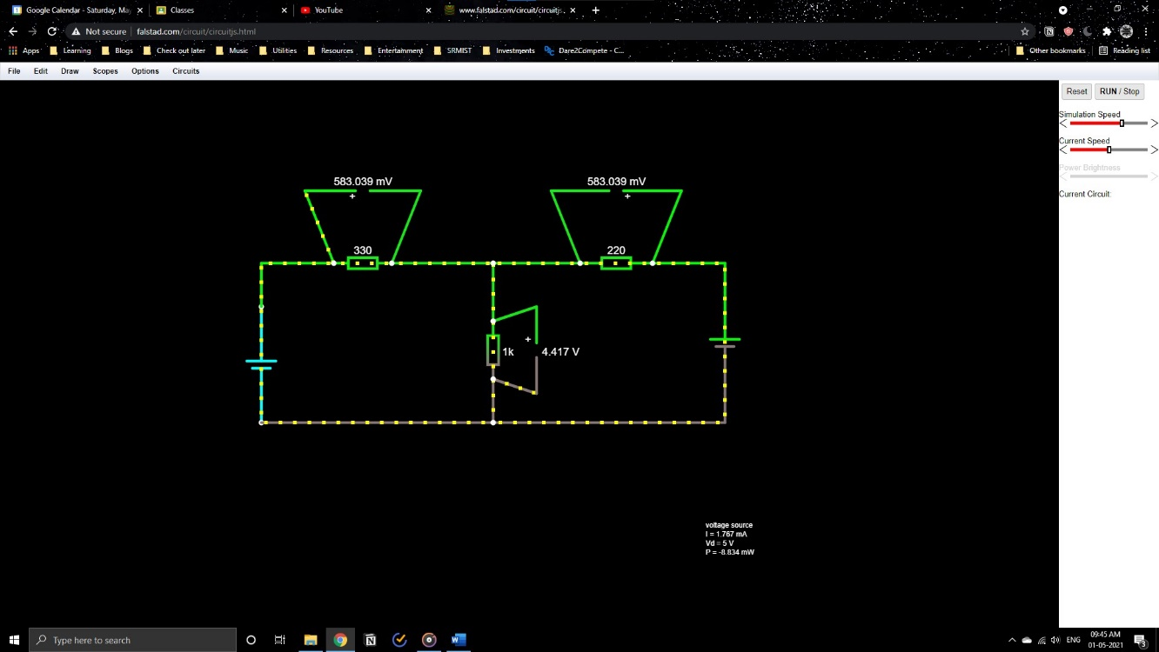

1. **Express the limitations of Ohm’s law?**

Ohm’s law is applicable only for metal conductors, provided that the temperature and other physical conditions remain constant. Ohm’s law is not applicable for gaseous conductors and semiconductors such as silicon and germanium.

1. **What is the practical application of Kirchhoff’s law?**

Kirchhoff’s law is valuable in analyzing electrical circuits. KCL is used to identify the current flowing through various branches within a circuit and then KVL can be used to find out the algebraic sum of the voltage drop across loops in a circuit.

1. **Compare series and parallel circuits**

In a series circuit, the current across each component remains the same whereas in a parallel circuit, the voltage across each component remains the same. It makes sense when we analyze these circuits using Kirchhoff’s law. The current will not split until and unless a junction is encountered and also the sum of the voltage drop across a loop in a circuit should be equal to the total voltage provided to the loop.

1. **What is the difference between series and parallel connection of batteries?**

In a series connection, batteries are connected to increase the voltage applied on the circuit and in a parallel connection the capacity of the battery is increased, i.e. it can run for a longer interlude.

DEPT. OF ELECTRICAL & ELECTRONICS ENGINEERING

SRM INSTITUTE OF SCIENCE AND TECHNOLOGY, Kattankulathur – 603 203

|  |
| --- |
| Title of Experiment : **2. VERIFICATION OF THEOREMS-**  **( THEVENIN,** NORTON,  MAXIMUM POWER TRANSFER ) |
| Name of the candidate : Kunal Keshan S  Register Number : RA2011004010051  Date of Experiment :30th April 2021 |

|  |  |  |  |
| --- | --- | --- | --- |
| Sl.  No. | Marks Split up | Maximum marks  (50) | Marks obtained |
| 1 | Pre Lab questions | 5 |  |
| 2 | Preparation of observation | 15 |  |
| 3 | Execution of experiment | 15 |  |
| 4 | Calculation / Evaluation of Result | 10 |  |
| 5 | Post Lab questions | 5 |  |
| **Total** | | **50** |  |

Staff Signature

**PRE LAB QUESTIONS**

**1. Define Lumped and distributed elements.**

**Lumped Elements:**

A section of transmission lines designed so that electric or magnetic energy is concentrated in it at specified frequencies, and inductance or capacitance may therefore be regarded as concentrated in it, rather than distributed over the length of the line.

**Distributed Elements:**

These are composed of lengths of transmission lines or other distributed components. The circuits containing distributed elements perform the same functions as conventional circuits of passive components. In such elements, electric or magnetic energy is not concentrated at specific points and are distributed over the length of transmission lines.

**2. State Thevenin’s theorem?**

Thevenin’s theorem states that “any linear circuit containing several voltages and resistors can be replaced by just one single voltage in series with a single resistance connected across the load.”

**3. State Norton’s theorem?**

Norton’s theorem states that “a linear active network consisting of the independent or dependent voltage source and current sources and the various elements can be substituted by an equivalent circuit consisting of a current source in parallel with a resistance.”

**4. List the applications of Thevenin’s and Norton’s theorems?**

Thevenin’s theorem can be applied to determine the charge in load voltage, to predict range of load voltage variation due to charge in load resistance, to obtain the norton’s equivalent circuit, to determine maximum power that can be transferred to load from the network.

Norton’s theorem helps to simplify any linear circuit, no matter how complex, to an equivalent circuit with just a single current source and parallel resistance connection to a load, It can also be used to represent any network of impedances at a given frequency.

**5. What are the different types of dependent or controlled sources?**

The different types of dependent or controlled sources are;

1. Voltage controlled voltage source(VCVS)
2. Voltage controlled current source(VCCS)
3. Current controlled voltage source(CCVS)
4. Current controlled current source(CCCS)

|  |  |
| --- | --- |
| **Experiment No. 2 a)**  **Date :** | **THEVENIN’S THEOREM** |

**Aim:**

To verify Thevenin’s theorem and to find the full load current for the given circuit.

**Apparatus Required:**

|  |  |  |  |
| --- | --- | --- | --- |
| Sl.No. | Apparatus | Range | Quantity |
| 1 | RPS (regulated power supply) | (0-30V) | 2 |
| 2 | Ammeter | (0-10mA) | 1 |
| 3 | Resistors | 1KΩ, 330Ω | 3,1 |
| 4 | Bread Board | -- | Required |
| 5 | DRB | -- | 1 |

**Statement:**

Any linear bilateral, active two terminal network can be replaced by a equivalent voltage source (VTH). Thevenin’s voltage or VOC in series with looking pack resistance RTH.

**Precautions:**

1. Voltage control knob of RPS should be kept at minimum position.
2. Current control knob of RPS should be kept at maximum position

**Procedure:**

1. Connections are given as per the circuit diagram.
2. Set a particular value of voltage using RPS and note down the corresponding ammeter readings.

**To find VTH**

1. Remove the load resistance and measure the open circuit voltage using multimeter (VTH).

**To find RTH**

1. To find the Thevenin’s resistance, remove the RPS and short circuit it and find the RTH using multimeter.
2. Give the connections for equivalent circuit and set VTH and RTH and note the corresponding ammeter reading.
3. Verify Thevenins theorem.

**Theoretical and Practical Values**

|  |  |  |  |  |  |
| --- | --- | --- | --- | --- | --- |
|  | E(V) | VTH(V) | RTH(Ω) | IL (mA) | |
| Circuit - I | Equivalent Circuit |
| Theoretical | 10 | 5 | 495 | 3.34 | 3.34 |
| Practical | 10 | 5 | 495 | 3.34 | 3.34 |

**Circuit - 1 : To find load current**

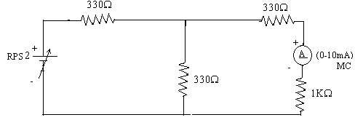

**To find VTH**

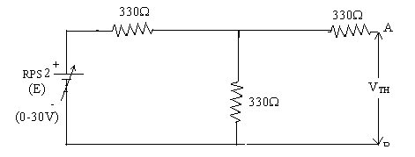

**To find RTH**

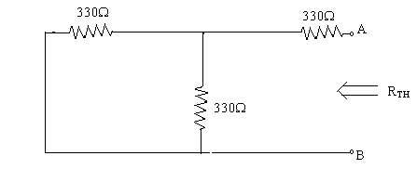

**Thevenin’s Equivalent circuit:**

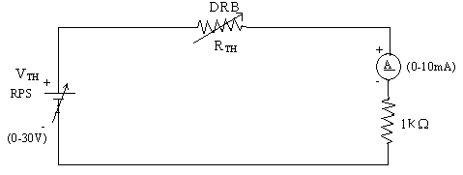

**Model Calculations:**

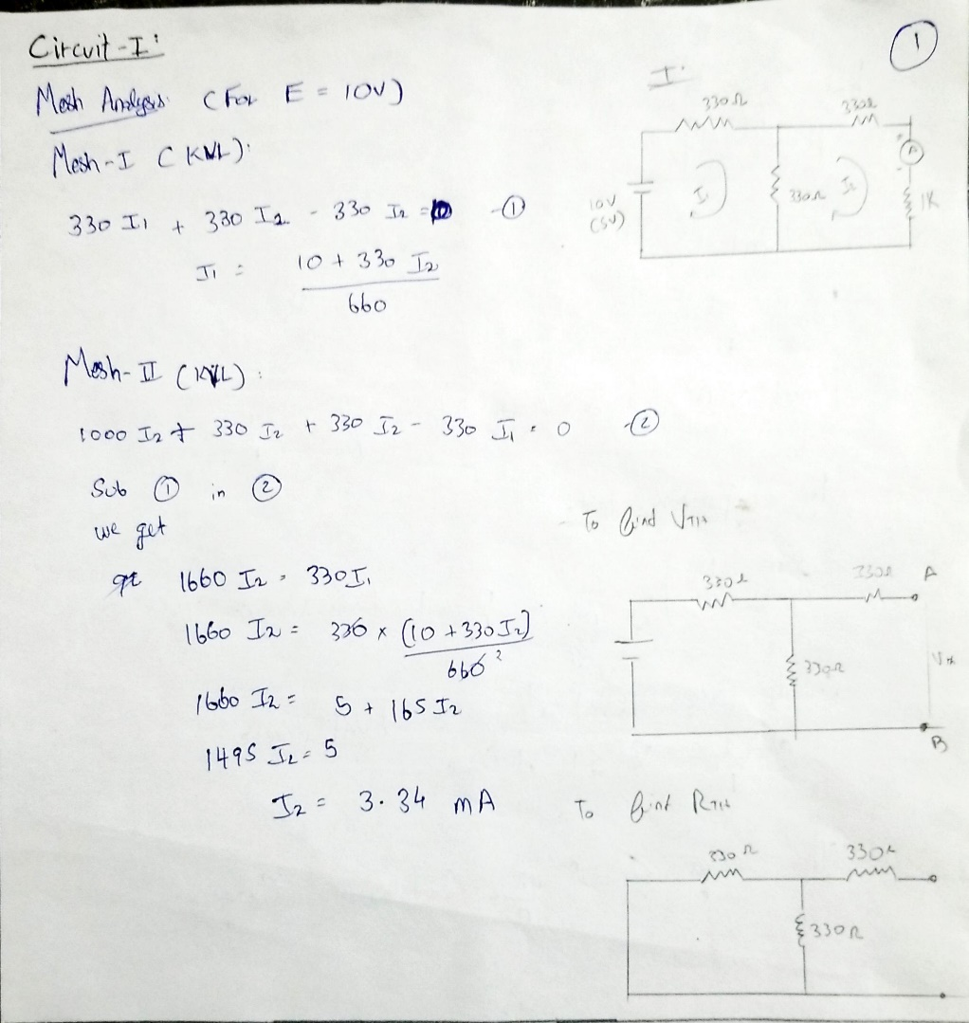

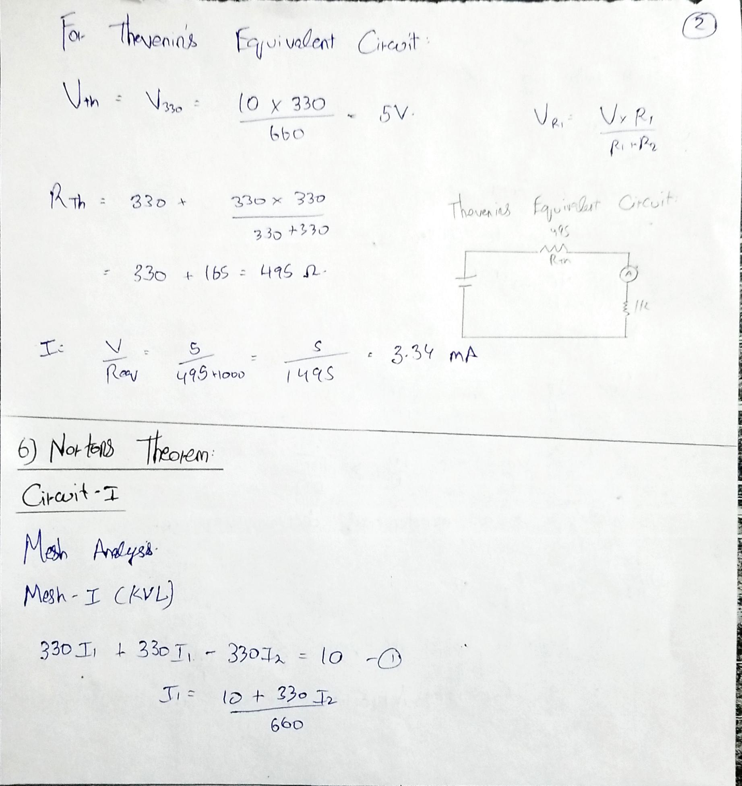

**Result:**

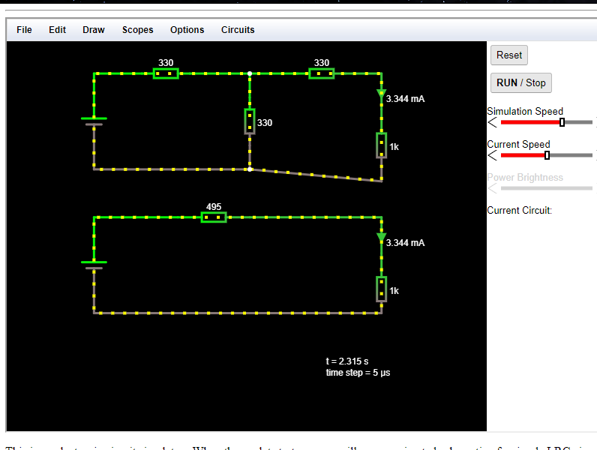

|  |  |
| --- | --- |
| **Experiment No. 2 b)**  **Date :** | **VERIFICATION OF NORTON’S THEOREM** |

**Aim:**

To verify Norton’s theorem for the given circuit.

**Apparatus Required:**

|  |  |  |  |
| --- | --- | --- | --- |
| Sl.No. | Apparatus | Range | Quantity |
| 1 | Ammeter | (0-10mA) MC  (0-30mA) MC | 1  1 |
| 2 | Resistors | 330, 1KΩ | 3,1 |
| 3 | RPS | (0-30V) | 2 |
| 4 | Bread Board | -- | 1 |
| 5 | Wires | -- | Required |

**Statement:**

Any linear, bilateral, active two terminal network can be replaced by an equivalent current source (IN) in parallel with Norton’s resistance (RN)

**Precautions:**

1. Voltage control knob of RPS should be kept at minimum position.
2. Current control knob of RPS should be kept at maximum position.

**Procedure:**

1. Connections are given as per circuit diagram.
2. Set a particular value in RPS and note down the ammeter readings in the original circuit.

**To Find IN:**

1. Remove the load resistance and short circuit the terminals.
2. For the same RPS voltage note down the ammeter readings.

**To Find RN:**

1. Remove RPS and short circuit the terminal and remove the load and note down the resistance across the two terminals.

**Equivalent Circuit:**

1. Set IN and RN and note down the ammeter readings.
2. Verify Norton’s theorem.

**To find load current in circuit 1:**

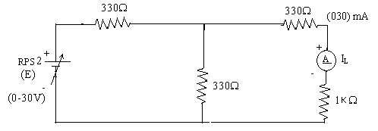

**To find IN**

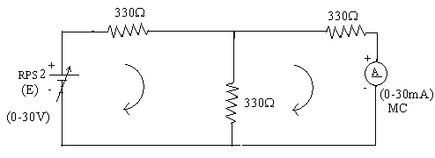

**To find RN**

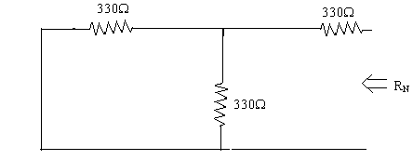

**Norton’s equivalent circuit**

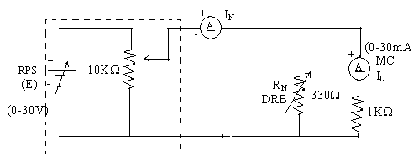

Constant current source

**Theoretical and Practical Values**

|  |  |  |  |  |  |
| --- | --- | --- | --- | --- | --- |
|  | E  (volts) | IN  (mA) | RN  (Ω) | IL (mA) | |
| Circuit - I | Equivalent Circuit |
| Theoretical Values | 10 | 10.1 | 495 | 3.34 | 3.34 |
| Practical Values | 10 | 10.1 | 495 | 3.34 | 3.34 |

**Model Calculations:**



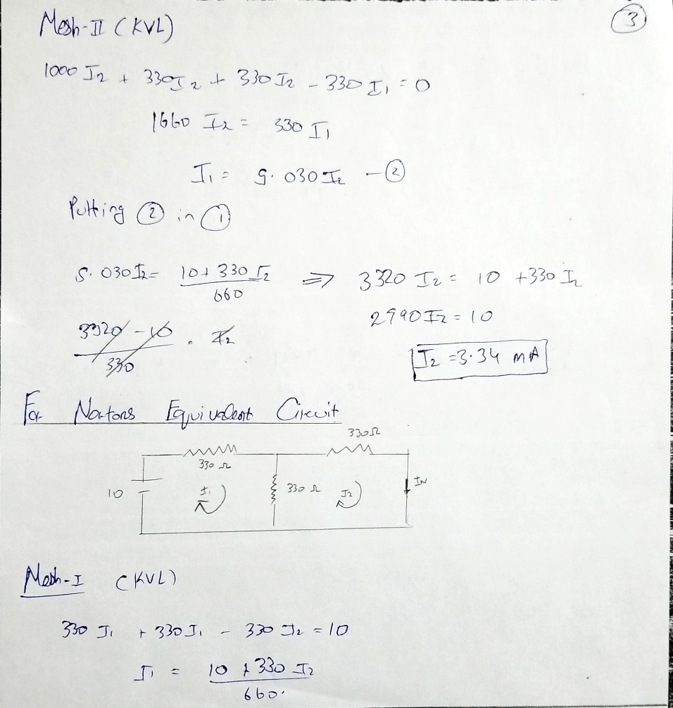

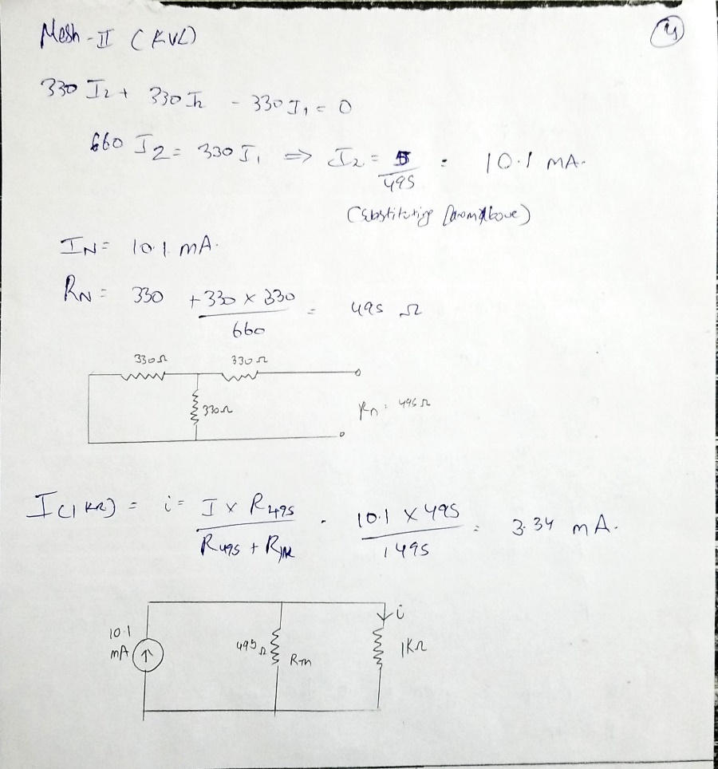

**Result:**

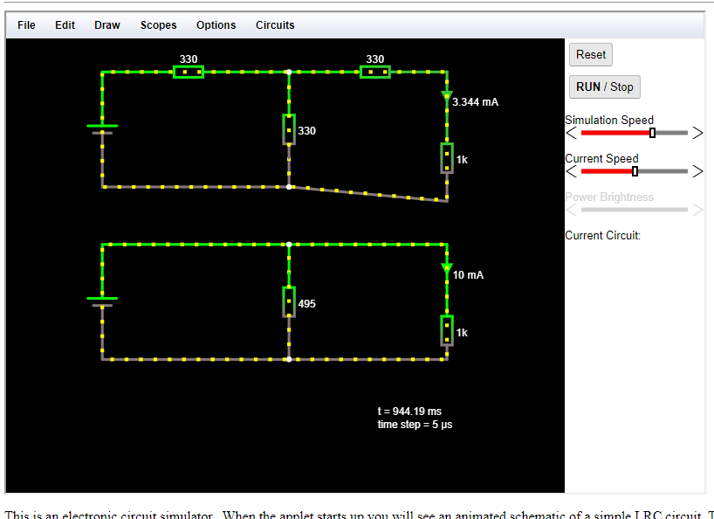

|  |  |
| --- | --- |
| **Experiment No. 2 c)**  **Date :** | **VERIFICATION OF MAXIMUM POWER TRANSFER THEOREM** |

**Aim:**

To verify maximum power transfer theorem for the given circuit

**Apparatus Required:**

|  |  |  |  |
| --- | --- | --- | --- |
| Sl.No. | Apparatus | Range | Quantity |
| 1 | RPS | (0-30V) | 1 |
| 2 | Voltmeter | (0-10V) MC | 1 |
| 3 | Resistor | 1KΩ, 1.3KΩ, 3Ω | 3 |
| 4 | DRB | -- | 1 |
| 5 | Bread Board & wires | -- | Required |

**Statement:**

In a linear, bilateral circuit the maximum power will be transferred from source to the load when load resistance is equal to source resistance.

**Precautions:**

1. Voltage control knob of RPS should be kept at minimum position.
2. Current control knob of RPS should be kept at maximum position.

**Procedure:**

**Circuit – I**

1. Connections are given as per the diagram and set a particular voltage in RPS.
2. Vary RL and note down the corresponding ammeter and voltmeter reading.
3. Repeat the procedure for different values of RL & Tabulate it.
4. Calculate the power for each value of RL.

**To find VTH:**

1. Remove the load, and determine the open circuit voltage using multimeter (VTH)

**To find RTH:**

1. Remove the load and short circuit the voltage source (RPS).
2. Find the looking back resistance (RTH) using multimeter.

**Equivalent Circuit:**

1. Set VTH using RPS and RTH using DRB and note down the ammeter reading.
2. Calculate the power delivered to the load (RL = RTH)
3. Verify maximum transfer theorem.

**Circuit - 1**

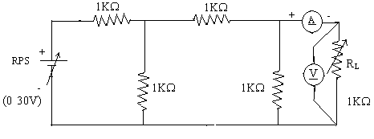

**To find VTH**

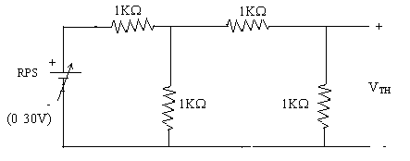

**To find RTH**

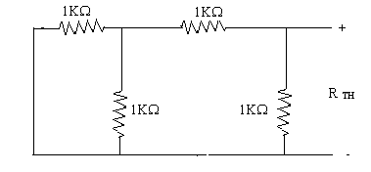

**Thevenin’s Equation Circuit**

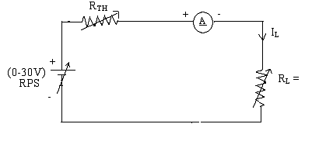

**Power VS RL**

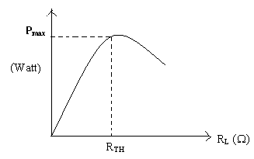

**Circuit – I**

|  |  |  |  |  |
| --- | --- | --- | --- | --- |
| **Sl.No.** | **RL (Ω)** | **I (mA)** | **V(V)** | **P=VI (mW)** |
| 1.  2.  3.  4.  5. | 200  400  600  800  1000 | 2.5  2  1.67  1.43  1.25 | 0.5  0.8  1  1.14  1.25 | 1.25  1.6  1.67  1.63  1.56 |

**To find Thevenin’s equivalent circuit**

|  |  |  |  |  |
| --- | --- | --- | --- | --- |
|  | **VTH (V)** | **RTH (Ω)** | **IL (mA)** | **P (milli watts)** |
| **Theoretical Value** | 2 | 600 | 1.67 | 1.67 |
| **Practical Value** | 2 | 600 | 1.67 | 1.67 |

**Model Calculations:**

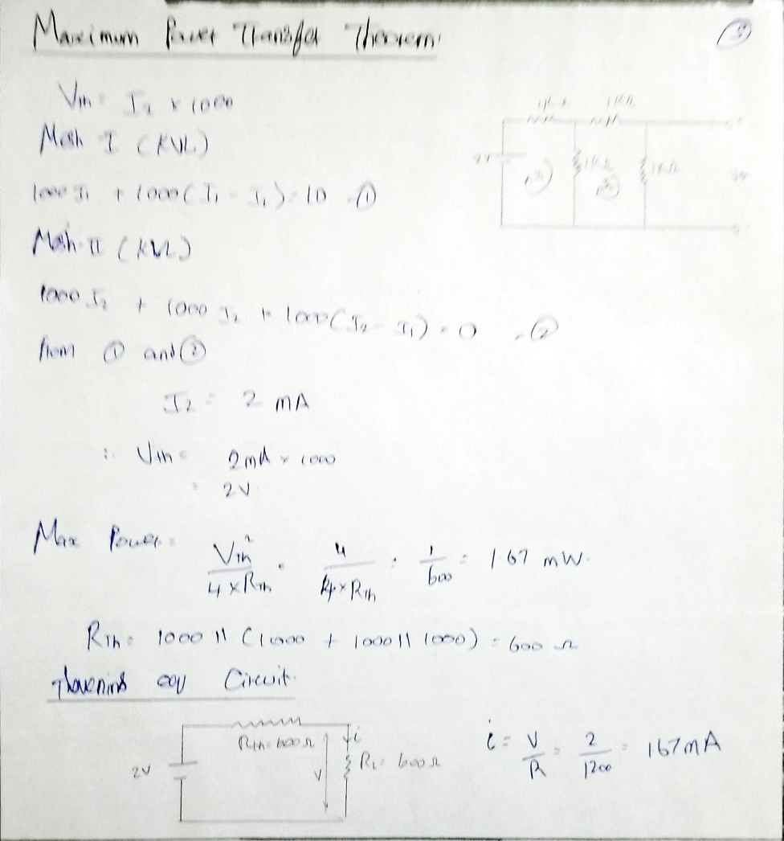

**Graph:**

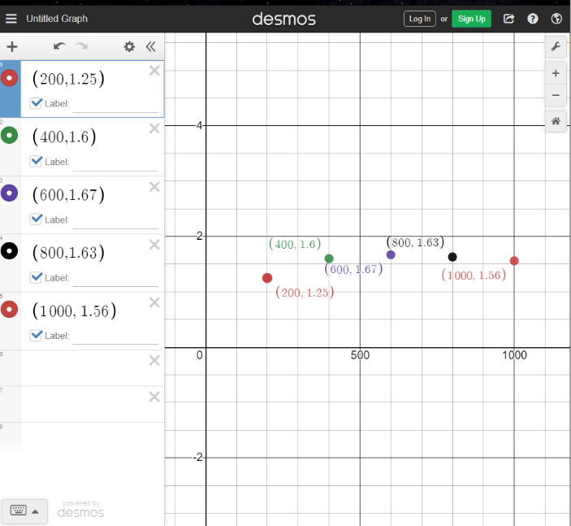

**Result:**

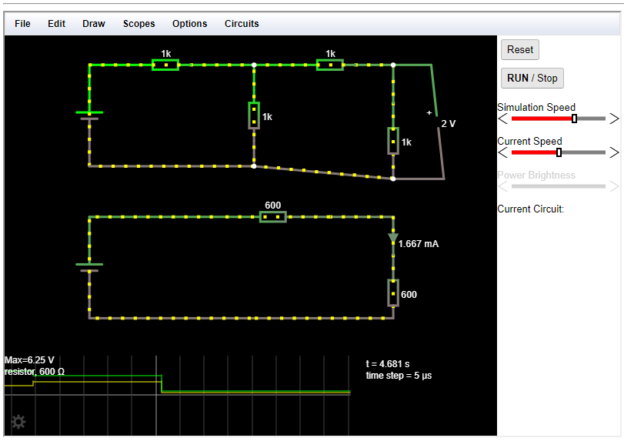

**POST LAB QUESTIONS**

1. **State Thevenin’s Theorem.**

Thevenin’s theorem states that any linear circuit containing several voltages and resistances can be replaced by just one single voltage in series with the load resistance.

1. **Draw the Thevenin’s equivalent circuit**



1. **State maximum power transfer theorem.**

Maximum power transfer theorem states that the DC voltage source will deliver maximum power to the variable load resistance only when RL = Rth (load resistance = source resistance)

1. **Write some applications of maximum transfer theorem.**
2. This method ensures the power to be dissipated in the load resistance.
3. Maximum power transfer theorem is applied mostly in radio communication.
4. **Write the steps to find IN**
5. Remove load resistance.
6. Find Rsby shorting all the voltage once or find it by short circuiting Rc.
7. Find IN(current through Rc line) by mesh analysis, node analysis or both.
8. **What are the steps to solve Maximum power transfer Theorem?**
9. Remove the load resistance.
10. Find Vth at the open circuited end.
11. Find Rth.
12. Draw the ‘thevenin’s equivalent circuit with Vth and Rth’
13. Put Rc = Rth.
14. Find the power dissipated by using the foumula P = Vth2/4Rth.

DEPT. OF ELECTRICAL & ELECTRONICS ENGINEERING

SRM INSTITUTE OF SCIENCE AND TECHNOLOGY, Kattankulathur – 603 203

|  |
| --- |
| Title of Experiment : **3**.**Transient analysis of Series RL, RC circuits** |
| Name of the candidate : Kunal Keshan  Register Number : RA2011004010051  Date of Experiment : 25th May 2021 |

|  |  |  |  |
| --- | --- | --- | --- |
| Sl.  No. | Marks Split up | Maximum marks  (50) | Marks obtained |
| 1 | Pre Lab questions | 5 |  |
| 2 | Preparation of observation | 15 |  |
| 3 | Execution of experiment | 15 |  |
| 4 | Calculation / Evaluation of Result | 10 |  |
| 5 | Post Lab questions | 5 |  |
| **Total** | | **50** |  |

Staff Signature

**PRE-LAB QUESTIONS**

**1) Define Transient.**

Electrical transients are momentary bursts of energy induced upon power, data, or communication lines. They are characterized by extremely high voltages that drive tremendous amounts of current into an electrical circuit for a few millionths, up to a few thousandths, of a second.

**2) Time constant for RL Circuit.**

The time constant for an RL circuit is defined by τ = L/R.

**3) Time constant for RC Circuit.**

The time constant for an RC circuit is defined by τ = R x C.

**4) How will you design the values of L & C in a transient circuit?**

The current is sinusoidal and the voltages over the L and C are both sinusoidal, too. The voltage over the C swings between 0 and 2E. In circuit theory we have 2 state variable differential equations, one for the inductor current and one for the capacitor voltage. They can be used "as is" for numerical simulation.

|  |  |
| --- | --- |
| **Experiment No. 3**  **Date : 25th May 2021** | **Transient analysis of series RL, RC circuits** |

**Aim:**

To obtain the transient response and measure the time constant of a series RL and RC circuit for a pulse waveform.

**Apparatus Required:**

|  |  |  |  |
| --- | --- | --- | --- |
| Sl. No. | Apparatus | Range | Quantity |
| 1 | Function Generator | 800 Hz | 1 |
| 2 | Inductor | 1 mH | 1 |
| 3 | Resistor | 4 KΩ | 1 |
| 4 | Capacitor | 1 nF | 1 |
| 5 | Bread Board & Wires | -- | Required |
| 6 | CRO |  | 1 |
| 7 | CRO Probes |  | 2 |

**Theory**

In this experiment, we apply a pulse waveform to the RL or RC circuit to analyze the transient response of the circuit. The pulse-width relative to a circuit’s time constant determines how it is affected by an RC or RL circuit.

Time Constant (τ): A measure of time required for certain changes in voltages and currents in RC and RL circuits. Generally, when the elapsed time exceeds five time constants (5τ) after switching has occurred, the currents and voltages have reached their final value, which is also called steady-state response.

The time constant of an RC circuit is the product of equivalent capacitance and the Thevenin’s resistance as viewed from the terminals of the equivalent capacitor.

τ = RC

A Pulse is a voltage or current that changes from one level to the other and back again. If a waveform’s high time equals its low time, as in figure, it is called a square wave. The length of each cycle of a pulse train is termed its period (T). The pulse width (tp) of an ideal square wave is equal to half the time period.

**Procedure for RL:**

1. Make the connections as per the circuit diagram.
2. Choose square wave mode in signal generator
3. Using CRO, adjust the amplitude to be 2 volts peak to peak.
4. Take care of the precaution and set the input frequency.
5. Observe and plot the output waveform.
6. Calculate the time required by the output to reach 0.632 times the final value (peak).
7. This value gives the practical time constant. Tabulate the theoretical and practical values.

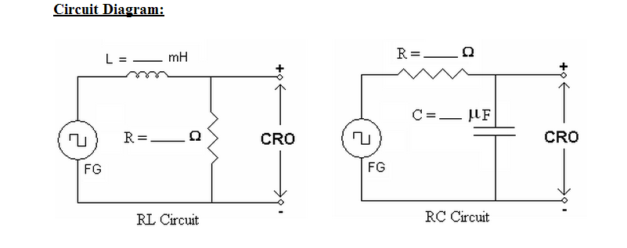

**Model Graph:**

**a) RL Transient :Output voltage across Resistor:**

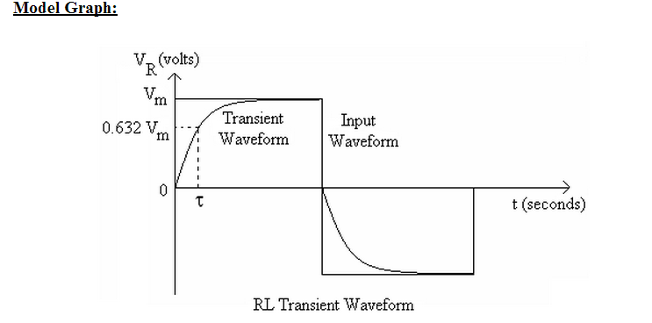

**b) RC Transient :Output voltage across Capacitor:**

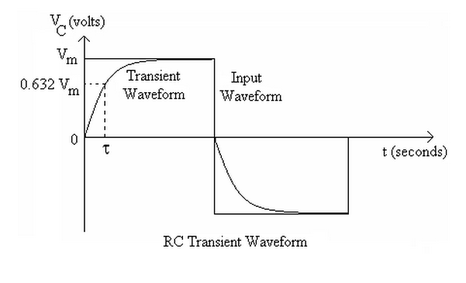

**Hardware setup:**

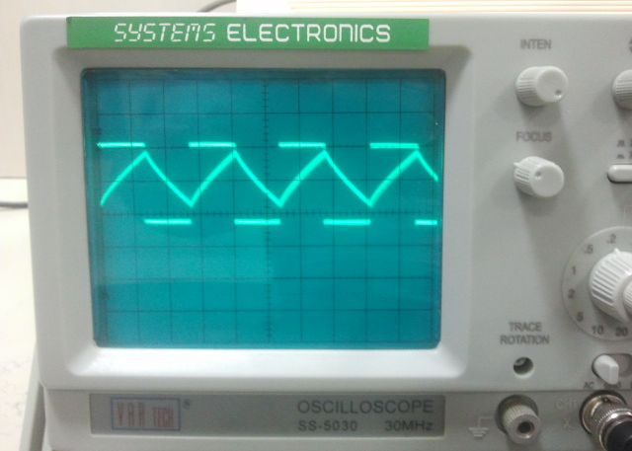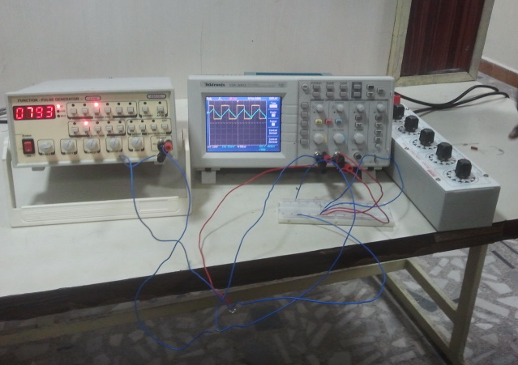

RL Transient Analysis:

|  |  |  |  |
| --- | --- | --- | --- |
| **R(ohms)** | **L(henry)** | **Experiment** | |
| **t(s)** | **VR** |
| 3 | 1 | 2.9 | 3 |
| 3 | 2 | 5.8 | 3 |

Graph:

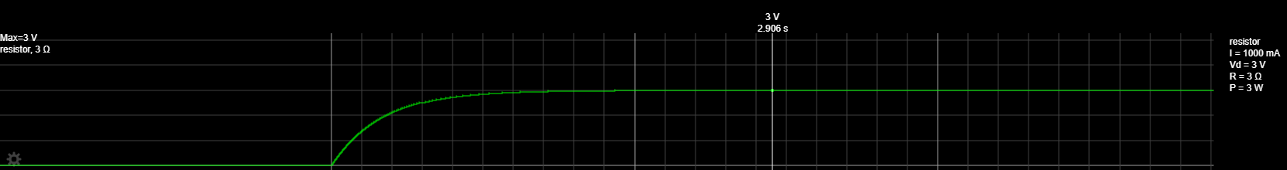

RC Transient Analysis:

|  |  |  |  |
| --- | --- | --- | --- |
| **R(ohms)** | **C(farads)** | **Experiment** | |
| **t(s)** | **VC** |
| 3 | 0.5 | 13 | 3 |
| 3 | 0.25 | 6.5 | 3 |

Graph:

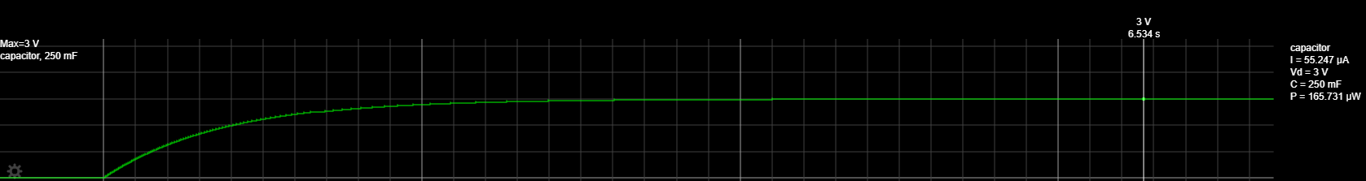

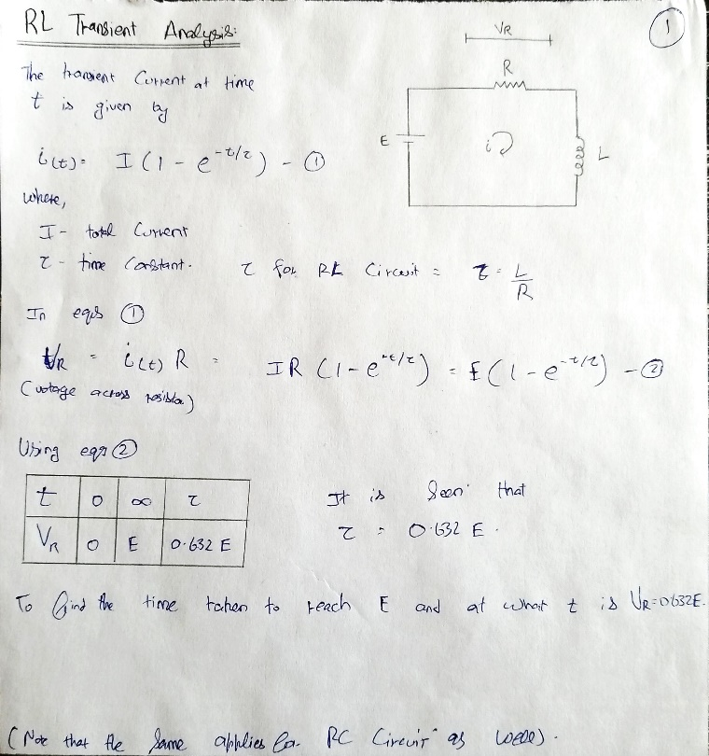**Model Calculations:**

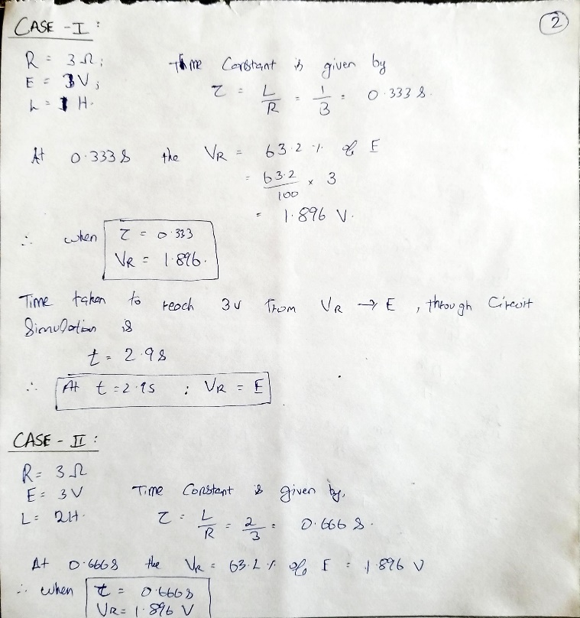

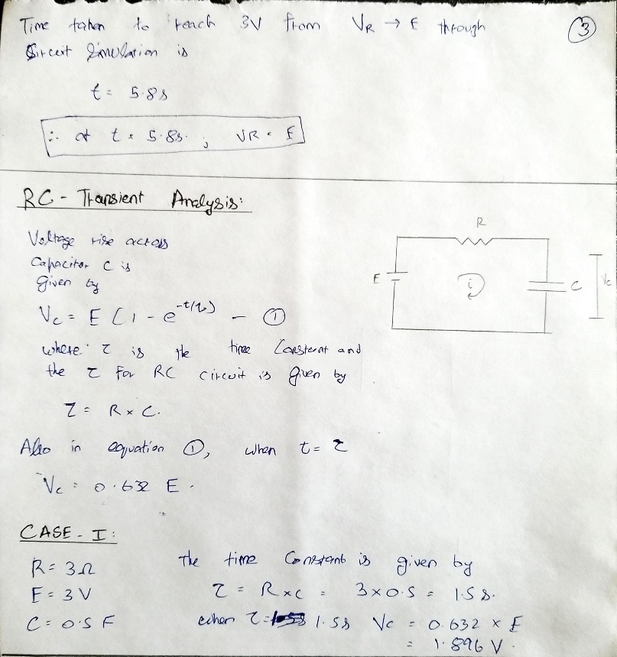

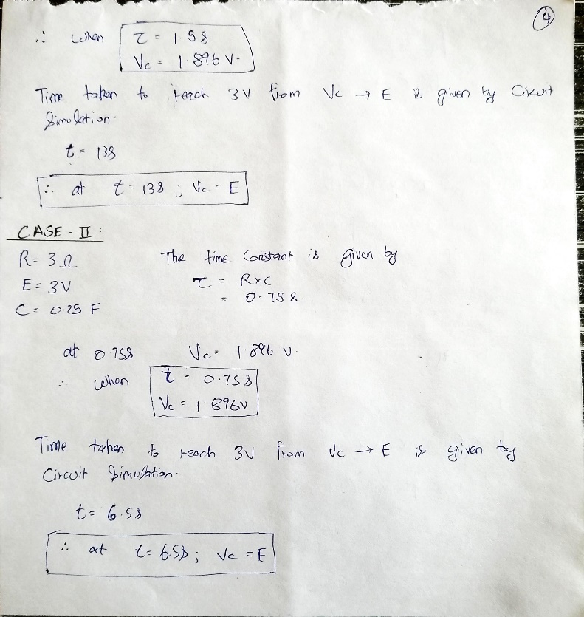

**Result:**

RL Transient:

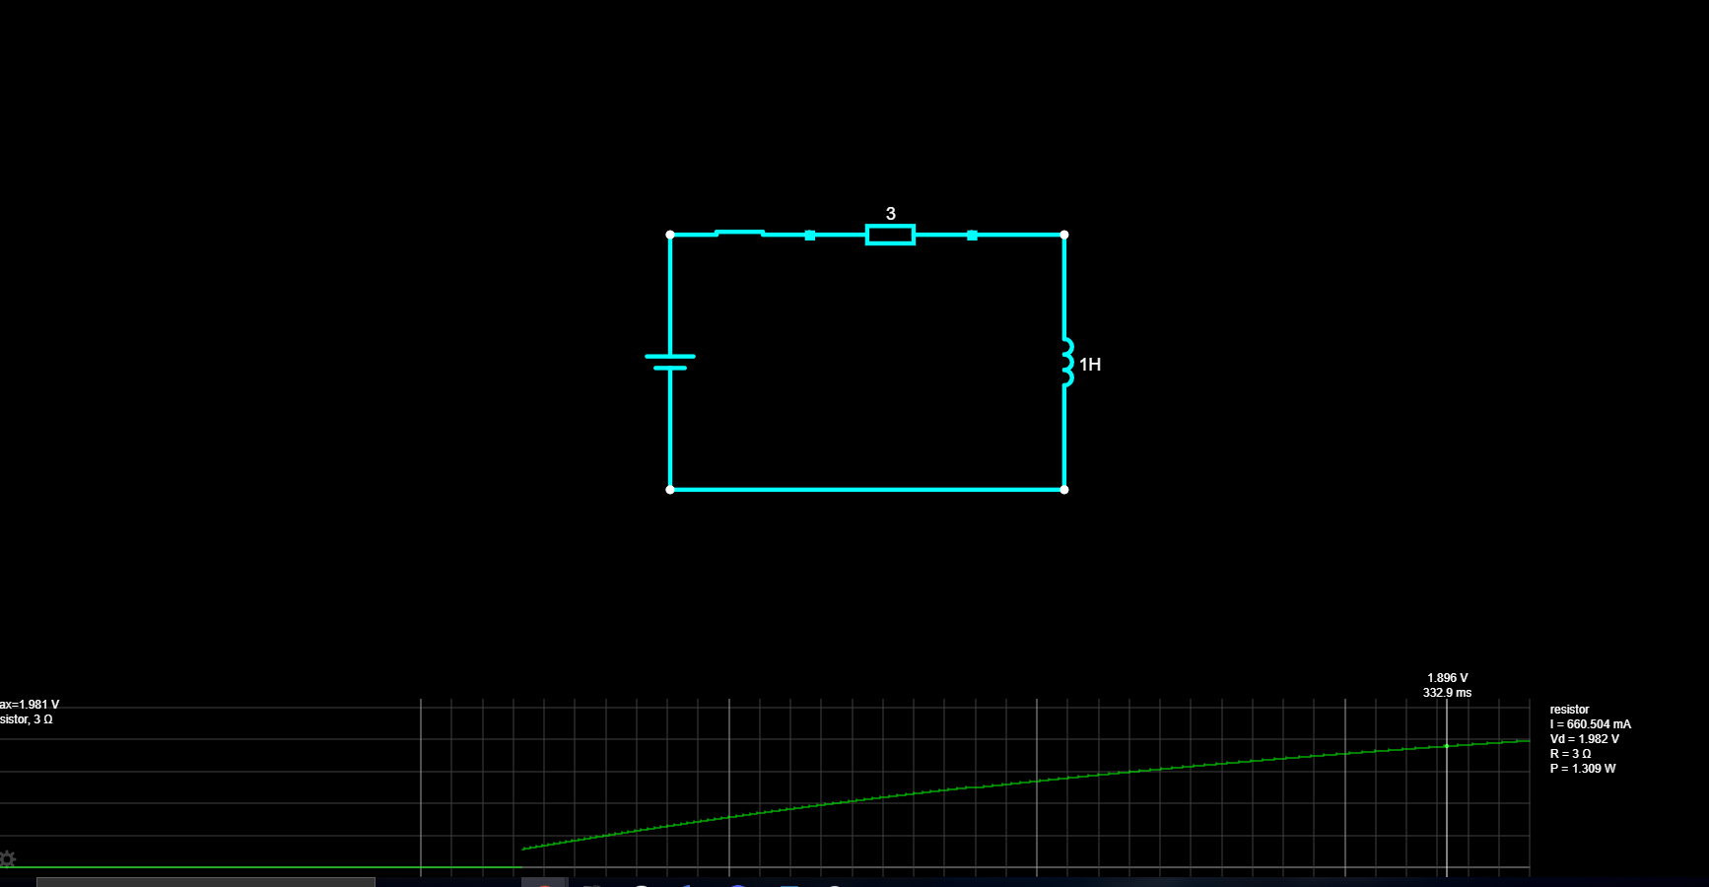

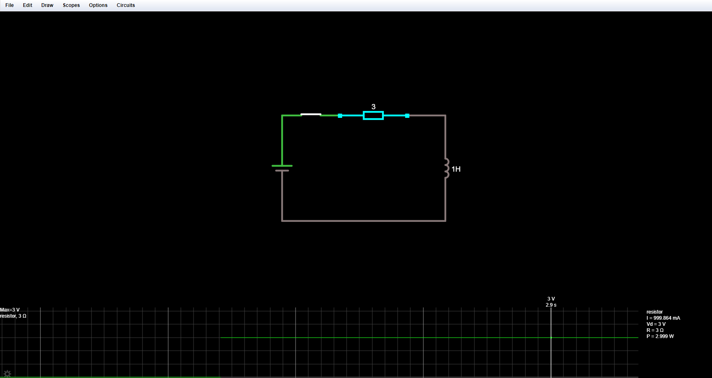

RC Transient:

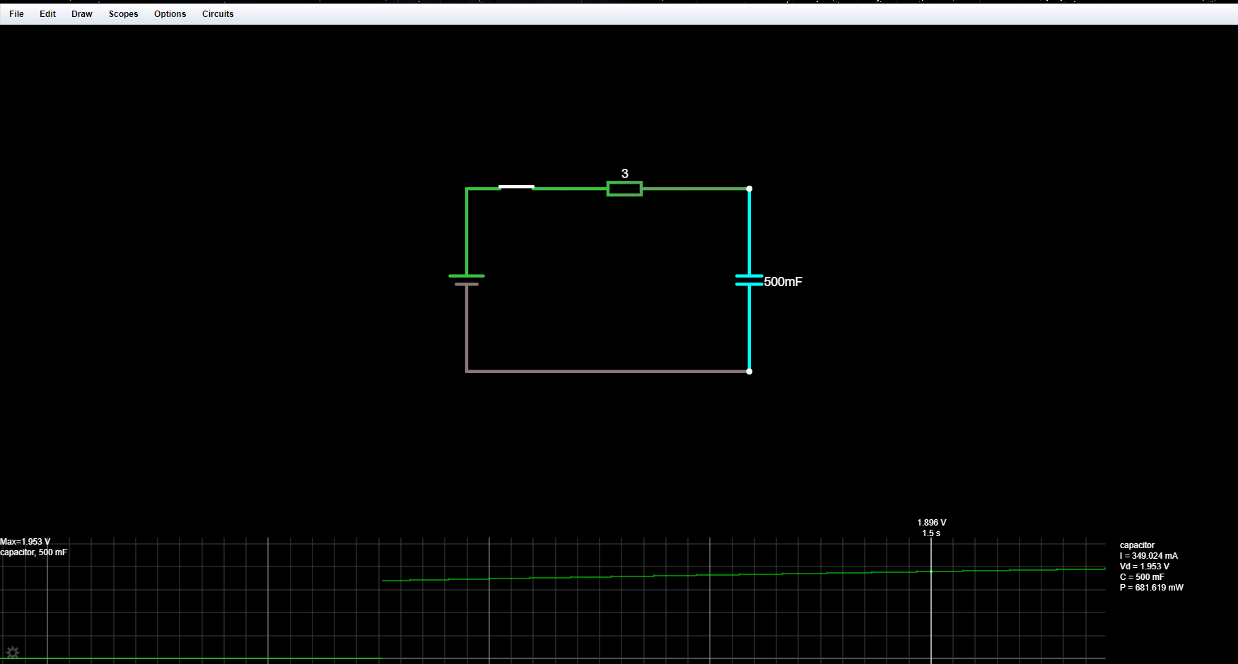

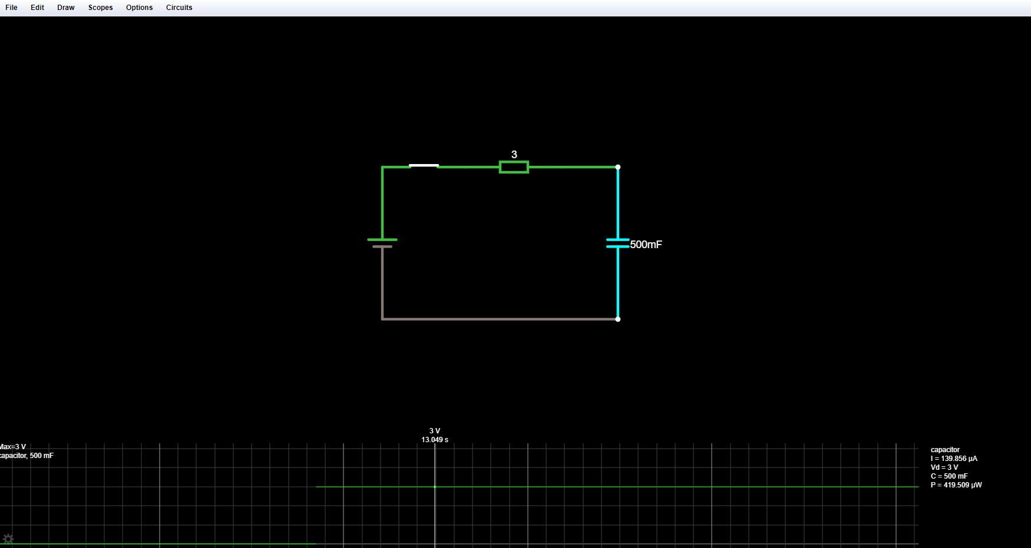

**POST LAB QUESTIONS**

**1) Why is it necessary to discharge the capacitor every time you want to record another transient voltage across the capacitor?**

A charged capacitor left by itself will retain the charge for even months or years. So, when it is disconnected from supply, the instant voltage it carries across terminals is maintained, which could often be dangerous.

So before handling a disconnected capacitor, it is very essential to discharge it to remove all charge and corresponding voltage. It is usual to discharge it through a resistor first, and then short the terminals directly to bring the voltage to zero.

**2) If the capacitor remains charged, what would you expect to see across the capacitor when you re-close the switch to try to record another transient?**

Because capacitors store energy in the form of an electric field, they tend to act like small secondary-cell batteries, being able to store and release electrical energy. A fully discharged capacitor maintains zero volts across its terminals, and a charged capacitor maintains a steady quantity of voltage across its terminals, just like a battery.

If the battery was replaced by a short circuit, when the switch is closed the capacitor would discharge itself back through the resistor, R as we now have a RC discharging circuit.

**3) What does the derivative of a step function look like?**

The unit step function is level in all places except for a discontinuity at t = 0. For this reason, the derivative of the unit step function is 0 at all points t, except where t = 0. Where t = 0, the derivative of the unit step function is infinite.

The derivative of a unit step function is called an impulse function.

**4) What does the integral of a step function look like?**

The integral of a unit step function is computed as such:

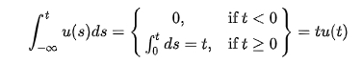

In other words, the integral of a unit step is a "ramp" function. This function is 0 for all values that are less than zero, and becomes a straight line at zero with a slope of +1.

DEPT. OF ELECTRICAL & ELECTRONICS ENGINEERING

SRM INSTITUTE OF SCIENCE AND TECHNOLOGY, Kattankulathur – 603 203

|  |
| --- |
| Title of Experiment : **4**. **LOAD TEST ON SINGLE PHASE TRANSFORMER** |
| Name of the candidate : Kunal Keshan S  Register Number : RA2011004010051  Date of Experiment : 25th May 2021 |

|  |  |  |  |
| --- | --- | --- | --- |
| Sl.  No. | Marks Split up | Maximum marks  (50) | Marks obtained |
| 1 | Pre Lab questions | 5 |  |
| 2 | Preparation of observation | 15 |  |
| 3 | Execution of experiment | 15 |  |
| 4 | Calculation / Evaluation of Result | 10 |  |
| 5 | Post Lab questions | 5 |  |
| **Total** | | **50** |  |

Staff Signature

**PRE-LAB QUESTIONS**

1. **Explain the working principle of transformer.**

The basic principle on which the transformer works is Faraday’s Law of Electromagnetic Induction or mutual induction between the two coils. The working of the transformer is explained below. The transformer consists of two separate windings placed over the laminated silicon steel core.

The winding to which AC supply is connected is called primary winding and to which load is connected is called secondary winding. It works on the alternating current only because an alternating flux is required for mutual induction between the two windings.

1. **What are the main parts of a transformer?**

There are three basic parts of a transformer:

1. an iron core which serves as a magnetic conductor,
2. a primary winding or coil of wire and
3. a secondary winding or coil of wire.

The primary is usually referred to as the input; the secondary as the output.

1. **What are the types of transformers?**

There are various types of transformers. The main types being, Step-Up and Step-Down Transformers. Other that this, there are various types of transformers such as,

1. Power transformer.
2. Distribution transformer.
3. Instrument transformer.
4. Current transformer.
5. Potential transformer.
6. Single and Three Phase transformer.
7. **What is the meaning of KVA rating of transformer?**

kVA stands for Kilovolt-Ampere and is the rating normally used to rate a transformer. The size of a transformer is determined by the kVA of the load. In many circumstances the power required by the load is equivalent to the rating of the transformer expressed in either VA or kVA. For example a 1KW (1000 Watts) load would require a 1kVA transformer @ unity power factor.

The Current that passes through transformer windings will determine the Copper Losses, whereas Iron Losses, Core Losses or Insulation Losses depends on voltage.

1. **What is the necessity of the load test for a transformer?**

Load test used to determine the performance of transformer at various loads, to find out its efficiency and regulation. In this method, a resistive load is connected to the transformer and it’s loaded up to the rated current.

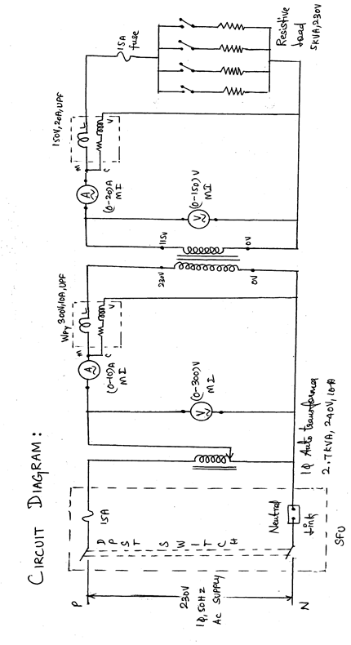

|  |  |
| --- | --- |
| **Experiment No. 4**  **Date : 25th May 2021** | **Load test on single phase transformer** |

**Aim**:

To conduct the load test on the given a single phase transformer for finding the efficiency and its regulation.

**Apparatus Required**:

|  |  |  |  |  |
| --- | --- | --- | --- | --- |
| S.NO | APPARATUS | RANGE | TYPE | QUANTITY |
| 1. | Voltmeter | (0-150)V  (0-300) V | MI  MI | 1  1 |
| 2. | Ammeter | (0-10)A  (0-20) A | MI  MI | 1  1 |
| 3. | Wattmeter | 150V,20A  300V,10A | UPF  UPF | 1  1 |
| 4. | Auto transformer | 240 V,  2.7 KVA,10A |  | 1 |

**Formula Used**:

1.Percentage Regulation = (Vo2-Vo) /Vo2*100

Where Vo2 = Secondary voltage on no load

Vo = Secondary voltage at a particular load

2. Power factor = Pout/V2*I2

Where Pout = Secondary wattmeter readings in Watts

V2 = Secondary voltage in Volts

I2 = Secondary current in Amps

3. Percentage efficiency = Pout/Pin*100

Where Pout = Secondary wattmeter readings in Watts

Pin = Primary wattmeter readings in Watts.

**Model Graph**:

% reg

**η**

Pout

**Procedure**

1.Connections are given as per the circuit diagram.

2.Verify whether the autotransformer is kept at zero voltage position.

3.By closing the DPST switch, 230V,1φ,50HZ AC supply is given to the transformer.

4.At no load, the readings from the meters are noted down.

5.The load is applied to the transformer in steps upto 125% of the rated value of the primary

Current by using rheostatic load..

6.The corresponding values from the meters are tabulated for different loads.

7.Then the load is removed gradually, auto transformer is brought to its minimum position and

the supply is switched off.

8.From the recorded values, the regulation, power factor and efficiency are calculated.

**TABULATION:**

|  |  |  |  |  |  |  |
| --- | --- | --- | --- | --- | --- | --- |
| **S.**  **No** | **Primary Voltage**  **V1 (V)** | **Primary Current I1 (A)** | **Secondary**  **Voltage**  **V2­ (V)** | **Secondary**  **Current**  **I2 (A)** | **%**  **Regulation**  **%** | **η**  **%** |
| **1.** | **240** | **483.6 mA** | **119.81** | **962.4 mA** | **0.058** | **99.3** |
| **2.** | **240** | **961.2 mA** | **119.24** | **1.92** | **0.53** | **99.2** |
| **3.** | **240** | **1.44** | **118.20** | **2.87** | **1.4** | **98.1** |
| **4.** | **240** | **1.92** | **116.65** | **3.80** | **2.6** | **96.1** |

**Model Calculation:**

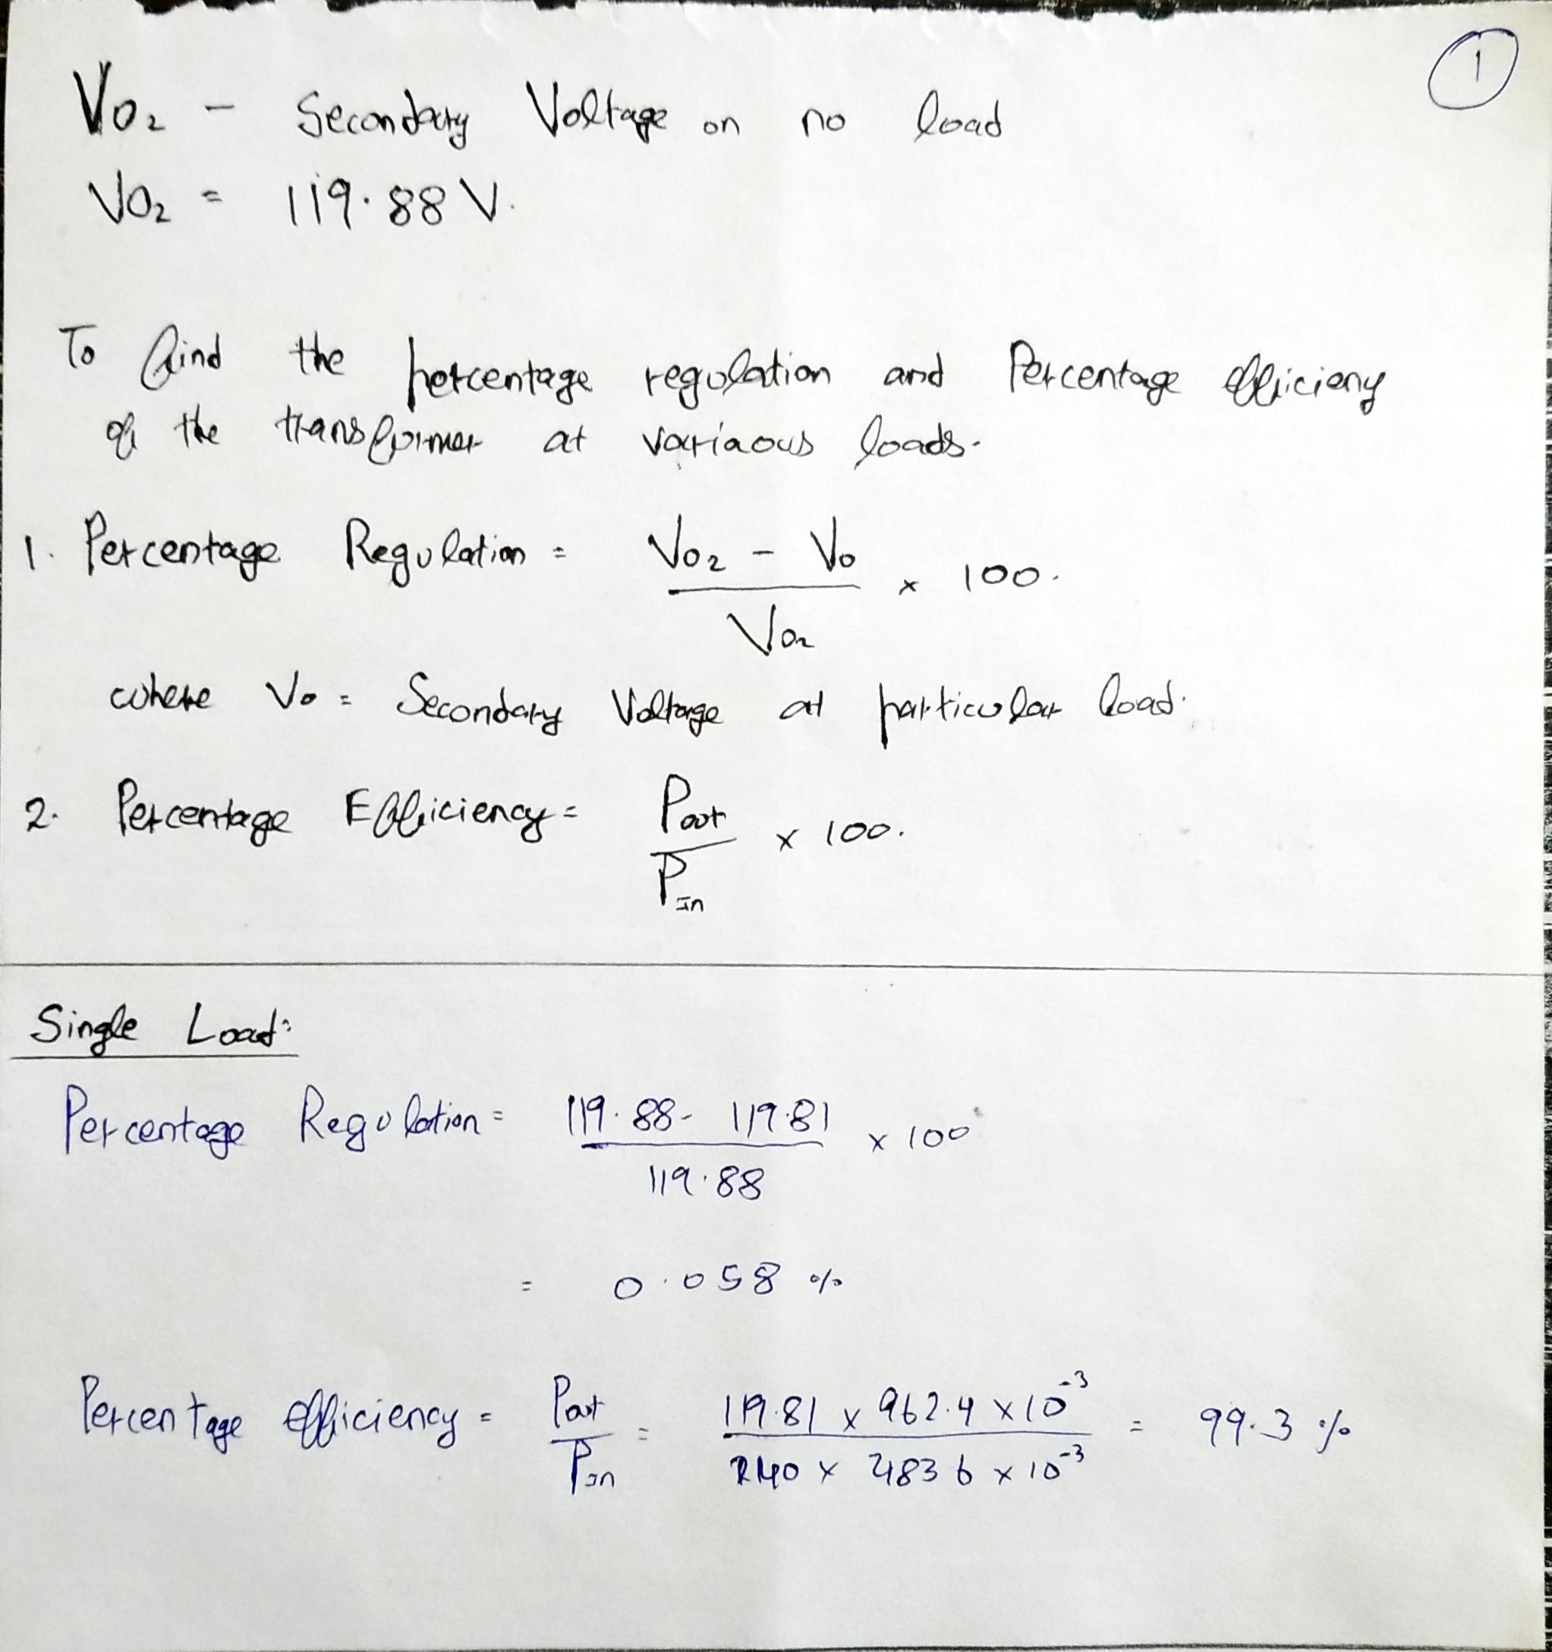

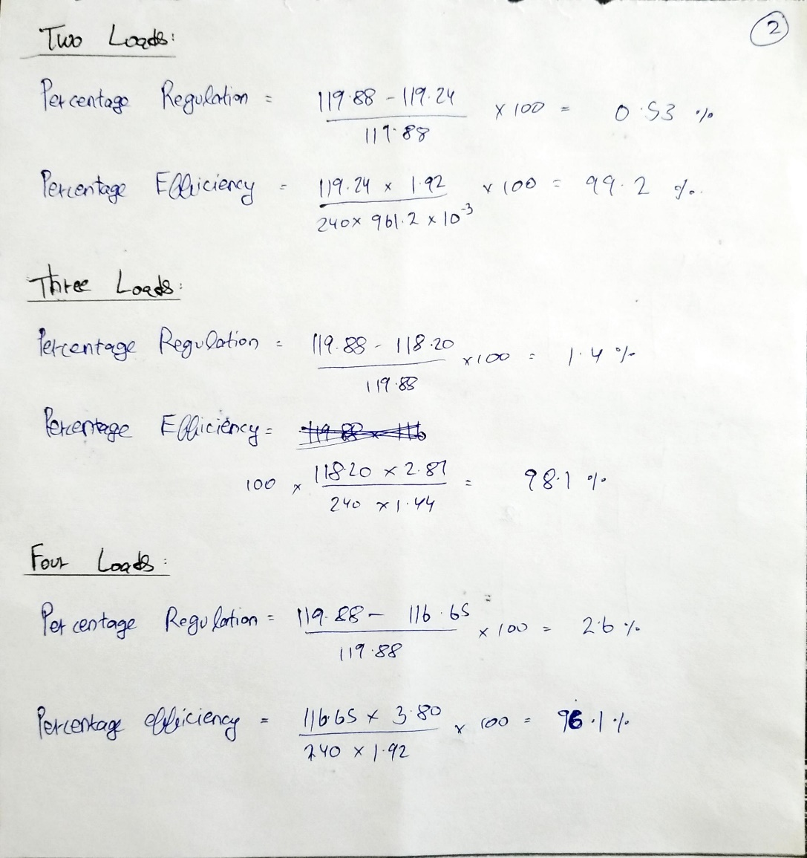

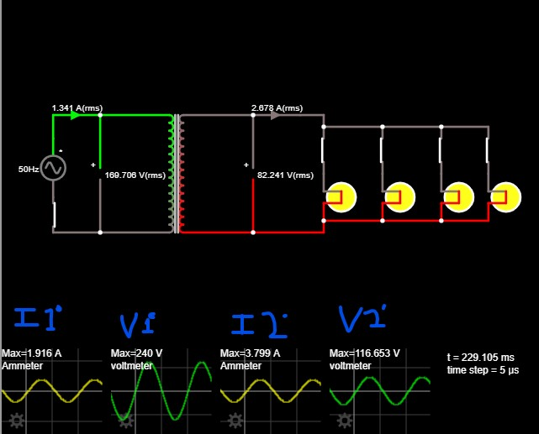**Result:**

**POST LAB QUESTIONS**

1. **What will happen if a DC voltage is given to the transformer primary?**

A constant dc source connected to the primary of transformer will have zero EMF. The constant current creates zero induced emf. As a result transformer primary will behave as a short circuit and heavy current will flow through the primary which will, in turn, burn the windings.

1. **What are the losses in a transformer?**

There are different kinds of losses that will be occurred in the transformer such as iron, copper, hysteresis, eddy, stray & dielectric. The copper loss mainly occurs due to the resistance in the transformer winding whereas hysteresis losses will be occurred due to the magnetization change within the core.

1. **How can we minimize the core losses in a transformer?**

Due to the constantly changing magnetic fields, there is a loss of current in the core. One easy solution for how to reduce eddy current losses in the transformer is to make the core by stacking thin sheets together. This will decrease the eddy current and hence the losses made by it too.

1. **What is meant by eddy current losses?**

When an alternating magnetic field is applied to a magnetic material, an emf is induced in the material itself according to Faraday’s Law of Electromagnetic induction. Since the magnetic material is a conducting material, these EMFs circulate current within the body of the material.

These circulating currents are called Eddy Currents. They will occur when the conductor experiences a changing magnetic field.

As these currents are not responsible for doing any useful work, and it produces a loss (I2R loss) in the magnetic material known as an Eddy Current Loss. Similar to hysteresis loss, eddy current loss also increases the temperature of the magnetic material.

1. **How hysteresis loss can be reduced?**

Hysteresis losses can be reduced by using material that has less area of the hysteresis loop. Hence, high grade or silica steel can be used for designing the core within a transformer because it has extremely less area of the hysteresis loop.

DEPT. OF ELECTRICAL & ELECTRONICS ENGINEERING

SRM INSTITUTE OF SCIENCE AND TECHNOLOGY, Kattankulathur – 603 203

|  |
| --- |
| Title of Experiment : **5**. **Demo of DC/AC machine & Parts** |
| Name of the candidate : Kunal Keshan  Register Number : RA2011004010051  Date of Experiment :01st June 2021 |

|  |  |  |  |
| --- | --- | --- | --- |
| Sl.  No. | Marks Split up | Maximum marks  (50) | Marks obtained |
| 1 | Pre Lab questions | 5 |  |
| 2 | Preparation of observation | 15 |  |
| 3 | Execution of experiment | 15 |  |
| 4 | Calculation / Evaluation of Result | 10 |  |
| 5 | Post Lab questions | 5 |  |
| **Total** | | **50** |  |

Staff Signature

**PRE-LAB QUESTIONS**

**1. What are the major parts of the DC generators?**

**The key parts of a DC generators are yoke, poles, pole shoes, armature core, armature winding, commutator, brushes, magnetic field system, end housings, bearings, and shafts.**

**2. Give the classification of AC machines.**

**AC machines can be differentiated based on four following criteria.**

* **Principle of Operation.**

1. **Synchronous**
2. **Induction**

* **Type of Current.**

1. **Single-phase.**
2. **Three-phase.**

* **Speed of Operation.**

1. **Variable Speed.**
2. **Constant Speed.**
3. **Adjustable Speed.**

* **Structural Features.**

1. **Open**
2. **Semi-enclosed.**
3. **Ventilated.**
4. **Pipe-ventilated.**
5. **Riveted frame-eye.**

**3. What is the use of brushes in DC motor?**

Brushes are connected to the lower end of the machine to allow the current flow between the moving parts and stationary wires.

**4. In a DC machine, rectification process is carried out in order to get unidirectional output (DC). This rectification process is carried out by ______________**

In a DC machine, electronic rectification is not used. Instead they use mechanical rectification with the help of **commutator-brush** assembly.

**5. Why the armature of DC motor is laminated?**

By using laminations, the path of eddy currents is divided into several small loops and hence area of the eddy current loops is minimized.

|  |  |
| --- | --- |
| **Experiment No. 5**  **Date :** | **Demo of DC/AC machine & Parts**  **1st June 2021** |

**Aim :** To know the construction of practical DC, AC machines and identify the parts

**DC Generator.**

A dc generator is an electrical machine which converts mechanical energy into direct current electricity. This energy conversion is based on the principle of production of dynamically induced emf. This article outlines basic construction and working of a DC generator.

**Construction of a DC Machine:**

Note: A DC generator can be used as a DC motor without any constructional changes and vice versa is also possible. Thus, a DC generator or a DC motor can be broadly termed as a DC machine. These basic constructional details are also valid for the construction of a DC motor. Hence, let's call this point as construction of a DC machine instead of just 'construction of a dc generator'.

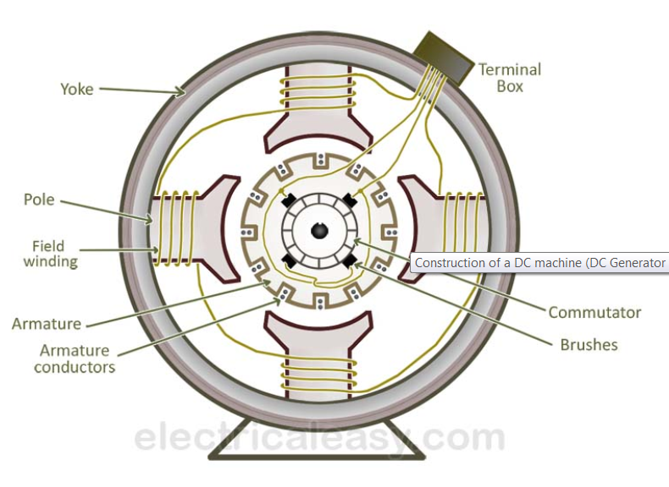

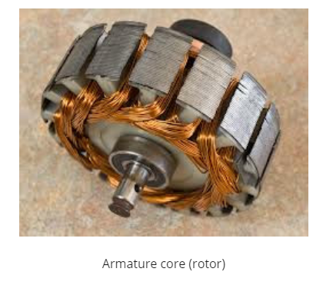

The above figure shows constructional details of a simple **4-pole DC machine**. A DC machine consists of two basic parts; stator and rotor. Basic constructional parts of a DC machine are described below.

1. **Yoke:** The outer frame of a dc machine is called as yoke. It is made up of cast iron or steel. It not only provides mechanical strength to the whole assembly but also carries the magnetic flux produced by the field winding.
2. **Poles and pole shoes:** Poles are joined to the yoke with the help of bolts or welding. They carry field winding and pole shoes are fastened to them. Pole shoes serve two purposes; (i) they support field coils and (ii) spread out the flux in air gap uniformly.
3. **Field winding:** They are usually made of copper. Field coils are former wound and placed on each pole and are connected in series. They are wound in such a way that, when energized, they form alternate North and South poles
4. **Armature core:** Armature core is the rotor of a dc machine. It is cylindrical in shape with slots to carry armature winding. The armature is built up of thin laminated circular steel disks for reducing eddy current losses. It may be provided with air ducts for the axial air flow for cooling purposes. Armature is keyed to the shaft.
5. [**Armature winding**](https://www.electricaleasy.com/2012/12/armature-winding-of-dc-machine.html)**:** It is usually a former wound copper coil which rests in armature slots. The armature conductors are insulated from each other and also from the armature core. Armature winding can be wound by one of the two methods; lap winding or wave winding. Double layer lap or wave windings are generally used. A double layer winding means that each armature slot will carry two different coils.
6. **Commutator and brushes:** Physical connection to the armature winding is made through a commutator-brush arrangement. The function of a commutator, in a dc generator, is to collect the current generated in armature conductors. Whereas, in case of a dc motor, commutator helps in providing current to the armature conductors. A commutator consists of a set of copper segments which are insulated from each other. The number of segments is equal to the number of armature coils. Each segment is connected to an armature coil and the commutator is keyed to the shaft. Brushes are usually made from carbon or graphite. They rest on commutator segments and slide on the segments when the commutator rotates keeping the physical contact to collect or supply the current.

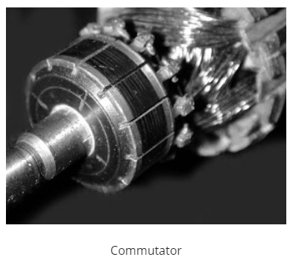

**CONSTRUCTION OF AC MACHINES (THREE PHASE INDUCTION MOTOR)**

The three phase induction motor is the most widely used electrical motor. Almost 80% of the mechanical power used by industries is provided by three phase induction motors because of its simple and rugged construction, low cost, good operating characteristics, the absence of commutator and good speed regulation. In three phase induction motor, the power is transferred from stator to rotor winding through induction. The induction motor is also called a synchronous motor as it runs at a speed other than the synchronous speed.

Like any other electrical motor induction motor also have two main parts namely rotor and stator.

**Stator**: As its name indicates stator is a stationary part of induction motor. A stator winding is placed in the stator of induction motor and the three phase supply is given to it.

**Rotor**: The rotor is a rotating part of induction motor. The rotor is connected to the mechanical load through the shaft.

The rotor of the three phase induction motor are further classified as

* Squirrel cage rotor,
* Slip ring rotor or wound rotor or phase wound rotor.

### STATOR OF THREE PHASE INDUCTION MOTOR

The stator of the three-phase induction motor consists of three main parts :

1. Stator frame,
2. Stator core,
3. Stator winding or field winding.

**PARTS OF AC MOTOR (3-PHASE INDUCTION MOTOR)**

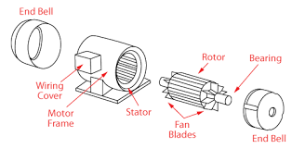

**3-Phase Induction Motor**

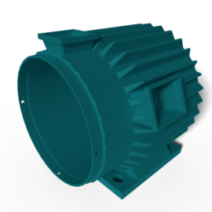

**STATOR FRAME**

### stator core

### STATOR CORE

### stator-winding

### STATOR WINDING OR FIELD WINDING

#### rotor of induction motor

#### SQUIRREL CAGE THREE PHASE INDUCTION MOTOR

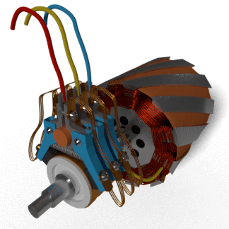

**SLIP RING OR WOUND ROTOR THREE PHASE INDUCTION MOTOR**

**POST-LAB QUESTIONS**

**1. Why we need starter for machines?**

Starters are used to protect DC motors from damage that can be caused by very high current and torque during startup. They do this by providing external resistance to the motor, which is connected in series to the motor’s armature winding and restricts the current to an acceptable level.

**2. Name any four the domestic electrical machines with name plate details.**

Electric Fans, hair dryer, record player, tape recorder and blowers are some domestic machines where DC motors are used.

**3. Difference between 3-phase squirrel cage and slip-ring induction motor?**

The slip ring motor has brushes for transferring power whereas the squirrel cage motor is brushless. The copper loss in the phase wound motor is high compared to squirrel cage motor. The efficiency of the slip ring motor is low whereas the squirrel cage motor has high efficiency.

**4. What are the various types of rotors used in the alternators?**

There are two types of rotors used in the construction of alternators,

1. Salient pole type.

It is used as low and medium speed alternator. They are mainly used for low speed turbine such as water power plant.

1. Smooth cylindrical type.

It is used for steam turbine driven alternator. The rotor of this generator rotates in very high speed.

**5. What are the applications of DC motors?**

Series motors are used in traction systems, cranes, air compressors, vacuum cleaner, etc.

Shunt motors are used in lathe machines, centrifugal pumps, fans, blowers, conveyors, spinning fans.

Compound motors are used in presses, elevators, rolling mills, heavy planners, etc.

DEPT. OF ELECTRICAL & ELECTRONICS ENGINEERING

SRM INSTITUTE OF SCIENCE AND TECHNOLOGY, Kattankulathur – 603 203

|  |
| --- |
| Title of Experiment : **6**. **Types of wiring (a)Fluorescent Lamp wiring,**  **(b) Stair case wiring** |
| Name of the candidate : Kunal Keshan S  Register Number : RA2011004010051  Date of Experiment : 15th June 2021 |

|  |  |  |  |
| --- | --- | --- | --- |
| Sl.  No. | Marks Split up | Maximum marks  (50) | Marks obtained |
| 1 | Pre Lab questions | 5 |  |
| 2 | Preparation of observation | 15 |  |
| 3 | Execution of experiment | 15 |  |
| 4 | Calculation / Evaluation of Result | 10 |  |
| 5 | Post Lab questions | 5 |  |
| **Total** | | **50** |  |

Staff Signature

**PRE LAB QUESTIONS**

1. **How does fluorescent lamp work?**

A fluorescent lamp generates light from collisions in a hot gas of free accelerated electrons with atoms, usually mercury vapor, in which electrons are bumped up to higher energy levels and then fall back while emitting at two UV emission lines.

1. **What is the difference between fluorescent lamp and incandescent lamp?**

The main difference lies in how they produce light. Incandescent lamps produce light by a heating of a metallic filament until it starts to radiate light. On the other hand, fluorescent lamps produce light by exciting gas and causing it to glow.

1. **What are the advantages of fluorescent light bulbs?**

They are energy efficient, have low production cost, have a long life, have a good selection of desired color temperature and has diffused light property.

1. **What is the voltage required to start a fluorescent lamp?**

The voltage required to start a fluorescent lamp lies between 200 to 600 V.

1. **What is the function of starter in a fluorescent lamp?**

Starters are used to help fluorescent lamps ignite in the initial starting stage of their operation. They are simply, timed switch. The switch opens and closes until the fluorescent tube “strikes” and lights-up.

|  |  |
| --- | --- |
| **Experiment No. 6 a)**  **Date :** | **FLUORESCENT LAMP WIRING** |

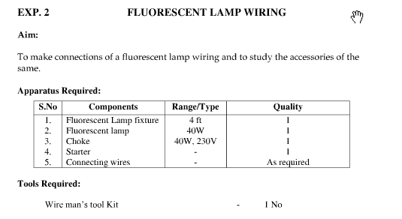

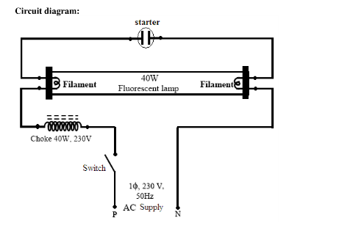

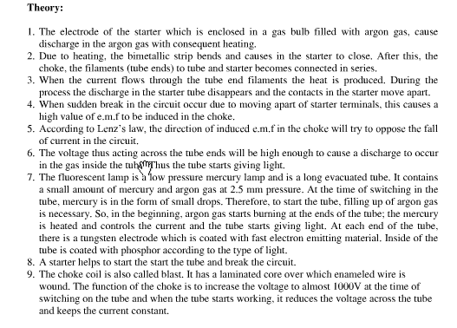

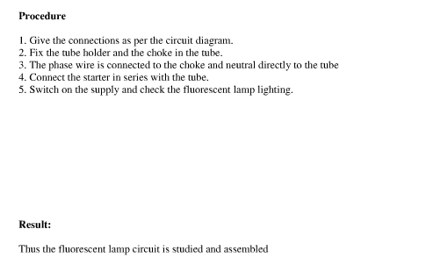

**Result:**

|  |  |
| --- | --- |
| **Experiment No. 6 b)**  **Date :** | **6. b) STAIRCASE WIRING** |

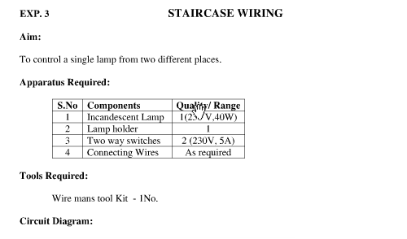

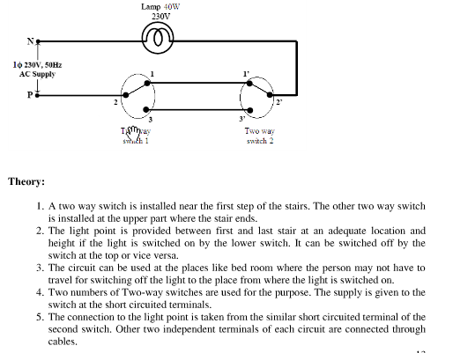

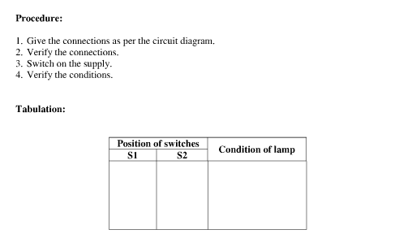



**Result:**

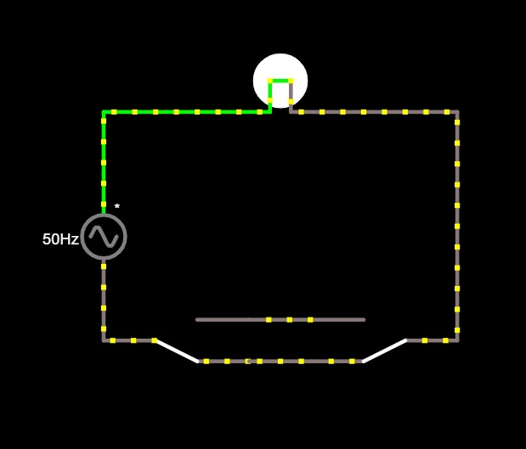

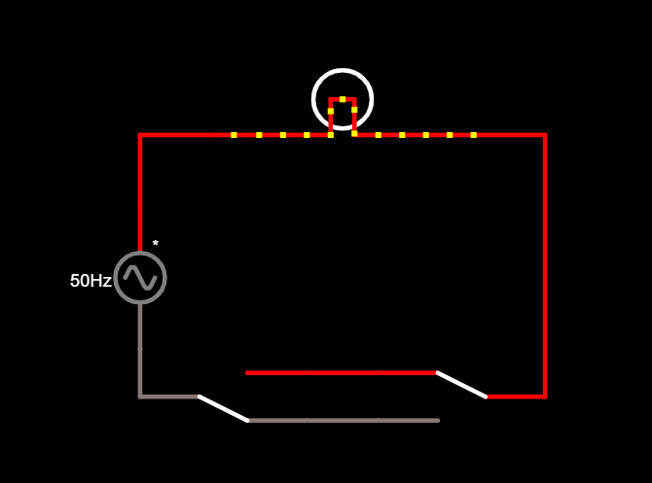

**POST LAB QUESTIONS**

1. **What is the use of staircase wiring?**

The main purpose of staircase wiring is to connect and control AC appliances and equipment’s from two separate locations. It is also used where a light bulb can be controlled from different places, no matter you are in the upper or lower portion of a stair.

1. **Why choke is used in fluorescent lamp?**

The purpose of choke is to provide a very high voltage initially between the filaments. Again once the gas in the tube is ionized the choke provides a low voltage. A choke is nothing but a coil/ballast, it increases the voltage for a brief period of time, and this increased voltage is used ionize the gases in the starter.

1. **What is the purpose of magnetic ballast in fluorescent lamp?**

The magnetic ballast uses a magnetic transformer of copper windings around a steel core to convert the input line voltage and current to the voltage and current required to start and operate the fluorescent lamps.

1. **Compare electronic ballast and magnetic ballast?**

A magnetic ballast uses coiled wire and creates magnetic fields to transform voltage required to start the fluorescent lamp.

An electronic ballast uses solid state components to transform voltage.

1. **List out the advantage of staircase wiring.**

They help in easy to control appliances from various points, are faster than a single switch, highly effective for larger places, living comfort can be increased and electricity can also be saved by staircase wiring.

**DEPT. OF ELECTRICAL & ELECTRONICS ENGINEERING**

**SRM INSTITUTE OF SCIENCE AND TECHNOLOGY, Kattankulathur – 603203.**

|  |
| --- |
| Title of Experiment :7. **Characteristics of semiconductor devices**  **(a) PN junction diode, (b) Zener diode, (c)BJT** |
| Name of the candidate : Kunal Keshan S  Register Number : RA2011004010051  Date of Experiment : 01.06.2021  Date of submission **:** 01.06.2021 |

|  |  |  |  |
| --- | --- | --- | --- |
| Sl.  No. | Marks Split up | Maximum marks  (50) | Marks obtained |
| 1 | Pre Lab questions | 5 |  |
| 2 | Preparation of observation | 15 |  |
| 3 | Execution of experiment | 15 |  |
| 4 | Calculation / Evaluation of Result | 10 |  |
| 5 | Post Lab questions | 5 |  |
| **Total** | | **50** |  |

**Staff Signature**

**PRE LAB QUESTIONS**

1. **What are intrinsic and extrinsic semiconductors?**

The pure form of the semiconductor is known as the intrinsic semiconductor and the semiconductor in which intentionally impurities is added is for making it conductive is known as extrinsic semiconductor.

**2. Give examples for Trivalent and Pentavalent impurity.**

Trivalent impurity atoms have 3 valence electrons. Some examples are Boron(B), Gallium(G) and Aluminium(Al).

Pentavalent impurity atoms have 5 valence electrons. Some examples are Phosphorus(P), Arsenic(As) and Antimony(As).

**3. What is the need for Zener diode?**

Zener diodes are used for voltage regulation, as reference elements, surge suppressors, and in switching applications and clipper circuits. The load voltage equals the breakdown voltage VZ of the diode.

**4. What is voltage regulation and mention its significance?**

Voltage regulation is a measure of change in the voltage magnitude between the sending and receiving end of a component. It is necessary to maintain the supply voltage of the equipment supplied by the transformer as the supply voltage directly affects the performance of the equipment.

**5. Give the different types of semiconductor devices with symbols.**

Diode, LEDs, Zener Diode, Photo Diode, Photo Cell, Solar Cell, Transistor, Rectifier etc.

|  |  |
| --- | --- |
| **Experiment No. 7 a)**  **Date :** | **CHARACTERISTICS OF PN JUNCTION DIODE**  **01.06.2021** |

**Aim**

To study the characteristics of PN Junction diode under forward and reverse bias conditions.

**Apparatus Required Components Required**

|  |  |  |  |  |  |  |  |  |
| --- | --- | --- | --- | --- | --- | --- | --- | --- |
| **S.No.** | **Name** | **Range** | **Qty** |  | **S.No.** | **Name** | **Range** | **Qty** |
| 1 | R.P.S | (0-30)V | 1 | 1 | Diode | IN4001 | 1 |
| 2 | Ammeter | (0–30)mA | 1 | 2 | Resistor | 1kΩ | 1 |
| (0-500)µA | 1 | 3 | Bread Board | - | 1 |
| 3 | Voltmeter | (0–1)V | 1 | 4 | connecting Wires | - | Req |
| (0-10)V | 1 |

**Theory**

A PN junction diode is a two terminal semiconducting device. It conducts only in one direction (only on forward biasing).

**Forward Bias**

On forward biasing, initially no current flows due to barrier potential. As the applied potential exceeds the barrier potential the charge carriers gain sufficient energy to cross the potential barrier and hence enter the other region. The holes, which are majority carriers in the P-region, become minority carriers on entering the N-regions, and electrons which are the majority carriers in the N-region, become minority carriers on entering the P-region. This injection of minority carriers results in the current flow, opposite to the direction of electron movement.

**Reverse Bias**

On reverse biasing, the majority charge carriers are attracted towards the terminals due to the applied potential resulting in the widening of the depletion region. Since the charge carriers are pushed towards the terminals no current flows in the device due to majority charge carriers. There will be some current in the device due to the thermally generated minority carriers. The generation of such carriers is independent of the applied potential and hence the current is constant for all increasing reverse potential. This current is referred to as Reverse Saturation Current (IO) and it increases with temperature. When the applied reverse voltage is increased beyond the certain limit, it results in breakdown. During breakdown, the diode current increases tremendously.

**Procedure**

**Forward Bias**

1. Connect the circuit as per the diagram.
2. Vary the applied voltage V in steps of 0.1V.
3. Note down the corresponding Ammeter readings I.
4. Plot a graph between V & I

**Observations**

1. Find the d.c (static) resistance = V/I.
2. Find the a.c (dynamic) resistance r = δV / δI (**r = ΔV/ΔI) = **.
3. Find the forward voltage drop. [Hint: it is equal to 0.7 for Si and 0.3 for Ge]

**Reverse Bias**

1. Connect the circuit as per the diagram.
2. Vary the applied voltage V in steps of 1.0V.
3. Note down the corresponding Ammeter readings I.
4. Plot a graph between V & I.
5. Find the dynamic resistance **r = δV / δI.**

**Formula for Reverse Saturation Current (IO):**

**Io  = ∂I/[exp(∂V/ηVT)]-1**

Where VT  is the voltage equivalent of Temperature = kT/q

-k is Boltzmann’s constant, q is the charge of the electron and T is the temperature in degrees Kelvin.

η =1 for Silicon and 2 for Germanium

**Circuit Diagram**

**Forward Bias**

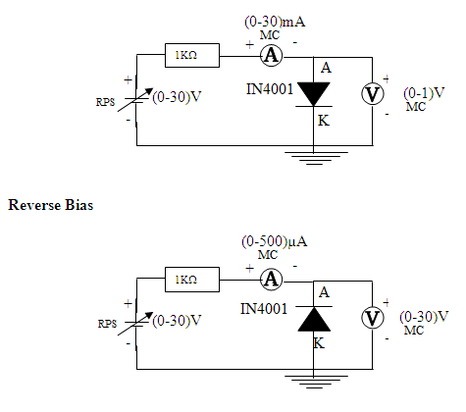

**Specification for 1N4001: Silicon Diode**

Peak Inverse Voltage: 50V

Idc = 1A.

Maximum forward voltage drop at 1 Amp is 1.1 volts

Maximum reverse current at 50 volts is 5μA

|  |  |  |
| --- | --- | --- |
| **S.No.** | **Voltage**  **(In Volts)** | **Current**  **(In mA)** |
| 1. | 0.1 | 0 |
| 2. | 0.2 | 0 |
| 3. | 0.3 | 0 |
| 4. | 0.4 | 0 |
| 5. | 0.5 | 0 |
| 6. | 0.6 | 2.05 |
| 7. | 0.7 | 14.3 |
| 8. | 0.72 | 19.3 |
| 9. | 0.74 | 31.3 |
| 10. | 0.76 | 44.2 |
| 12. | 0.765 | 49.2 |

**Tabular Column**

**Forward Bias Reverse Bias**

|  |  |  |
| --- | --- | --- |
| **S.No.** | **Voltage**  **(In Volts)** | **Current**  **(In μA)** |
| 1. | 100 | 0 |
| 2. | 200 | 0 |
| 3. | 300 | 0 |
| 4. | 400 | 8322.1 |
| 5. | 400.08 | 99933 |
| 6. | 400.098 | 183251 |
| 7. | 400.11 | 266574 |
| 8. | 400.12 | 349900 |

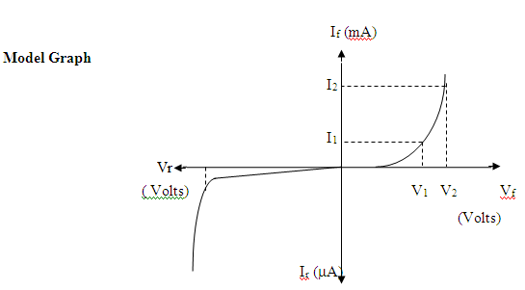

**Graph:**

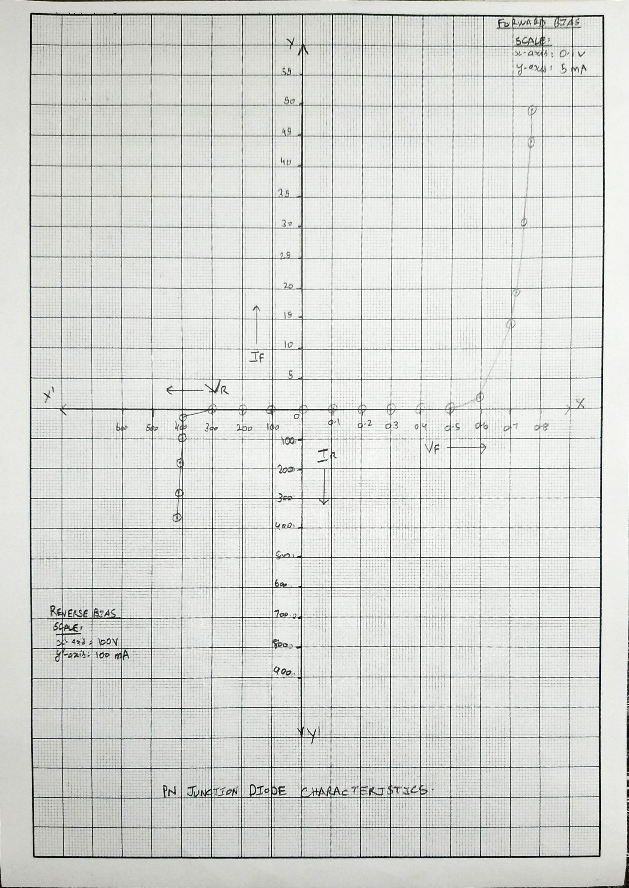

**Result:**

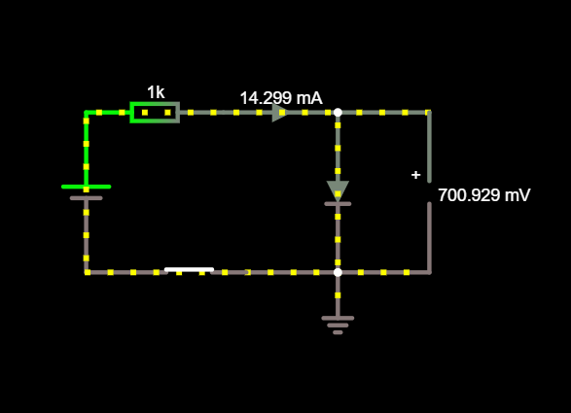

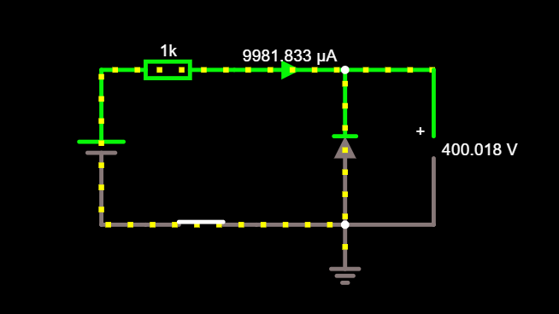

|  |  |
| --- | --- |
| **Experiment No. 7 b)**  **Date :** | **CHARACTERISTICS OF ZENER DIODE**  **01.06.2021** |

**Aim**

To find the forward and reverse bias characteristics of a given Zener diode.

**Apparatus Required Components Required**

|  |  |  |  |  |  |  |  |  |
| --- | --- | --- | --- | --- | --- | --- | --- | --- |
| **S.No.** | **Name** | **Range** | **Qty** |  | **S.No.** | **Name** | **Range** | **Qty** |
| 1 | R.P.S | (0-30)V | 1s | 1 | Zener diode | FZ5.1 | 1 |
| 2 | Ammeter | (0–30)mA | 2 | 2 | Resistor | 1KΩ | 1 |
| 3 | Bread Board | - | 1 |
| 3 | Voltmeter | (0–10)V | 1 | 4 | Wires | - | Req |
| (0–1)V | 1 |

**Theory**

A properly doped crystal diode, which has a sharp breakdown voltage, is known as Zener diode.

**Forward Bias**

On forward biasing, initially no current flows due to barrier potential. As the applied potential increases, it exceeds the barrier potential at one value and the charge carriers gain sufficient energy to cross the potential barrier and enter the other region. the holes ,which are majority carriers in p-region, become minority carriers on entering the N-regions and electrons, which are the majority carriers in the N-regions become minority carriers on entering the P-region. This injection of minority carriers results current, opposite to the direction of electron movement.

**Reverse Bias**

When the reverse bias is applied, due to majority carriers small amount of current (ie) reverse saturation current flows across the junction. As the reverse bias is increased to breakdown voltage, sudden rise in current takes place due to Zener effect.

**Zener Effect**

Normally, PN junction of Zener Diode is heavily doped. Due to heavy doping the depletion layer will be narrow. When the reverse bias is increased the potential across the depletion layer is more. This exerts a force on the electrons in the outermost shell. Because of this force the electrons are pulled away from the parent nuclei and become free electrons. This ionization, which occurs due to electrostatic force of attraction, is known as Zener effect. It results in large number of free carriers, which in turn increases the reverse saturation current

**Procedure**

**Forward Bias**

1. Connect the circuit as per the circuit diagram.

2. Vary the power supply in such a way that the readings are taken in steps of 0.1V in the voltmeter till the needle of power supply shows 30V.

3. Note down the corresponding ammeter readings.

4. Plot the graph :V (vs) I.

5. Find the dynamic resistance **r = δV / δI.**

**Reverse Bias**

1. Connect the circuit as per the diagram.
2. Vary the power supply in such a way that the readings are taken in steps of 0.1V in the voltmeter till the needle of power supply shows 30V.
3. Note down the corresponding Ammeter readings I.
4. Plot a graph between V & I
5. Find the dynamic resistance **r = δV / δI.**
6. Find the reverse voltage Vr at Iz=20 mA.

**Circuit Diagram**

**Forward Bias**

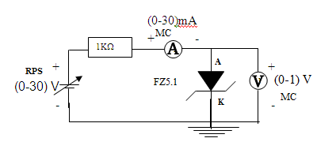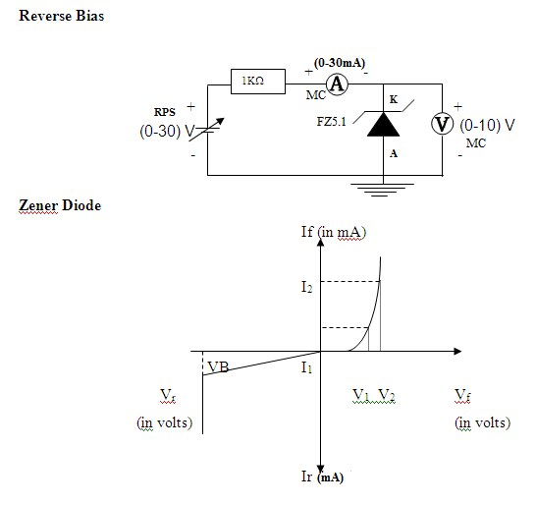

# Tabular Column

**Forward Bias Reverse Bias**

|  |  |  |
| --- | --- | --- |
| **S.No.** | **Voltage**  **(In Volts)** | **Current**  **(In mA)** |
| 1. | 0.1 | 0 |
| 2. | 0.2 | 0 |
| 3. | 0.3 | 0 |
| 4. | 0.4 | 0 |
| 5. | 0.5 | 0 |
| 6. | 0.6 | 2.08 |
| 7. | 0.7 | 14.1 |
| 8. | 0.71 | 17..3 |
| 9. | 0.73 | 25.3 |
| 10. | 0.75 | 36.8 |

|  |  |  |
| --- | --- | --- |
| **S.No.** | **Voltage**  **(In Volts)** | **Current**  **(In mA)** |
| 1. | 100 | 0 |
| 2. | 200 | 0 |
| 3. | 300 | 0 |
| 4. | 400 | 0 |
| 5. | 400.08 | 99.92 |
| 6. | 400.1 | 199.9 |
| 7. | 400.11 | 299.9 |
| 8. | 400.12 | 399.9 |
| 9. | 400.13 | 499.9 |
| 10. | 400.14 | 599.9 |

**Graph:**

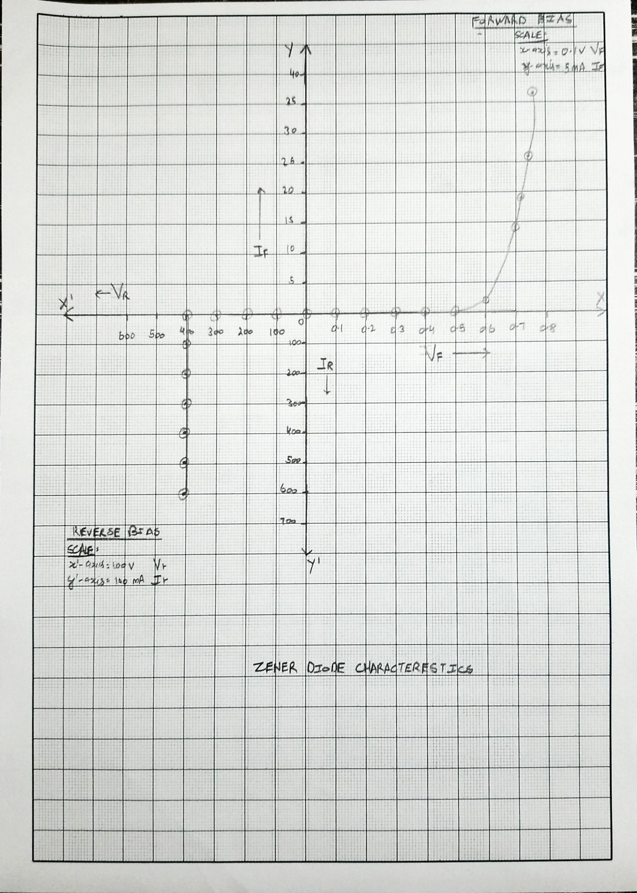

**Result:**

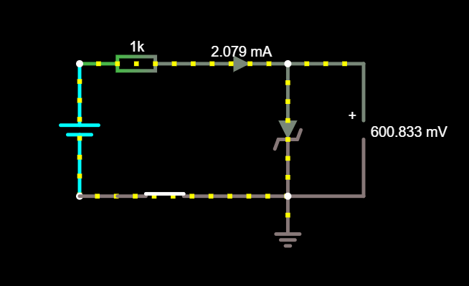

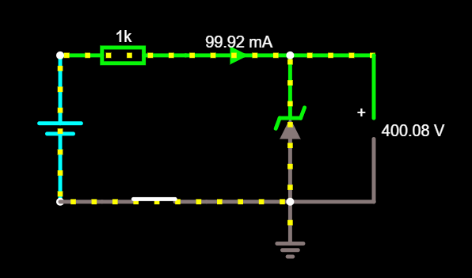

|  |  |
| --- | --- |
| **Experiment No. 7 c)**  **Date :** | **CHARACTERISTICS OF BJT (CE CONFIGURATION)**  **01.06.2021** |

**Aim**

To plot the transistor (BJT) characteristics of CE configuration.

**Apparatus Required Components Required**

|  |  |  |  |  |  |  |  |  |
| --- | --- | --- | --- | --- | --- | --- | --- | --- |
| **S.No.** | **Name** | **Range** | **Qty** |  | **S.No.** | **Name** | **Range** | **Qty** |
| 1 | R.P.S | (0-30)V | 2 | 1 | Transistor | BC 107 | 1 |
| 2 | Ammeter | (0–30) mA  MC | 1 | 2 | Resistor | 10 KΩ | 1 |
| (0–250) µA  MC | 1 | Resistor | 1 KΩ | 1 |
| 3 | Voltmeter | (0–30)V  MC | 1 | 3 | Bread Board |  | 1 |
| (0–1)V  MC | 1 | 4 | Wires |  |  |

**Theory**

A BJT is a three terminal two – junction semiconductor device in which the conduction is due to both the charge carrier. Hence it is a bipolar device. BJT is classified into two types – NPN & PNP. A NPN transistor consists of two N types in between which a layer of P is sandwiched. The transistor consists of three terminal emitter, collector and base. The emitter layer is the source of the charge carriers and it is heavily doped with a moderate cross sectional area. The collector collects the charge carries and hence moderate doping and large cross sectional area. The base region acts a path for the movement of the charge carriers. In order to reduce the recombination of holes and electrons the base region is lightly doped and is of hollow cross sectional area. Normally the transistor operates with the EB junction forward biased.

**Procedure**

**Input Characteristics**

1. Connect the circuit as per the circuit diagram.
2. Set VCE, vary VBE in regular interval of steps and note down the corresponding IB reading. Repeat the above procedure for different values of VCE.
3. Plot the graph: VBE Vs IB for a constant VCE.

**Output Characteristics**

1. Connect the circuit as per the circuit diagram.
2. Set IB, Vary VCE in regular interval of steps and note down the corresponding IC reading. Repeat the above procedure for different values of IB.
3. Plot the graph: VCE Vs IC for a constant IB.

**Pin Diagram**

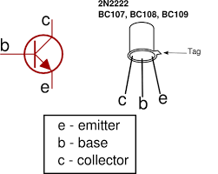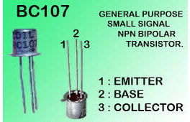

Specification: BC107/50V/0.1A,0.3W,300 MH

**Circuit Diagram**

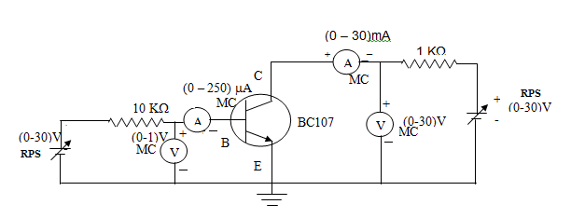 **Model Graph**

**Input Characteristics Output Characteristics**

VCE = 0V

VCE = 5V

IB

µA

mA

VBE(V)

VCE(V)

0

0

IB=60μA

IB=40μA

IB=20μA

IC

**Tabular Column**

**Input Characteristics**

|  |  |  |  |  |
| --- | --- | --- | --- | --- |
| **VCE = 0 V** | | **RPS(V)** | **VCE = 2V** | |
| **VBE(V)** | **IB(μA)** | **VBE(V)** | **IB(μA)** |
| 0 | 0 | 0 | 0 | 0 |
| 0.1 | 0 | 0.1 | 0.1 | 0 |
| 0.2 | 0 | 0.2 | 0.2 | 0 |
| 0.3 | 0 | 0.3 | 0.3 | 0 |
| 0.4 | 4.2 | 0.5 | 0.49 | 0.2 |
| 0.5 | 19.6 | 0.7 | 0.59 | 10 |
| 0.52 | 37.6 | 0.9 | 0.6 | 28 |
| 0.53 | 47 | 1 | 0.61 | 38 |

**Output Characteristics**

|  |  |  |  |
| --- | --- | --- | --- |
| **IB=20μA** | | **IB=40μA** | |
| **VCE(V)** | **IC(mA)** | **VCE** | **Ic(mA)** |
| 0 | 0 | 0 | 0 |
| 5 | 2 | 5 | 4 |
| 10 | 2 | 10 | 4 |
| 15 | 2 | 15 | 4 |
| 20 | 2 | 20 | 4 |
| 25 | 2 | 25 | 4 |
| 30 | 2 | 30 | 4 |
| 40 | 2 | 40 | 4 |

Result:

Input Characteristics:

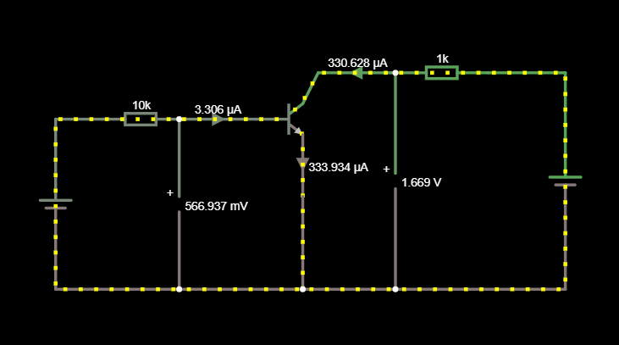

Output Characteristics:

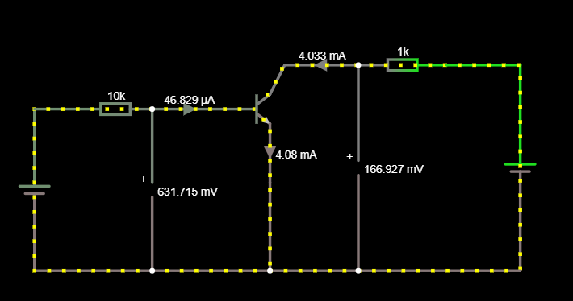

Graph: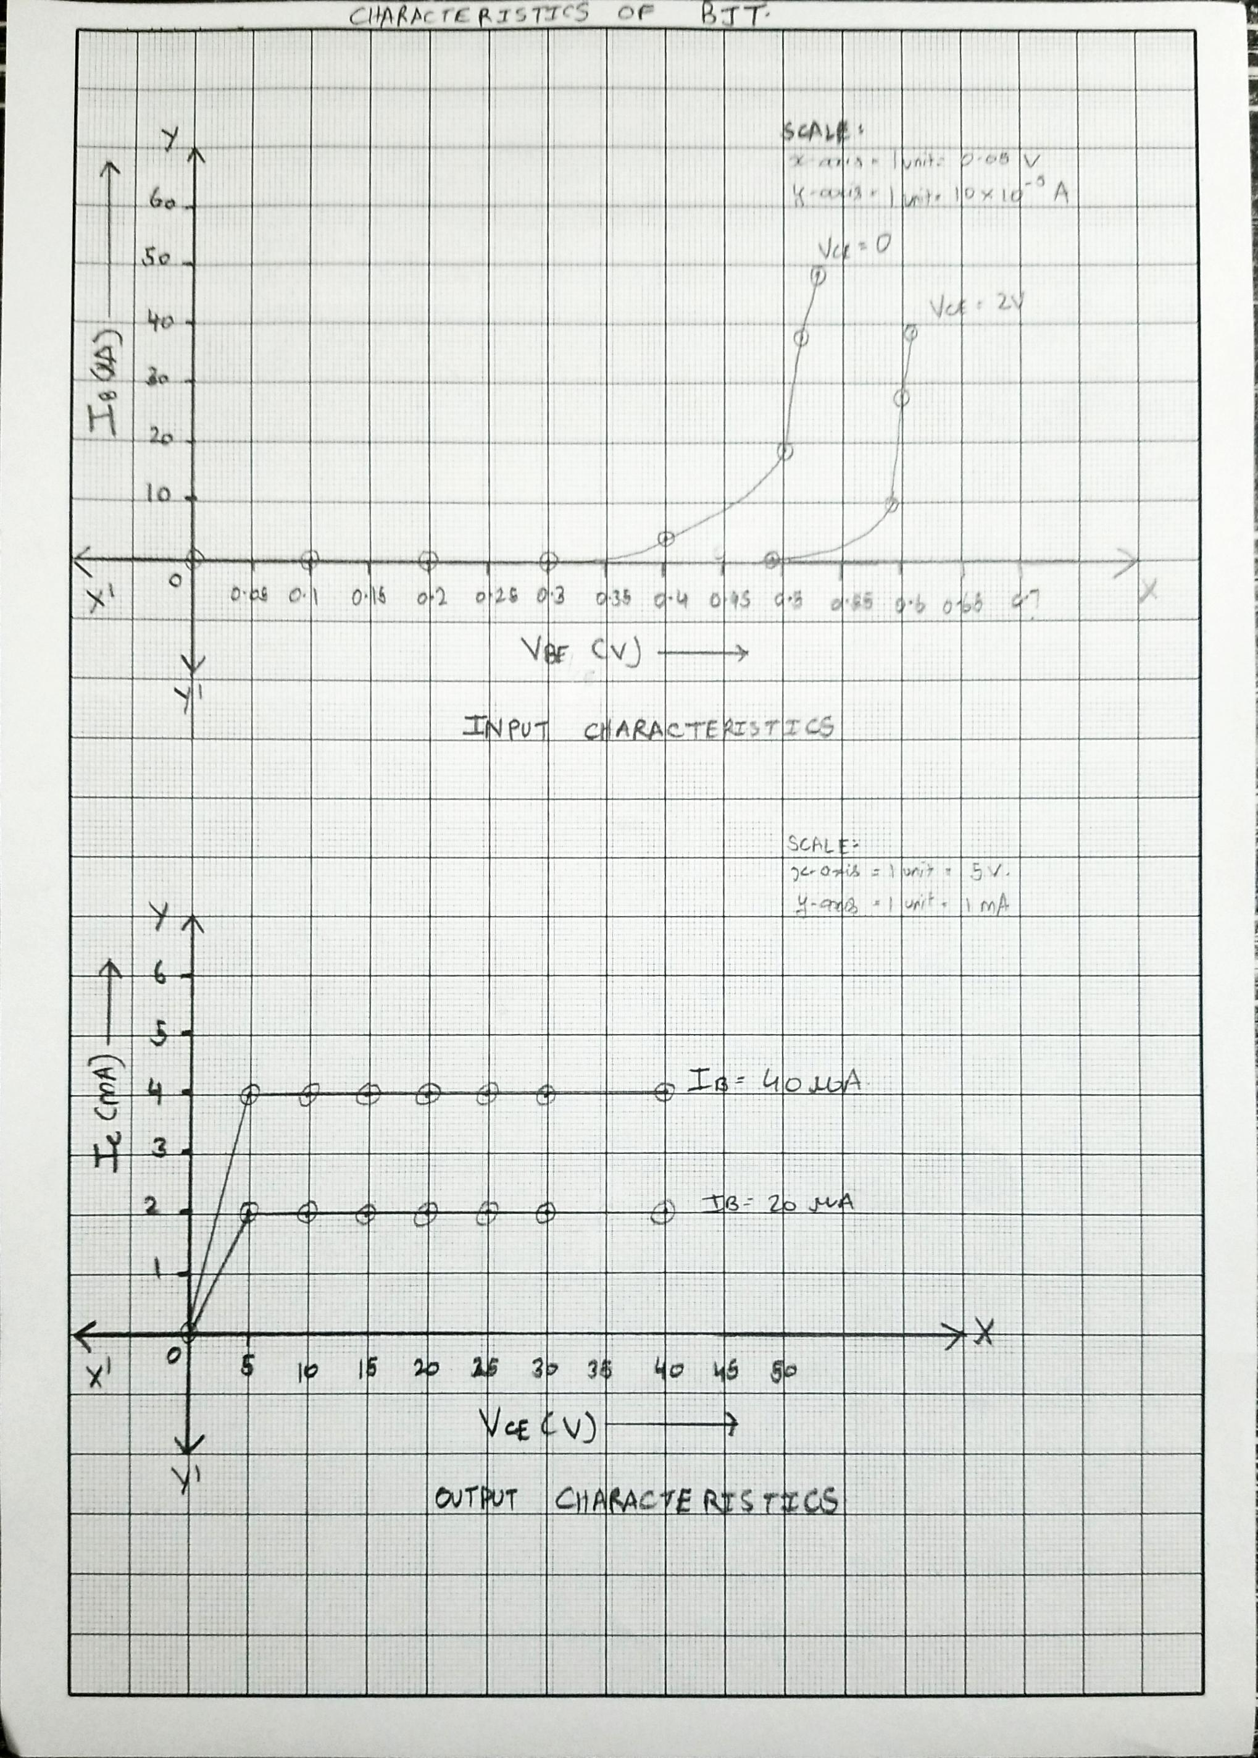

POST LAB QUESTIONS

**1 What is Punch through voltage?**

The reverse-bias voltage applied to the drain terminal that results in significant drain-to-source current even though the transistor is biased in its off state.

**2 What is early effect?**

The Early effect, named after its discoverer James M. Early, is the variation in the effective width of the base in a bipolar junction transistor (BJT) due to a variation in the applied base-to-collector voltage.

**3 State maximum rating of transistor.**

A transistor is a common device used to amplify or switch electronic signals and electrical power. The maximum rating of a transistor is the maximum amount of power that a device can dissipate in a typical operating environment.

**4. What is leakage current and mention its range?**

Leakage current is the current that flows through the protective ground conductor to ground. In the absence of a grounding connection, it is the current that could flow from any conductive part of the surface of non-conductive parts to ground if a conductive path was available. Usually, the level of the leakage current if from about 10mA to some 100mA.

**5. What is base – width modulation?**

The base-width modulation is the variation of the width of the base in a bipolar transistor to a variation in the applied base-to-collector voltage. It is produced by applying the modulating voltage to the base of a transistor amplifier.

**DEPT. OF ELECTRICAL & ELECTRONICS ENGINEERING**

**SRM INSTITUTE OF SCIENCE AND TECHNOLOGY, Kattankulathur – 603203.**

|  |
| --- |
| Title of Experiment : **8. Wave shaping circuits ( Half wave & Full Rectifiers, Clippers)** |
| Name of the candidate : Kunal Keshan S  Register Number : RA2011004010051  Date of Experiment : 22nd June 2021  Date of submission **: 29th June 2021** |

|  |  |  |  |
| --- | --- | --- | --- |
| Sl.  No. | Marks Split up | Maximum marks  (50) | Marks obtained |
| 1 | Pre Lab questions | 5 |  |
| 2 | Preparation of observation | 15 |  |
| 3 | Execution of experiment | 15 |  |
| 4 | Calculation / Evaluation of Result | 10 |  |
| 5 | Post Lab questions | 5 |  |
| **Total** | | **50** |  |

**Staff Signature**

**PRE LAB QUESTIONS (Rectifiers)**

**1 What is the necessity of rectifier?**

A rectifier in the power supply helps in converting AC to DC power supply. They are used inside the power supplies of virtually all electronic equipment’s.

**2 What is PIV of a diode in Full Wave Rectifier (FWR) and Half Wave Rectifier (HWR)?**

Peak Increase Voltage (PIV) is the maximum value of reverse voltage which occurs at the peak of the input cycle when the diode is reverse-biased. For a FWR the PIV is 2*Vi where Vi is the amplitude of the input signal. For a HWR the PIV is Vi where Vi is the amplitude of the input signal.

**3 What is ripple factor? Why it is required?**

Ripple factor is defined as the ratio of RMS value of an alternating current component in the rectified output to the average value of rectified output. It is essential to measure the rate of fluctuation within the resolved output.

**4 Why are filters connected at the output of rectifiers?**

Filters or Capacitors are used to filter the pulsating DC output after rectification so that a nearly constant DC voltage is supplied to the load. The pulsating output of the rectifiers has an average DC value and an AC portion that is called ripple voltage.

**5 What are the types of filters used in rectifier? And which is better and why?**

**Types of filters.**

1. Series Inductor Filter.
2. Shunt Capacitor Filter
3. Half Wave Rectifier with Capacitor Filter.
4. Full wave Rectifier with Shunt Capacitor Filter.
5. L – C Filters.
6. R – C Filters.
7. Choke Input L – Section Filter.
8. Π – Filter or Capacitance Input Filter

|  |  |
| --- | --- |
| **Experiment No. 8 a)**  **Date :** | **SINGLE PHASE HALF WAVE RECTIFIER**  **29th June 2021** |

**Aim**

To construct a half wave rectifier using diode and to draw its performance characteristics.

**Apparatus Required Components Required**

|  |  |  |  |  |  |  |  |  |
| --- | --- | --- | --- | --- | --- | --- | --- | --- |
| **S.**  **No.** | **Name** | **Range** | **Qty** |  | **S.**  **No.** | **Name** | **Range** | **Qty** |
| 1 | Transformer | 230/(6-0-6)V | 1 | 1 | Diode | IN4007 | 1 |
| 2 | R.P.S | (0-30)V | 2 |
| 2 | Resistor | 1K Ω | 1 |
| 3 | Bread Board | - | 1 |
| 4 | Capacitor | 100µf | 1 |
| 5 | CRO | - | 1 |

**Formulae**

**With out Filter**

(i) Vrms = Vm / 2

(ii) Vdc = Vm / ∏

(iii) Ripple Factor = √ ((Vrms / Vdc)2 – 1)

(iv) Efficiency = (Vdc / Vrms)2 x 100

**With Filter**

(i) Vrms = √ (Vrms2 + Vdc2)

(ii) Vrms = Vrpp / (√3 x 2)

(iii) Vdc = Vm – V rpp / 2

(iv) Ripple Factor = Vrms / Vdc

Vrpp = Vmax - Vmin

**Procedure**

**Without Filter**

1. Give the connections as per the circuit diagram.
2. Give 230v, 50HZ I/P to the step down TFR where secondary connected to the Rectifier I/P.
3. Take the rectifier output across the Load.
4. Plot its performance graph.

**With Filter**

1. Give the connections as per the circuit diagram.

1. Give 230v, 50HZ I/P to the step down TFR where secondary connected to the Rectifier I/P.
2. Connect the Capacitor across the Load.
3. Take the rectifier output across the Load.
4. Plot its performance graph.

**Circuit Diagram**

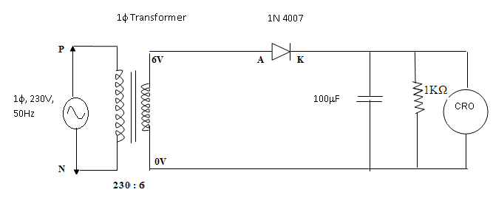

**Tabular Column**

**Without Filter**

|  |  |  |  |  |
| --- | --- | --- | --- | --- |
| Vm (V) | Vrms (V) | Vdc (V) | Ripple factor | Efficiency |
| 7.72 | 3.86 | 2.45 | 1.21 | 40% |

**With Filter**

|  |  |  |  |
| --- | --- | --- | --- |
| Vrpp (V) | Vrms (V) | Vdc (V) | Ripple factor |
| 1.245 | 0.359 | 3.29 | 0.1091 |

**Model Graph**

**V**in (Volts)

**t (ms)**

**V**o

(Volts)

**t (ms)**

**t (ms)**

**V**o

(Volts)

**Without Filter**

**With Filter**

**Graph:**

**Vin** 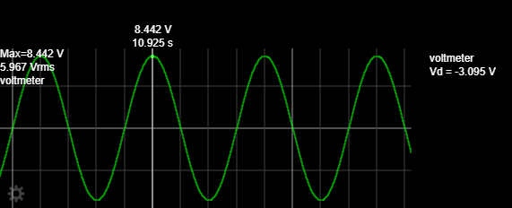

**Vo Without Filter**

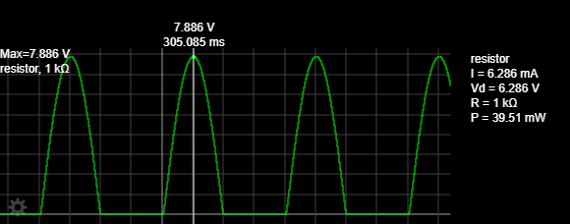

**Vo With Filter**

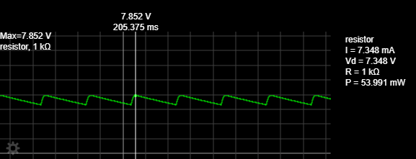

**Result:**

**Without Filter:**

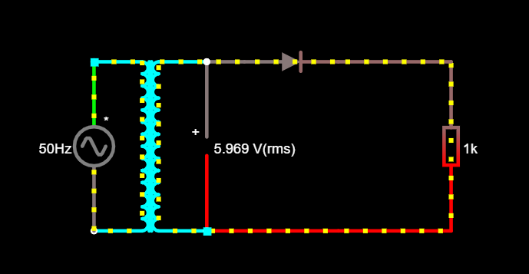

**With Filter:**

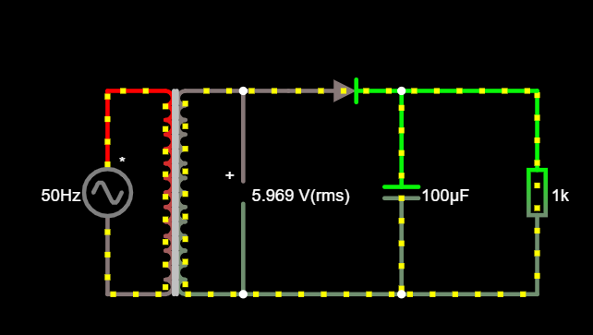

|  |  |
| --- | --- |
| **Experiment No. 8 b)**  **Date :** | **SINGLE PHASE FULL WAVE RECTIFIER**  **22nd June 2021** |

**Aim**

To construct a single phase full-wave rectifier using diode and to draw its performance characteristics.

**Apparatus Required Components Required**

|  |  |  |  |  |  |  |  |  |
| --- | --- | --- | --- | --- | --- | --- | --- | --- |
| **S.**  **No.** | **Name** | **Range** | **Qty** |  | **S.**  **No.** | **Name** | **Range** | **Qty** |
| 1 | Transformer | 230/(6-0-6)V | 1 | 1 | Diode | IN4007 | 2 |
| 2 | R.P.S | (0-30)V | 2 |
| 2 | Resistor | 1K Ω | 1 |
| 3 | Bread Board | - | 1 |
| 4 | Capacitor | 100µf | 1 |
| 5 | CRO | 1Hz-20MHz | 1 |
|  | 6 | Connecting wires | - | Req |

**Formulae**

**Without Filter**

(i) Vrms = Vm / √2

(ii) Vdc = 2Vm / ∏

(iii) Ripple Factor = √ ((Vrms / Vdc)2 – 1)

(iv) Efficiency = (Vdc / Vrms)2 x 100

**With Filter**

(i) Vrms = Vrpp /(2*√ 3)

(ii) Vdc = Vm – V rpp

(iv) Ripple Factor = Vrms’/ Vdc

**Procedure**

**Without Filter**

1. Give the connections as per the circuit diagram.
2. Give 230v, 50HZ I/P to the step down TFR where secondary connected to the Rectifier I/P.
3. Take the rectifier output across the Load.
4. Plot its performance graph.

**With Filter**

* + - 1. Give the connections as per the circuit diagram.

1. Give 230v, 50HZ I/P to the step down TFR where secondary connected to the Rectifier I/P.
2. Connect the Capacitor across the Load.
3. Take the rectifier output across the Load.
4. Plot its performance graph.

**Circuit Diagram**

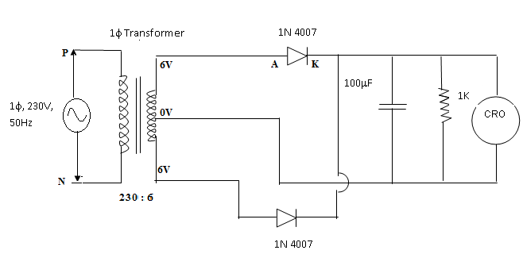

**Tabular Column**

**Without Filter**

|  |  |  |  |  |
| --- | --- | --- | --- | --- |
| Vm | Vrms | Vdc | Ripple factor | Efficiency |
| 5.40 | 3.81 | 3.44 | 0.48 | 81% |

**With Filter**

|  |  |  |  |
| --- | --- | --- | --- |
| Vrms | Vrpp | Vdc | Ripple factor |
| 4.10 | 14.2 | 8.4 | 0.48 |

**Model Graph**

**V**in (Volts)

**t (ms)**

**V**o

(Volts)

**t (ms)**

**t (ms)**

**V**o

(Volts)

**Without Filter**

**With Filter**

**Graph:**

**Vin,**

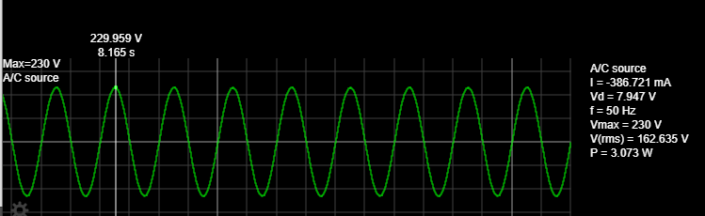

**Vo, Without Filter:**

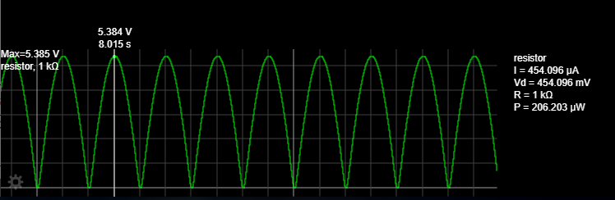

**Vo, With Filter:**

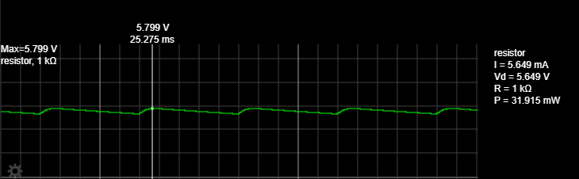

**Result:**

**Without Filter:**

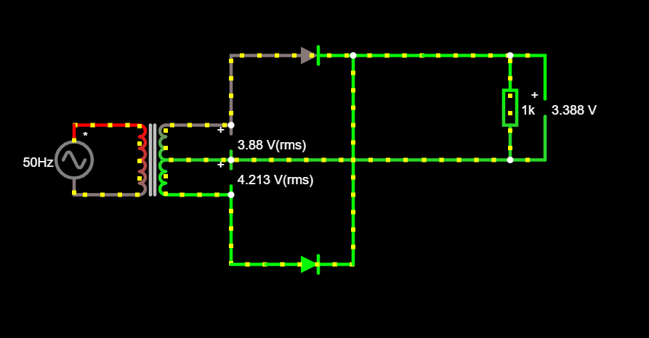

**With Filter:**

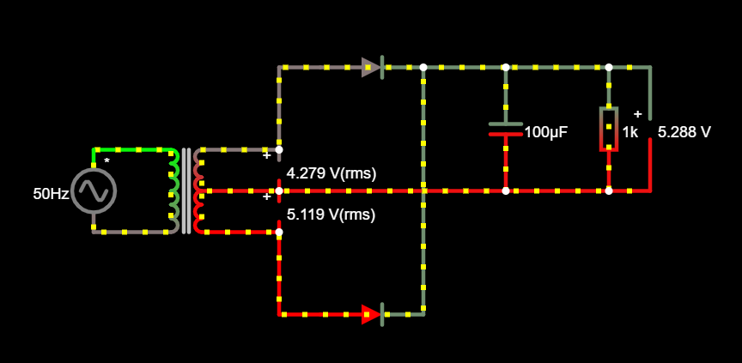

**POST LAB QUESTIONS**

**1. What is Transformer Utilization Factor (TUF)?**

Transformer Utilization Factor (TUF) is defined as the ratio of DC power output of a rectifier to the effective Transformer VA rating used in the same rectifier.

**2. Mention the value of ripple factor for HWR, FWR & rectifier with center tapped transformer.**

Ripple factor of a full wave rectifier is 0.48 and the ripple factor for a half wave rectifier is 1.21.

**3. What is the difference between uncontrolled rectifier and controlled rectifier? Which is advantageous and why?**

The rectifier circuit using diodes only are called uncontrolled rectifiers. When SCRs (Silicon Controlled Rectifier) are used to convert AC to DC, they are called controlled rectifiers. Advantages of Controlled rectifiers over uncontrolled rectifiers, they compensate the DC line voltage variations caused by voltage variations the medium voltage power network and keep voltage constant even in case of load variation. Advantages of Uncontrolled rectifiers over controlled rectifiers, in full wave rectifiers we can obtain output voltage during the positive and negative half cycles

**4. State the average and peak value of output voltage and current for full wave rectifier and half wave rectifier.**

For Full Wave Rectifier:

Average value of output voltage = 2Vm/π;

RMS voltage = Vm/(2)^1/2

For Half Wave Rectifier:

Average value of Output voltage = Vm/π;

RMS voltage = Vm/2

Where Vm is the input voltage.

**5. What is PIV of a diode in half wave and full wave rectifier?**

Peak Increase Voltage (PIV) is the maximum value of reverse voltage which occurs at the peak of the input cycle when the diode is reverse-biased. For a FWR the PIV is 2*Vi where Vi is the amplitude of the input signal. For a HWR the PIV is Vi where Vi is the amplitude of the input signal.

**Clippers**

**PRE LAB QUESTIONS**

**1. What are the differences between linear and nonlinear wave shaping circuit?**

The process by which the form of a non-sinusoidal signal is altered by transmission through a linear network is called linear wave shaping and the circuit is used is called linear wave shaping circuit.

The process of production non-sinusoidal output wave forms from sinusoidal input, using non-linear elements is called as nonlinear wave shipping.

**2. What are the applications of wave shaping circuit?**

It is used to hold the waveform at a particular DC level, to limit the voltage level of the waveform of some presenting value and suppressing all other voltage levels in excess of the present level.

**3. What is wave shaping?**

Wave shaping is used to create or modify specified time-varying electrical voltage or current waveforms using combinations of active electronic devices, such as transistors or analog or digital integrated circuits, and resistors, capacitors, and inductors.

**4. What is the necessity of wave shaping?**

To cut off the positive and negative portions of the input waveform. It is often needed to alter the shape of waveform like cutting off positive or negative portion of wave, generation of one wave from other, holding wave at some DC level.

**5. Mention the application of clipper and clamper.**

They are frequently used for the separation of synchronizing signals from the composite signals. Used to protect the electronic circuits by applying the AC input signals to the described voltage range. Without any alteration, the shape of the applied signal in any electronic circuit, the DC level can be shifted as desired by the clamper circuits.

|  |  |
| --- | --- |
| **Experiment No. 8c)**  **Date :** | **CLIPPERS**  **29th June 2021** |

**Aim**

To study the clipping circuits for different reference voltages and to verify the responses.

**Apparatus Required Components Required**

|  |  |  |  |  |  |  |  |  |
| --- | --- | --- | --- | --- | --- | --- | --- | --- |
| **S.No.** | **Name** | **Range** | **Qty** |  | **S.No.** | **Name** | **Range** | **Qty** |
| 1 | CRO | 1Hz-20MHz | 1 | 1 | Resistor | 10KΩ | 1 |
| 2 | RPS | (0–30) V | 1 |
| 3 | Bread Board | **-** | 1 |
| 4 | Connecting Wires | - | Req |  | 2 | Diode | IN4007 | 1 |
| 5 | Function Generator | 1Hz-1MHz | 1 |  |

**Theory**

The non-linear semiconductor diode in combination with resistor can function as clipper circuit. Energy storage circuit components are not required in the basic process of clipping. These circuits will select part of an arbitrary waveform which lies above or below some particular reference voltage level and that selected part of the waveform is used for transmission. So they are referred as voltage limiters, current limiters, amplitude selectors or slicers. There are three different types of clipping circuits.

1) Positive Clipping circuit.

2) Negative Clipping.

3) Positive and Negative Clipping (slicer).

In positive clipping circuit positive cycle of Sinusoidal signal is clipped and negative portion of sinusoidal signal is obtained in the output of reference voltage is added, instead of complete positive cycle that portion of the positive cycle which is above the reference voltage value is clipped. In negative clipping circuit instead of positive portion of sinusoidal signal, negative portion is clipped. In slicer both positive and negative portions of the sinusoidal signal are clipped.

**Procedure**

1. Connect the circuit as shown in the circuit diagram.

2. Connect the function generator at the input terminals and CRO at the output terminals of the circuit.

3. Apply a sine wave signal of frequency 1 KHz, Amplitude greater than the reference voltage at the input and observe the output waveforms of the circuits.

**Circuit Diagram**

**Positive Clipper**

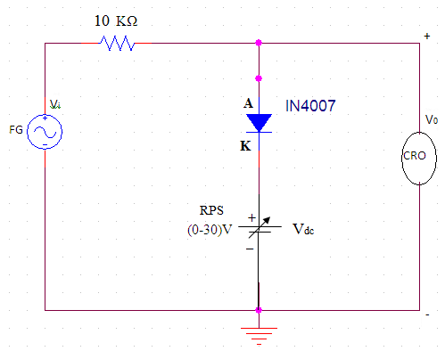

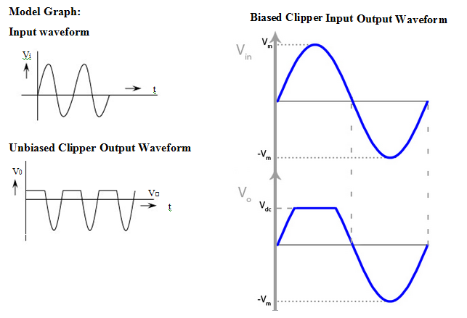

**Negative Clipper**

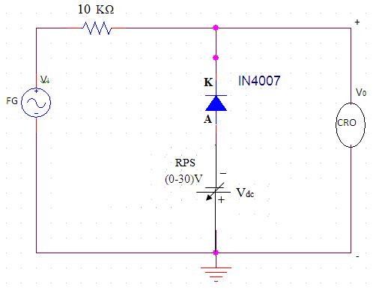

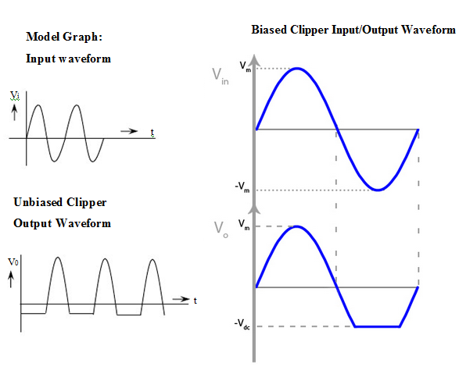

**Tabulation:**

**Positive Clipper** **Negative Clipper**

|  |  |  |  |
| --- | --- | --- | --- |
| **Unbiased Clipper** | | | |
| **Vref = 0V** | | **Vref = 0V** | |
| **Output voltage**  **(V)** | **Time Period**  **(ms)** | **Output voltage**  **(V)** | **Time Period**  **(ms)** |
| 115 | 270 | 131 | 200 |
| **Biased Clipper** | | | |
| **Vref = 2V** | | **Vref = 2 V** | |
| **Output voltage**  **(V)** | **Time Period**  **(ms)** | **Output voltage**  **(V)** | **Time Period**  **(ms)** |
| 132 | 290 | 137 | 230 |

Graph:

Vin,

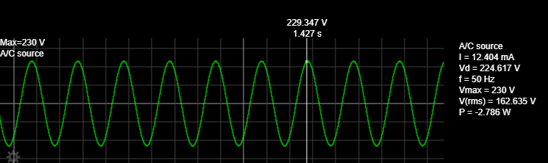

sVo, Positive Clipper.

Unbiased:

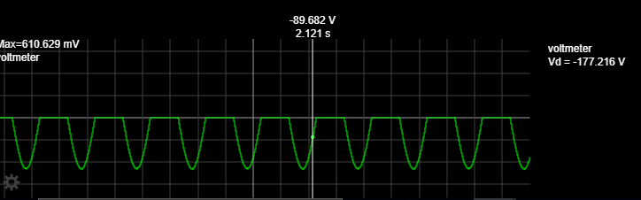

Biased:

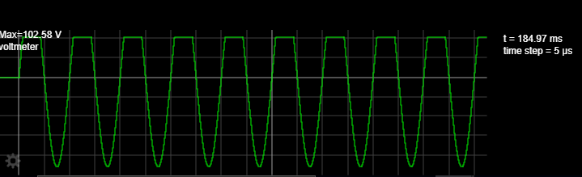

Vo, Negative Clipper.

Unbiased:

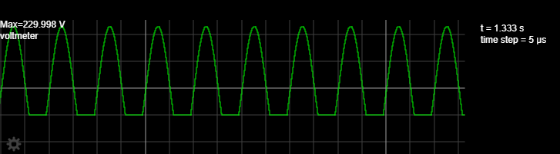

Biased:

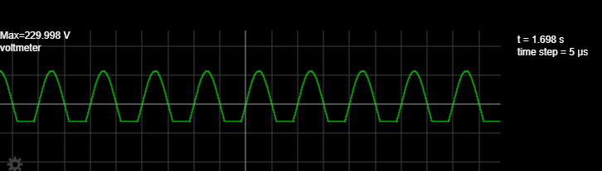

Result:

Positive Clipper:

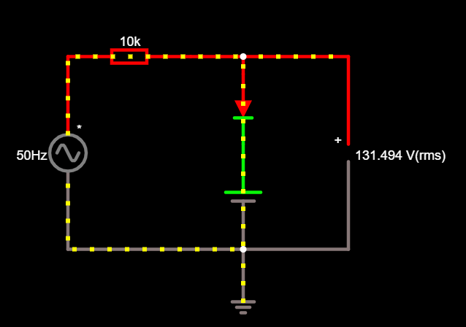

Negative Clipper:

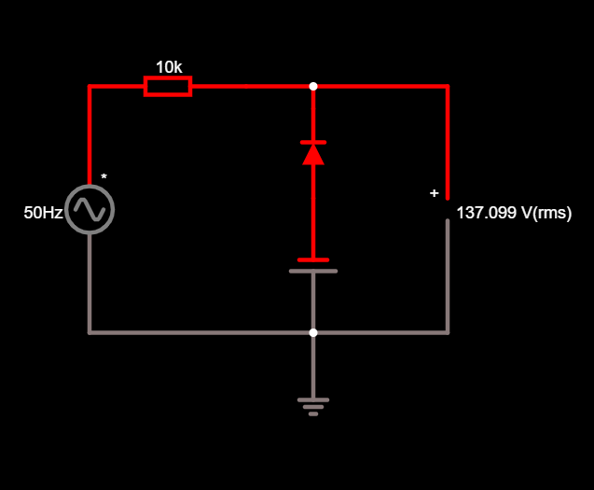

**POST LAB QUESTIONS**

**1.** **Differentiate +ve and -ve Clippers.**

A clipper circuit in which the diode is connected in series to the input signal and that attenuates the positive portions of the waveform, is termed as positive clippers.

The negative clippers are almost the same as the positive clipper, with only one difference. If the diode has its polarity reversed, the circuits, will become a negative clipper circuit.

**2. What is the function of Clampers?**

A clamper is an electronic circuit that fixed either the positive or the negative peak excursions of a signal to a defined value by shifting its DC value.

**3. Write the classifications of clippers and clampers.**

The clipper circuits are generally classified into three types: Series clippers, Shut clippers and Dual (combination) clippers. Clampers can be broadly classified into two types: Positive Clampers and Negative Clampers.

**4. Draw the output for the given input to the clamper circuit**

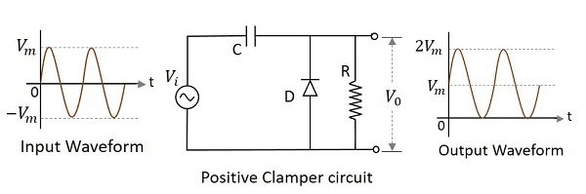

**5. What is the need of wave shaping circuit?**

In electronics application, it is often needed to alter the shape of waveform like cutting off positive or negative portion of wave, generation of one wave from other, holding wave at some dc level etc. To do this wave shaping circuits are needed.

**DEPT. OF ELECTRICAL & ELECTRONICS ENGINEERING**

**SRM INSTITUTE OF SCIENCE AND TECHNOLOGY, Kattankulathur – 603203.**

|  |
| --- |
| Title of Experiment : **9.**  **Displacement measurement using LVDT and pressure measurement using Strain gauge** |
| Name of the candidate : Kunal Keshan  Register Number : RA2011004010051  Date of Experiment :13.07.2021  Date of submission **:** 13.07.2021 |

|  |  |  |  |
| --- | --- | --- | --- |
| Sl.  No. | Marks Split up | Maximum marks  (50) | Marks obtained |
| 1 | Pre Lab questions | 5 |  |
| 2 | Preparation of observation | 15 |  |
| 3 | Execution of experiment | 15 |  |
| 4 | Calculation / Evaluation of Result | 10 |  |
| 5 | Post Lab questions | 5 |  |
| **Total** | | **50** |  |

**Staff Signature**

|  |  |
| --- | --- |
| **Experiment No. 9 a)**  **Date :** | **Displacement measurement using Linear Variable Differential Transformer** |

**Aim**: To measure the displacement and to determine the characteristics of LVDT (Linear Variable Differential Transformer).

**Apparatus required**: LVDT, Digital displacement indicator, Calibration jig (with micrometre).

**THEORY: LVDT (LINEAR VARIABLE DIFFERENTIAL TRANSFORMER)**

The most widely used inductive transducer to translate the linear motion into electrical signals is the linear variable differential transformer (LVDT). The basic construction of LVDT is shown in Figure 1.



Figure 1. Linear Variable Differential Transformer

The transformer consists of a single primary P and two secondary windings S1 and S2 wound on a cylindrical former. The secondary windings have equal number of turns and are identically placed on either side. A moveable soft iron core is placed inside the transformer. The displacement to be measured is applied to the arm attached to the soft iron core. In practice the arm is made of highly permeability, nickel iron which is hydrogen annealed. This gives low harmonics low null voltage and high sensitivity. This is slotted longitudinally to reduce eddy current losses. The assembly is placed in stainless steel housing and the end leads provides electrostatic and electromagnetic shielding. The frequency of AC applied to primary windings may be between 50 Hz to 20 kHz. Since the primary winding is excited by an alternating source, it produces an alternating magnetic field which in turn induces alternating current voltage in the two secondary windings. Figure 2 depicts a cross-sectional view of an LVDT. The core causes the magnetic field generated by the primary winding to be coupled to the secondary. When the core is centred perfectly between both secondary and the primary as shown, the voltage induced in each secondary is equal in amplitude and 180 degree out of phase. Thus the LVDT output (for the series-opposed connection shown in this case) is zero because the voltage cancels each other. E0 = Es1 - Es2 = 0.



Figure 2. View of LVDT Core and Windings

Displacing the core to the left causes the first secondary to be more strongly coupled to the primary than the second secondary. The resulting higher voltage of the first secondary in relation to the second secondary causes an output voltage that is in phase with the primary voltage. Likewise, displacing the core to the right causes the second secondary to be more strongly coupled to the primary than the first secondary. The greater voltage of the second secondary causes an output voltage to be out of phase with the primary voltage.

**Procedure**:

1. Plug power chord to AC mains 230 V, 50 Hz and switch on the instrument.
2. Place the READ/CAL switch at READ position.
3. Balance the amplifier with the help of zero knob so that display should read zero without connecting the LVDT to instrument.
4. Replace the READ/CAL switch at CAL position.
5. Adjust the calibration point by rotating CAL knob so display should read 10.00 i.e., maximum calibration range.
6. Again keep the READ/CAL switch at READ position and connect the LVDT cable to instrument.
7. Make mechanical zero by rotating the micrometre. Display will read (00.00) this is null balancing.
8. Give displacement with micrometre and observe the digital readings.
9. Plot the graph of micrometre reading v/s digital reading.

**Model Graph:**

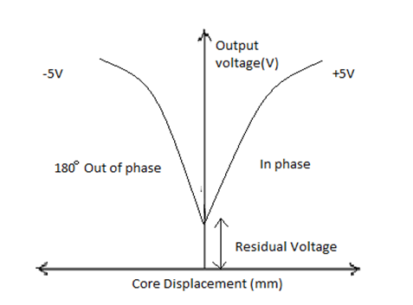

**Tabulations:**

|  |  |
| --- | --- |
| **CORE DISPLACEMENT**  **(mm)** | **SECONDARY OUTPUT**  **VOLTAGE(mV)** |
| 0 | 0 |
| **3** | **25.91** |
| **6** | **50.05** |
| **9** | **70.66** |
| **-3** | **25.91** |
| **-6** | **50.05** |
| **-9** | **70.66** |

**Graph:**

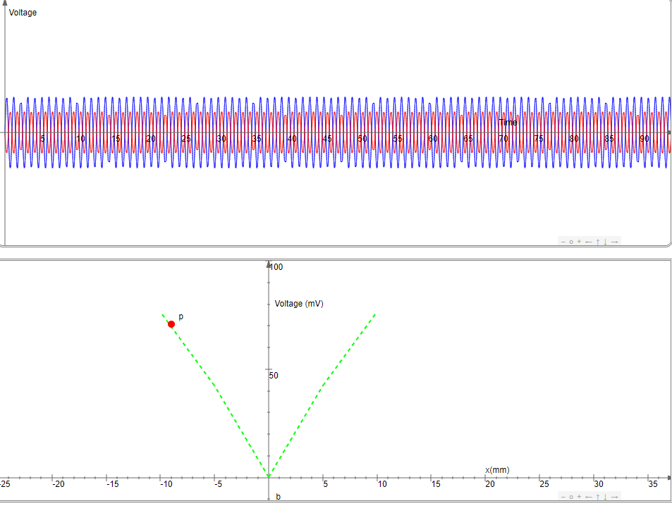

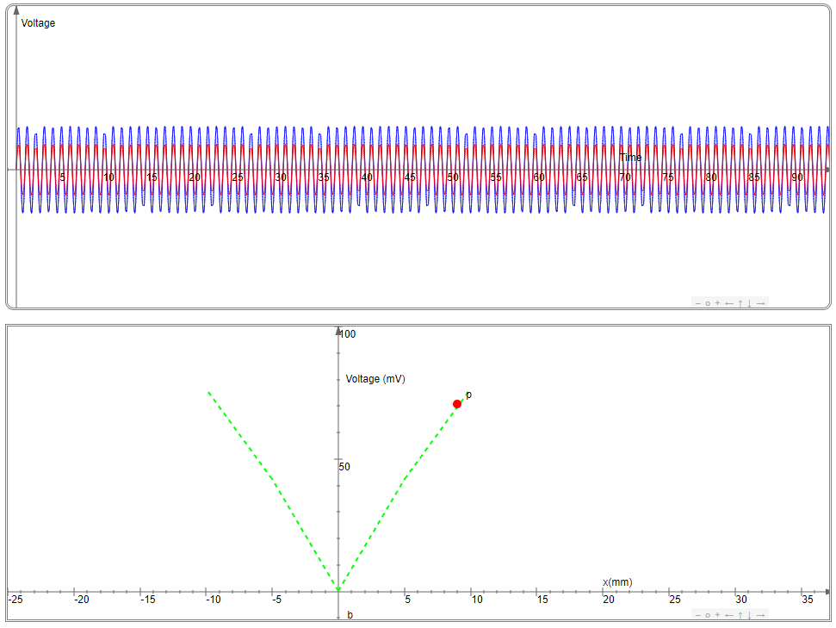

**Result:**

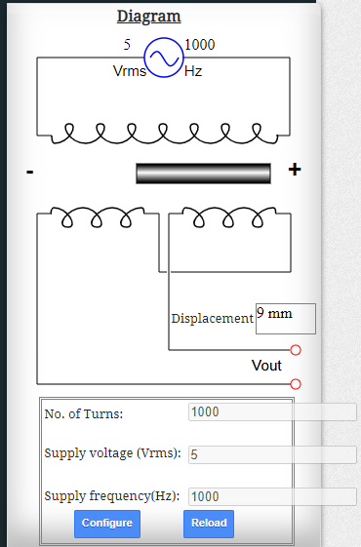

**POST LAB QUESTIONS:**

**1. What are the three principles of Inductive transducers?**

In Inductive transducers, the basic principle is that self-inductance of a single coil or the mutual inductance between two coils is changed by a quantity to be measured. Usually the measured value could be a rotatory or linear displacement, force, pressure, torque, velocity, acceleration, and vibration.

Inductive transducers work on one of the following principles for its working:

* 1. Change of self-inductance.
  2. Change of Mutual Inductance.
  3. Production of eddy current.

**2. What are the limitations of LVDT?**

1. Large displacement is needed for small output.
2. It is affected due to external magnetic field and hence the entire LVDT circuit needs to be shielded to achieve desired accuracy.
3. Vibrations due to displacement can affect the performance of the LVDT device.
4. The performance of LVDT is affected due to increase in temperature.
5. In order to get DC output, external demodulator is required.
6. It has limited dynamic response.

**3. Where LVDT is used?**

There are two main ways in which an LVDT can be used;

**Main transducer** – the LVDT will convert displacement into an electrical signal.

**Secondary Transducer** – An LVDT can also be used as a secondary transducer where it will measure force, weight or pressure.

Other Applications include:

Power turbines, Hydraulics, Aircrafts, Satellites, Nuclear reactors, Factory automation, Process and control, Materials testing, general industrial application, etc.

**4. What are the different types of transducers used for displacement measurement?**

A displacement transducer, or DT, is an electrical transducer used in measuring linear position. The output signal of the linear displacement sensor is the measurement of the distance an object has traveled in units of millimeter, or inches and can have negative and positive values.

**5. What is the difference between variable resistance & variable inductance displacement transducer?**

The variable resistance transducers are one of the most commonly used types of transducers. The variable resistive transducers are used for measuring various physical quantities like temperature, pressure, displacement, force, vibration, etc. These are usually used as the secondary transducers, where the output from the primary mechanical transducer acts as the input for the variable resistance transducer.

Variable Inductance Transducers is a measure that relates electrical flux to current. Inductance is monitored through the resonant frequency of the inductance could to an applied voltage. As inductance changes, the resonant frequency of the coils changes. Electronic circuits that convert frequency to voltage are used to gain a voltage output to inductive transducers.

**PRE LAB QUESTIONS (Strain gauge):**

**1. How does a strain gauges work?**

A strain gauge is a sensor whose measured electrical resistance varies with changes in strain. Strain gauges convert the applied force, pressure, torque, ect. Into an electrical signal which can be measured.

**2. What is piezo-resistive effect?**

It is the change in the electrical resistivity of as semiconductor or metal when mechanical strain is applied. It only causes a change in the electrical resistance, not in electrical potential.

**3. What are the types of strain gauge?**

1. Linear Strain Gauge.
2. Membrane Rosette Strain Gauges.
3. Double linear strain gauges.
4. Full bridge strain gauges.
5. Shear strain gauge.
6. Half bridge strain gauge.
7. Column strain gauges.
8. 45 – Rosette.

**4. Define gauge factor.**

Gauge or strain factor of a strain gauge is the ration of relative change in electrical resistance R, to the mechanical strain ε. It is defined as:

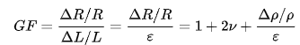

**5. Mention some practical applications of strain gauge.**

It is used in the fields of civil engineering and geotechnical monitoring to detect failures in structures like buildings, bridges, and much more.

They are also frequently used for static testing.

|  |  |
| --- | --- |
| **Experiment No. 9 b)**  **Date :** | **Strain measurement using Strain gauge** |

**Aim**: To measure the strain using strain gauge.

**Apparatus Required**: Strain gauge, weight, LABVIEW software.

**Theory**: Strain is the amount of deformation of a body due to an applied force. More specifically, strain (e) is defined as the fractional change in length, Strain can be positive (tensile) or negative (compressive). Although dimensionless, strain is sometimes expressed in units such as in./in. or mm/mm. In practice, the magnitude of measured strain is very small. Therefore, strain is often expressed as microstrain (me), which is e x 10-6. When a bar is strained with a uniaxial force, as in Figure 1, a phenomenon known as Poisson Strain causes the girth of the bar, D, to contract in the transverse, or perpendicular, direction. The magnitude of this transverse contraction is a material property indicated by its Poisson's Ratio. The Poisson's Ratio n of a material is defined as the negative ratio of the strain in the transverse direction (perpendicular to the force) to the strain in the axial direction (parallel to the force), or n = eT/e. The most widely used gage is the bonded metallic strain gage. The metallic strain gauge consists of a very fine wire or, more commonly, metallic foil arranged in a grid pattern. The grid pattern maximizes the amount of metallic wire or foil subject to strain in the parallel direction (Figure 2). The cross-sectional area of the grid is minimized to reduce the effect of shear strain and Poisson Strain. The grid is bonded to a thin backing, called the carrier, which is attached directly to the test specimen.

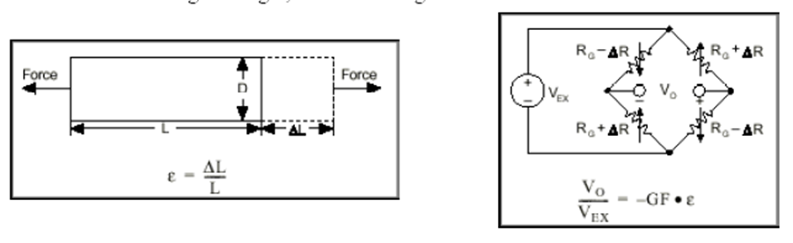

**Figure 1. Strain measurement**

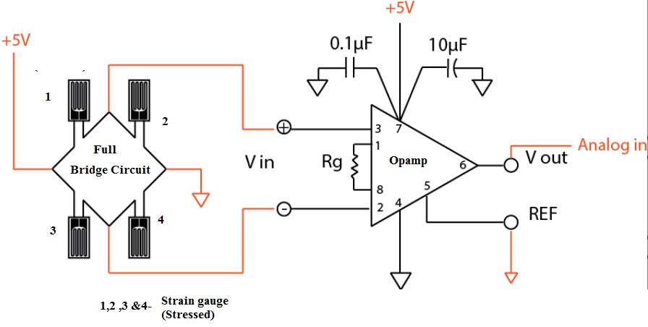

**Figure 2. Full- Bridge Strain gauge circuit**

**Procedure**:

1. Connect the cantilever strain measurement assembly to the main trainer and switch ON the trainer

2. Connect the multi meter at the Instrument output with multimeter in DC VOLTAGE mode and 20 V Range.

3. Connect this STRAIN output also to display section marked Vout.

4. Now without any strain or load in the cantilever beam. So adjust the OFFSET CONTROL to 0 volts at the output.

5. Now place 500 grams weights on the pan suspended n the beam and adjust the gain or call control to read 0.5 volt by multimeter at the strain output terminal.

6. Now remove the weight from the pan and the output must be 0 volt. IF not then readjust OFFSET Control

7. Table the readings for different weight or strain on the load cell as well as display readings.

**Tabulation:**

|  |  |  |  |  |
| --- | --- | --- | --- | --- |
| **S.no** | **Weight in Pan (grams)** | **Voltage measured(mv)** | **Display reading** | **Calculated value** |
| **1** | **1000** | **0.18** | **0.18** | **0.18** |
| **2** | **2000** | **0.37** | **0.37** | **0.37** |
| **3** | **3000** | **0.55** | **0.55** | **0.55** |
| **4** | **4000** | **0.74** | **0.74** | **0.74** |
| **5** | **5000** | **0.92** | **0.92** | **0.92** |
| **6** | **6000** | **1.1** | **1.1** | **1.1** |
| **7** | **7000** | **1.29** | **1.29** | **1.29** |
| **8** | **8000** | **1.47** | **1.47** | **1.47** |
| **9** | **9000** | **1.66** | **1.66** | **1.66** |
| **10** | **10000** | **1.8** | **1.8** | **1.8** |

**Result:**

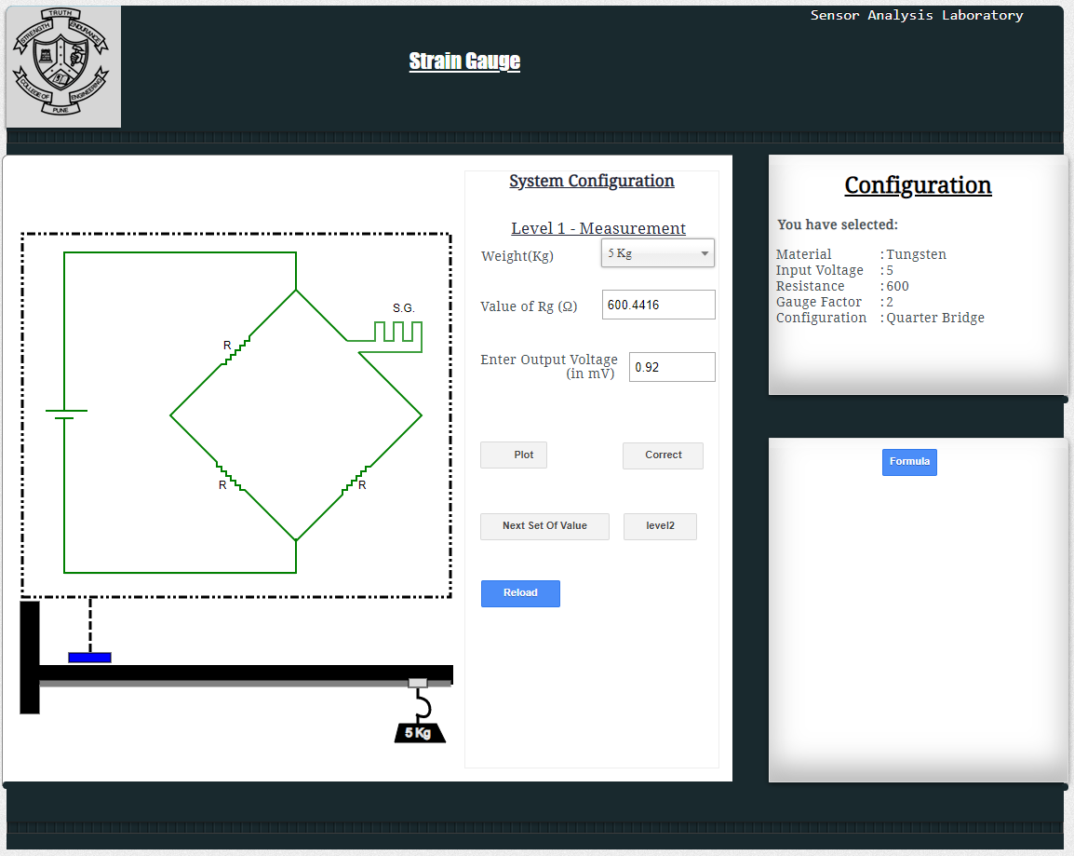

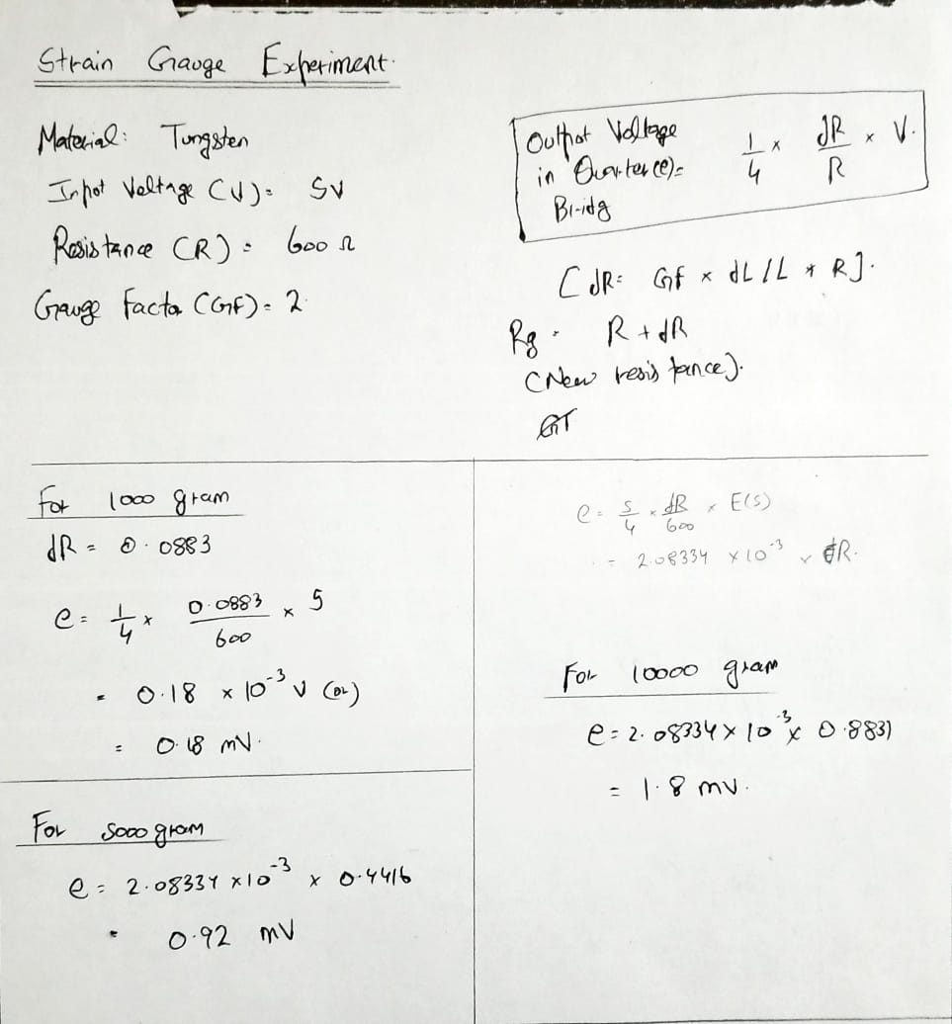

**POST-LAB QUESTIONS:**

**1. How can you apply the principle of stain gauge?**

A Strain gauge is a sensor whose resistance varies with applied force; It converts force, pressure, tension, weight, etc., into a change in electrical resistance which can then be measured. When external forces are applied to a stationary object, stress and strain are the result.

**2. What is meant by passive transducer?**

Passive transducer is a device which converts the given non-electrical energy into electrical energy by external force. Resistance strain gauge, differential transformer are some examples of passive transducers.

**3. What is sensitivity of strain gauge?**

A fundamental parameter of the strain gauge is its sensitivity to strain, expressed quantitatively as the gage factor (GF). GF is the ration of the fractional change in electrical resistance to the fractional change in length, or strain:

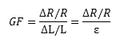

**4. What is a microstrain?**

Microstrain is the strain expressed in terms of parts per million.

**5. What are the limitations of a strain gauge?**

They are not suited for underwater application. They need to be protected with a water tight housing.

Only the surface strain of the component can be measured, but not the integral strain of the component.

It can only measure the strain of a point on the surface of a component in a certain direction, and cannot perform global measurement.

**DEPT. OF ELECTRICAL & ELECTRONICS ENGINEERING**

**SRM INSTITUTE OF SCIENCE AND TECHNOLOGY, Kattankulathur – 603203.**

|  |
| --- |
| Title of Experiment : **10. Verification and interpretation of Logic Gates.** |
| Name of the candidate : Kunal Keshan  Register Number : RA2011004010051  Date of Experiment : 6th July 2021 |

|  |  |  |  |
| --- | --- | --- | --- |
| Sl.  No. | Marks Split up | Maximum marks  (50) | Marks obtained |
| 1 | Pre Lab questions | 5 |  |
| 2 | Preparation of observation | 15 |  |
| 3 | Execution of experiment | 15 |  |
| 4 | Calculation / Evaluation of Result | 10 |  |
| 5 | Post Lab questions | 5 |  |
| **Total** | | **50** |  |

**Staff Signature**

**PRE-LAB QUESTIONS**

**1. Name the different Logic Gates.**

There are seven basic logic gates: AND, OR, XOR, NOT, NAND, NOR, and XNOR.

**2. List out the IC names for the different logic Gates.**

There are many IC with different logic gate arrangement, some of them are,

* 7400 Quad 2 input NAND Gate.
* 7402 quad 2 input NOR gate.
* 7404 Hex NOT gates.
* 7408 quad 2 input AND gate.
* 7432 quad 2 input OR gate.
* 7486 quad 2 input XOR gate.
* 747266 quad 2 input XNOR gate.
* 74133 single 13 input NAND gate.

**3. What is the Boolean expression for a NOR gate?**

The Boolean expression for a logic NOR gate is denoted by a plus sign, ( + ) with a line or Overline, ( ‾‾ ) over the expression to signify the NOT or logical negation of the NOR gate giving us the Boolean expression of: A+B = Q.

**4. How does a NOR gate work?**

A NOR gate is a logic gate that produces a high output only if all inputs are false and a low output otherwise. It is the inverse of an OR gate, it can have any number of input probes but only one output probe.

**5. Expression for Ex-OR and Ex-NOR?**

XOR is represented as A ⊕ B. The symbol of exclusive OR operation is represented by a plus ring surrounded by a circle ⊕.

The logical XNOR operation is represented by ⊙. That is a dot surrounded by a circle. The expression of XNOR operation between variables A and B is represented as A ⊙ B.

|  |  |
| --- | --- |
| **Experiment No. 10**  **Date :** | **Verification and interpretation of truth tables for AND, OR, NOT, NAND, NOR Exclusive OR (EX-OR), Exclusive NOR (EX-NOR) Gates.** |

**Aim**: To verify the Boolean expression using logic gates.

**Apparatus:** Logic trainer kit, logic gates / ICs, wires.

**Theory:**  Logic gates are electronic circuits which perform logical functions on one or more inputs to produce one output. There are seven logic gates. When all the input combinations of a logic gate are written in a series and their corresponding outputs written along them, then this input/ output combination is called **Truth Table**. The following logic gates and their working are explained.

**i) AND Gate**

AND gate produces an output as 1, when all its inputs are 1; otherwise the output is 0. This gate can have minimum 2 inputs but output is always one. Its output is 0 when any input is 0.

[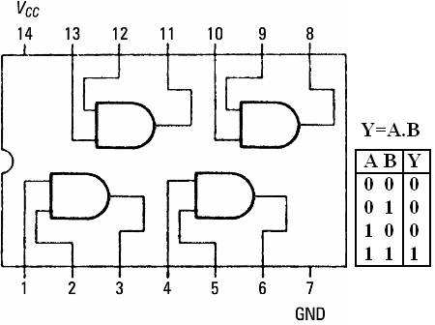](https://sites.google.com/site/amtmttl/st2/IC7408.PNG?attredirects=0)

**IC 7408**

**ii) OR Gate**

OR gate produces an output as 1, when any or all its inputs are 1; otherwise the output is 0. This gate can have minimum 2 inputs but output is always one. Its output is 0 when all input are 0.

[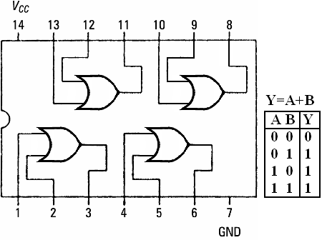](https://sites.google.com/site/amtmttl/st2/IC7432.PNG?attredirects=0)

IC 7432

**iii) NOT Gate**

NOT gate produces the complement of its input. This gate is also called an INVERTER. It always has one input and one output. Its output is 0 when input is 1 and output is 1 when input is 0.

[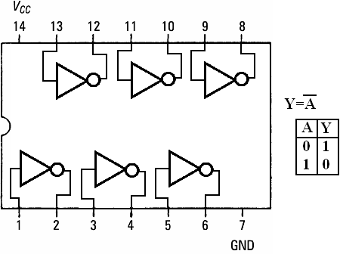](https://sites.google.com/site/amtmttl/st2/IC7404.PNG?attredirects=0)

IC 7404

**iv) NAND Gate**

NAND gate is actually a series of AND gate with NOT gate. If we connect the output of an AND gate to the input of a NOT gate, this combination will work as NOT-AND or NAND gate. Its output is 1 when any or all inputs are 0, otherwise output is 1.

[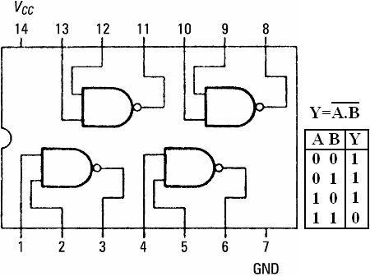](https://sites.google.com/site/amtmttl/st2/IC7400.png?attredirects=0)

**IC 7400**

**v) NOR Gate**

NOR gate is actually a series of OR gate with NOT gate. If we connect the output of an OR gate to the input of  a NOT gate, this combination will work as NOT-OR or NOR gate. Its output is 0 when any or all inputs are 1, otherwise output is 1.

[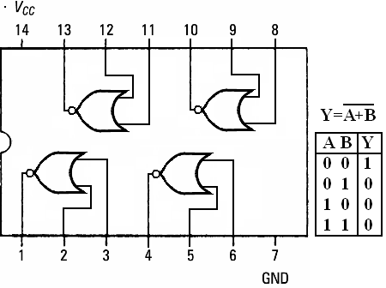](https://sites.google.com/site/amtmttl/st2/IC7402.PNG?attredirects=0)

**IC 7402**

**vi) Exclusive OR (X-OR) Gate**

X-OR gate produces an output as 1, when number of 1’s at its inputs is **odd**, otherwise output is 0. It has two inputs and one output.

[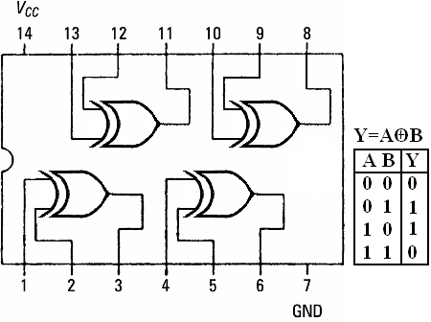](https://sites.google.com/site/amtmttl/st2/IC7486.PNG?attredirects=0)

**IC 7486**

**vii) Exclusive NOR (X-NOR) Gate**

X-NOR gate produces an output as 1, when number of 1’s at its inputs is **not odd**, otherwise output is 0. It has two inputs and one output.

[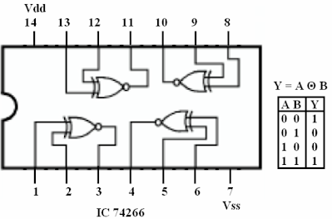](https://sites.google.com/site/amtmttl/st2/IC74266.PNG?attredirects=0)

**Procedure:**

1. Connect the trainer kit to ac power supply.
2. Connect the inputs of any one logic gate to the logic sources and its output to the logic indicator.
3. Apply various input combinations and observe output for each one.
4. Verify the truth table for each input/ output combination.
5. Repeat the process for all other logic gates.
6. Switch off the ac power supply.

**POST-LAB QUESTIONS**

**1. Name the universal Gates?**

The NOR gate and NAND gate are universal logic gates.

**2.** **Deduce the logic of AND gate using NAND and NOR?**

**AND USING NAND:** Connect a NOT using NAND at the output of the NAND to invert it and get AND logic.

**AND USING NOR:** Connect two NOT using NORs at the inputs of NOR to get AND logic.

**3. What is the symbol of NAND gate?**

The logic NAND function is given by the Boolean expression Y=A.B¯. Here A, B are the inputs and Y is the output.

**4. How many NAND gates are required to make an OR gate?**

Three NAND gates are required to make an OR gate.

**5. How many NOR gates are required to implement a NAND gate?**

Four NOR gates are required to implement a NAND gate.

**DEPT. OF ELECTRICAL & ELECTRONICS ENGINEERING**

**SRM INSTITUTE OF SCIENCE AND TECHNOLOGY, Kattankulathur – 603203.**

|  |
| --- |
| Title of Experiment : **11. Reduction of Boolean expression using K-map** |
| Name of the candidate : Kunal Keshan  Register Number : RA2011004010051  Date of Experiment :13.07.2021 |

|  |  |  |  |
| --- | --- | --- | --- |
| Sl.  No. | Marks Split up | Maximum marks  (50) | Marks obtained |
| 1 | Pre Lab questions | 5 |  |
| 2 | Preparation of observation | 15 |  |
| 3 | Execution of experiment | 15 |  |
| 4 | Calculation / Evaluation of Result | 10 |  |
| 5 | Post Lab questions | 5 |  |
| **Total** | | **50** |  |

**Staff Signature**

**PRE LAB QUESTIONS:**

**1. How many Cells are in 4 and 5 Variable K- Map.**

4 variables have 2n = 24 = 16 minterms. A 4 variable K-map will have 16 cells.

5 variable K-map have 32 cells.

**2. What do you mean by don’t care condition in K-map or truth table?**

The “Don’t care” conditions allows us to replace the empty cell of K-map to form a grouping of the variables which is larger than that of forming groups without don’t cares. While forming groups of cells, we can consider don’t care cell as 1 or 0 or we can also ignore that cell. The help us to form a larger group of cells.

**3. Write the Distributive property of Boolean algebra.**

Distributive laws states that the multiplication of two variables and adding the result with a variable will result in the same value as multiplication of addition of the variable with individual variables. Ex: A + BC = (A+B)(A+C).

**4. Write down the De Morgan law.**

De Morgan’s law states that the complement of the union of two sets is the intersection of their complements and the complement of the intersection of two sets is the union of their complements.

**5. State the difference between SOP and POS.**

The main difference between SOP and POS is that the SOP is a way of representing a Boolean expression using min terms or product terms, while the POS is a way of representing a Boolean expression using max terms or sum terms.

|  |  |
| --- | --- |
| **Experiment No. 11**  **Date :13.07.2021** | **Reduction of Logic Expression using**  **Karnaugh map** (**K- Map)** |

**Aim:** To simply and verify the Boolean expression using K-map.

**Apparatus:** Logic trainer kit, logic gates / ICs, wires.

**Theory:**

**Karnaugh maps:** Karnaugh maps or K-maps for short, provide another means of simplifying and optimizing logical expressions. This is a graphical technique that utilizes a sum of product (SOP) form. SOP forms combine terms that have been ANDed together that then get ORed together. This format lends itself to the use of De Morgan's law which allows the final result to be built with only NAND gates. The K-map is best used with logical functions with four or less input variables. One of the advantages of using K-maps for reduction is that it is easier to see when a circuit has been fully simplified. Another advantage is that using K-maps leads to a more structured process for minimization. In order to use a K-map, the truth table for a logical expression is transferred to a K-map grid. The grid for two, three, and four input expressions are provided in the tables below. Each cell corresponds to one row in a truth table or one given state in the logical expression. The order of the items in the grid is not random at all; they are set so that any adjacent cell differs in value by the change in only one variable. Because of this, items can be grouped together easily in rectangular blocks of two, four, and eight to find the minimal number of groupings that can cover the entire expression. Note that diagonal cells require that the value of more than two inputs change, and that they also do not form rectangles.

|  |  |  |  |  |
| --- | --- | --- | --- | --- |
|  | A'B’  00 | A’B  01 | AB  11 | AB’  10 |
| C’  0 |  |  |  |  |
| C  1 |  |  |  |  |

|  |  |  |
| --- | --- | --- |
|  | A’  0 | A  1 |
| B’  0 |  |  |
| B  1 |  |  |

**Figure 1. Three variables K Map Figure 2. Two variables K- Map**

**Given expression**

**F(C,A,B) = CAB + C'AB + CA'B + C'A'B**

**Simplification Using Boolean Properties**

CAB + C'AB + CA'B + C'A'B = AB(C + C') + A'B(C + C') Distributive Property

= AB + A'B C + C' is always true

= (A + A')B Distributive Property

= B A + A' is always true

**Simplification using K- Map**



**Procedure:**

1. Connect the trainer kit to ac power supply.
2. Connect the circuit based on the given logic functions to be simplified.
3. Connect the inputs of first stage to logic sources and output of the last gate to logic indicator.
4. Apply various input combinations and observe output for each one.
5. Verify the output before and after reducing the expression.
6. Switch off the ac power supply.

**Result:**

Reduction of logic using Kmap has been understood.

**Post-lab questions**

**1. Simply the expression F=AB+A­B’**

= A ( B + B’)

**=** A (1)

F = A

**2. Name the different reduction techniques**

1. Select K-map according to the number of variables.
2. Identify minterms or maxterms as given in problem.
3. For SOP put 1’s in blocks of K-map respective to the minterms (0’s elsewhere).
4. For POS put 0’s in blocks of K-map respective to the maxterms(1’s elsewhere).
5. Make rectangular groups containing total terms in power of two like 2,4,8 ..(except 1) and try to cover as many elements as you can in one group.
6. From the groups made in step 5 find the product terms and sum them up for SOP form.

**3. Give the merits and demerits of K-map**

Advantages of K-map:

1. It is a fast method for simplifying expression up to four variables.
2. It gives a visual method of logic simplification.
3. Prime and essential implicants are identified fast.
4. It is more suitable for class room teachings on logic simplification.

Disadvantages of K-map:

1. It is not suitable for computer reduction.
2. K-maps are not suitable when the number of variables involved exceed four.
3. Care must be taken to fill in every cell with the relevant entry, such as 0, 1 or don’t care terms.

**4. What are differences between K-map and Quine McCluskey?**

Unlike K-map, the Quine-McCluskey method uses tables, which provides simple pattern recognitions. Quine-McCluskey method is a tabular method that has an advantage when large number of inputs are present. Whit more inputs, pattern recognition in K-map can be tedious and sometimes impossible. The Quine-McClusey consists of two steps: 1. Finding all prime implicants of the function, and 2. Selecting a minimal set of prime implicants of the function.

**5. Give steps for reducing two variable expression using K-map?**

1. Firstly, we define the given expression in its canonical form.
2. Next, we create the K-map by entering 1 to each product terms into the K-map cell and fill the remaining cells with zeros.
3. Next, we form the groups by considering each one in K-map.
4. In the next step, we find the boolean expression for each group.
5. Lastly, we find the Boolean expression of the output.

**DEPT. OF ELECTRICAL & ELECTRONICS ENGINEERING**

**SRM INSTITUTE OF SCIENCE AND TECHNOLOGY, Kattankulathur – 603203.**

|  |
| --- |
| Title of Experiment : **12. Study of modulation and demodulation techniques.** |
| Name of the candidate : Kunal Keshan S  Register Number : RA2011004010051  Date of Experiment :  Date of submission **:** |

|  |  |  |  |
| --- | --- | --- | --- |
| Sl.  No. | Marks Split up | Maximum marks  (50) | Marks obtained |
| 1 | Pre Lab questions | 5 |  |
| 2 | Preparation of observation | 15 |  |
| 3 | Execution of experiment | 15 |  |
| 4 | Calculation / Evaluation of Result | 10 |  |
| 5 | Post Lab questions | 5 |  |
| **Total** | | **50** |  |

**Staff Signature**

**PRE-LAB QUESTIONS**

**1. What is meant by modulation and demodulation in communication?**

Modulation is the process of varying one or more properties of a periodic waveform, the carrier signal, with a modulating signal that typically contains information that is to be transmitted.

Demodulation is defined as extracting the original information-carrying signal from a modulated carrier wave.

**2. What is modulation and demodulation?**

Modulation is the process of varying one or more properties of a periodic waveform, the carrier signal, with a modulating signal that typically contains information that is to be transmitted.

Demodulation is defined as extracting the original information-carrying signal from a modulated carrier wave.

**3. What is modulation and what is the purpose of it?**

Modulation is the process of varying one or more properties of a periodic waveform, the carrier signal, with a modulating signal that typically contains information that is to be transmitted.

To involve data information or speech information, another wave has to be imposed known as input signal above the carrier wave. This process of imposing an input signal on a carrier wave is known as modulation. It modifies the shape of the carrier wave to encode the data information that we intended on carrying. It is similar to hiding the code in the carrier wave.

**4. Compare AM and FM**

In AM, a radio wave is known as the “carrier” or “carrier wave” is modulated in amplitude by the signal that is to be transmitted. In FM, a radio wave is known as the “carrier” or “carrier wave” is modulated in frequency by the signal that is to be transmitted.

**5. What is the difference between a modem and router?**

A modem is a device that modulates an analog signal to digital information. It also decodes carrier signals to demodulated the transmitted information.

Routers are computer networking devices that server two functions: 1. Create and maintain a local area network and 2. Manage the data entering and leaving the network as well as data moving inside of the network.

|  |  |
| --- | --- |
| **Experiment No. 12**  **Date :** | **Study of modulation and demodulation techniques.** |

**Aim**: To study the different modulation and demodulation techniques

# Theory:

# Modulation and demodulation

Communication is the basic attraction of mankind as it gives the knowledge of what is going on around us. In our daily life, we communicate with many people and use the entertainment media like television, radio, internet and newspaper to get ourselves involved. These entertainment media act as a source of communication**.**[**Electronic communication**](http://www.edgefx.in/latest-zigbee-communication-based-projects-for-patients-monitoring/) comprises TV, radio, internet, etc. When we want to transmit a signal from one location to another, we have to strengthen the signal. After undergoing strengthening process the signal travels to a long distance. This is called as modulation, and this article gives an overview of the modulation and [types of modulation techniques](http://www.elprocus.com/different-types-of-modulation-techniques-in-communication-systems/).

Communication is nothing but, the process of exchanging (two way communication) or passing (one way communication) information from one person to another. The basic electronic communication system consists of these components: transmitter, receiver and communication channel.

**Types of Modulation**

Communication is the basic attraction of mankind as it gives the knowledge of what is going on around us. In our daily life, we communicate with many people and use the entertainment media like television, radio, internet and newspaper to get ourselves involved. These entertainment media act as a source of communication. Electronic communication comprises TV, radio, internet, etc. When we want to transmit a signal from one location to another, we have to strengthen the signal. After undergoing strengthening process the signal travels to a long distance. This is called as modulation, and this article gives an overview of the modulation and types of modulation techniques.

Communication is nothing but, the process of exchanging (two way communications) or passing (one way communication) information from one person to another. The basic electronic communication system consists of these components: transmitter, receiver and communication channel.

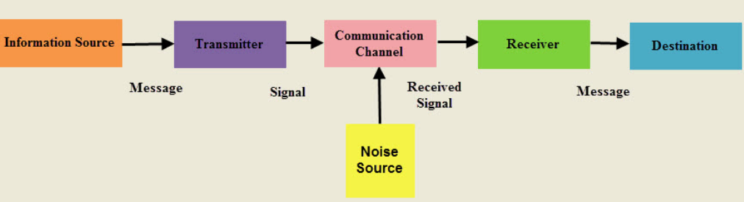

Figure 1. Communication System

A transmitter is a group of electronic circuits designed to convert the information into a signal for transmission over a given communication medium.

A receiver is a group of electronic circuits designed to convert the signal back to the original information.

The communication channel is the medium which is designed to transmit the electronic signal from one place to another.

Modulation is a way of sending signals of low frequency over long distances without a huge loss of energy by the use of another wave of very high frequency called a carrier wave.

Modulation is nothing but, a carrier signal that varies in accordance with the message signal. Modulation technique is used to change the signal characteristics. Basically, the modulation is of following two types:

* Analog Modulation
* Digital Modulation

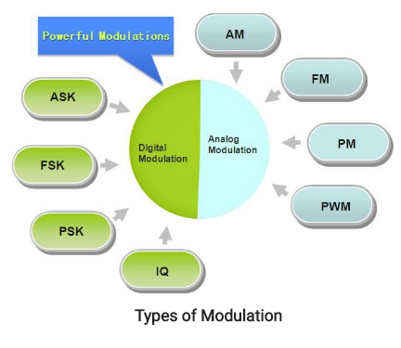

Figure 1. Types of Modulation

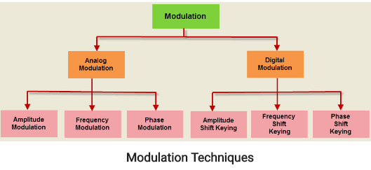

Figure 2. Modulation Techniques

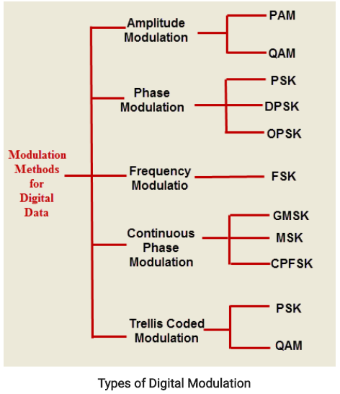

Figure 3. Types of Digital Modulation Techniques

High frequency signals are more directional and because high frequency waves have a small wavelength there is less diffraction. Also smaller aerials are needed because the size of the aerial has to be of the same sort of size as the wavelength of the signal to be transmitted.

Therefore a sound with a frequency of 256 Hz (middle C) received by a microphone, converted to an electrical signal and then transmitted would have a wavelength of 300000000/256 = 1 170 000 m, over 1000 km!

However a wave of frequency 100 MHz has a wavelength of only 3 m.

We can compare amplitude modulation with a long tube of soft clay on a conveyor belt. The clay moves between the hands of two people, one at each end of the belt.

Modulation – the person at one end moulds the clay by pressing on it as it moves between their hands. By squeezing and relaxing they make a tube of clay with a changing diameter.

At the other end of the belt there is a person with their eyes shut and their hands on either side of the clay at the other end. As the clay moves past their hands are forced in and out by the changing diameter of the clay cylinder. This is called detection

In reality we start with a carrier wave of very high frequency and add to it the audio signal (of relatively low frequency). This addition of the audio signal is called modulation. This can be done either by changing the amplitude of the carrier wave (amplitude modulation) or by changing its frequency (frequency modulation).

The audio signal is produced (Figure 1) and converted to an electrical signal by the microphone.

Figure 1

The high frequency carrier wave (with a frequency of say 100 MHz) (Figure 2) is produced by the transmitter.

Figure 2

These two signals are added together (modulation) (Figure 3).

Figure 3

The modulated signal is transmitted (Figure 4).

Figure 4

The modulated signal is received by the aerial.

A diode is used to separate the high frequency carrier wave from the low frequency audio signal (demodulation) by removing half the signal. This leaves the outline of the audio signal (Figure 5).

Figure 5

This signal is now amplified and fed to a loudspeaker.

The receiver is tuned to the carrier wave frequency. The following two diagrams (Figures 6 and 7) show two carrier waves of different frequency both modulated by the same frequency audio signal.

Figures 6 and 7

**Result :**

Study of Modulation and Demodulation is completed.

**POST-LAB QUESTIONS**

**1. What are the different types of modulation?**

1. Amplitude Modulation.
2. Frequency Modulation.
3. Phase Modulation

**2. Which type of modulation is used in television?**

All analog television systems use vestigial sideband modulation, a form of amplitude modulation in which one sideband is partially removed. This reduces the bandwidth of the transmitted signal, enabling narrower channels to be used.

**3. What is PPM modulation?**

Pulse-Position modulation is a form of signal modulation in which M message bits are encoded by transmitting a signal pulse in one of 2M possible required time shifts. This is repeated every T seconds, such that the transmitted bit rate is M/T bits per second.

**4. What is PWM modulation?**

Pulse-Width Modulation, is a method of reducing the average power delivered by an electrical signal, by effectively chopping it up into discrete parts. The average value of voltage fed to the load is controlled by turning the switch between supply and load on and off at a fast rate.

**5. What are NTSC and PAL?**

NTSC (national television system committee) is responsible for producing the detailed technical specifications for the transmission standard.

PAL (phase alternating line) is a color encoding system for analogue television used in broadcast television systems in most countries broadcasting at 25 fps.